2025 Waterloo Email Tournament Finals Commentary
Bert Schoose (French) vs Ed Menzel (PAA)
Neutral Commentary – Joe Beard
Game Played: March 30 to May 18, 2025
Commentary compiled by Ed Menzel

Contents
Bidding Phase 3
16-0500 set up 4
16-0700 French 6
16-0700 PAA 9
16-0900 French 11
16-0900 PAA 13
16-1100 French 15
16-1100 PAA 18
16-1300 French 21
16-1300 PAA 25
16-1500 French 28
16-1500 PAA 31
16-1700 French 35
16-1700 PAA 38
16-1900 French 40
16-1900 PAA 43
17-0700 French 46
17-0700 PAA 50
17-0900 French 53
17-0900 PAA 57
17-1100 French 59
17-1100 PAA 64
17-1300 French 67
17-1300 PAA 71
17-1500 French 73
17-1500 PAA 76
17-1700 French 78
17-1700 PAA 80
17-1900 French 83
17-1900 PAA 87
18-0700 French 89
18-0700 PAA 93
18-0900 French 94
18-0900 PAA 97
18-1100 French 99
18-1100 PAA 104
18-1300 French 105
18-1300 PAA 109
18-1500 French 111
18-1500 PAA 114
18-1700 French 115
18-1900 French 118
18-1900 PAA 121
19-0700 French 123
19-0700 PAA 126
19-0900 French 127
19-0900 PAA 128
19-1100 French 129
19-1100 PAA 131
19-1300 French 132
Epilogue: 133

Joe: First, a brief dose of nostalgia:
It's hard to believe that The Avalon Hill Game Company (TAHGC) originally published WATERLOO in 1962 and that, more than six decades later, it still continues to be a favorite title for a small but dedicated band of wargamers even now. Of course, today's WATERLOO -- at least as it is played in contemporary tournament circles -- is no longer identical to the game that first saw print sixty-three years ago. In point of fact, WATERLOO has repeatedly been improved in minor (and not so minor) ways in the decades since it first landed on game store shelves in the second year of the Kennedy presidency. This process really started in the 1970s when TAHGC -- in an attempt to clarify a collection of recurring rules and map questions, and to also improve the game's play balance -- tapped Bruno Sinagaglio to clean things up with a limited rules rewrite. Later, a small number of minor (but quite important) system tweaks were added (e.g.: the Anglo-Allied/Prussian noncooperation rule and the change from five "game" days comprised of six game turns, to four campaign days each with seven game turns) -- all thanks to the efforts of WBC WATERLOO Tournament directors Rob Beyma and Marty Musella. Now, with a redesigned and unambiguous game map, and with more colorful counters – "hat tip" to Frank Jorden – the current version of WATERLOO now offers players pretty much everything they want from an Avalon Hill "classic" game.

Bidding Phase
Ed: The current tournament game is generally viewed as favoring the PAA. A bidding system is used to affect a better play balance. The bid represents the number of combat factors that are to be removed from the PAA starting forces. Bert initiated the bidding with an offer of 5 for the PAA. Against most players I am willing to go to 6 for the favored side. I bid 6 and Bert accepts.

16-0500 set up
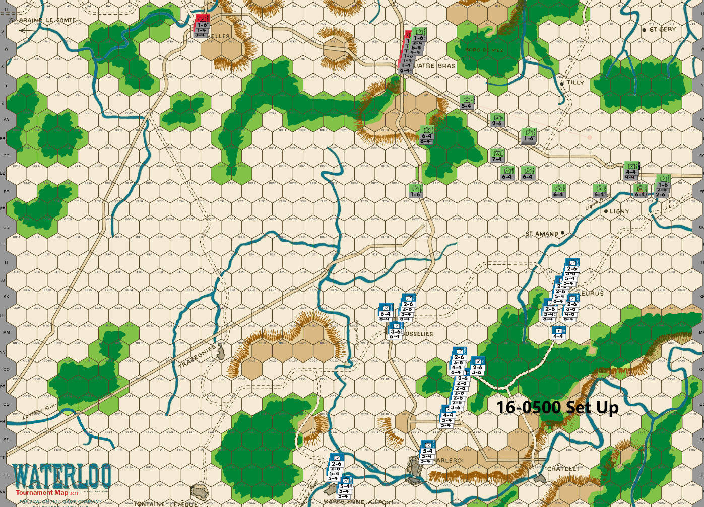
Bert: My goal as the French player is to try and threaten as broad a front as possible in order to spread out the PAA player’s defenders. I think that early attrition of the defender is very beneficial when playing the French side and the broader the front, the more likely that you can force your opponent into offering up additional blocking units as targets. To accomplish the broad front strategy, I expect that my set up will allow me to reach the far western sector of the battlefield by turn 4 with a contingent of cavalry followed by the slower infantry a turn or two after that. Breaking through the forest hexes blocking the approach to Nivelles is always a challenge, but I do plan to get some supporting units to the forest hexes southeast of the city, as quickly as possible, to threaten any large blocking units with at least a 3-1 attack. The attacks towards Quatre Bras and the Tilly corridor will mostly be dictated by how Ed defends those areas, but I hope to threaten both of them as long as is feasible.
Frankly, most of the attacks across the entire front are highly dependent on the PAA player’s decisions of where to defend. I expect Ed to be passive on the early turns with some minimal blocking units. I suspect his counterattacking will be in the southeast approach to Quatre Bras, once I get there, but likely not before then. I think there will be some counterattacks as I try to break through the woods near Nivelles. I plan to aggressively expose some units to early PAA attacks in order to put pressure on his positions, but I doubt I’ll be successful in drawing Ed into any kind of meaningful battles in the early turns – of course, he might shake things up and surprise me this game. Looking forward to it, either way.
Ed is a great gamer, and it has always been a pleasure to play against him and so I hope for both our sakes that we have a good and well-played game. I also very much look forward to Joe’s insightful feedback on our play. I have learned a lot from reading and absorbing his feedback and I treasure the opportunity to once again get to learn from his wisdom. I hope the readers enjoy this endeavor as well!
Ed: One Prussian 6-4 is removed as a result of the bid. Treskow sets up to block any French from gaining access to a hex adjacent to the critical hilltop hexes south of Quatre Bras. The rest of my set up is intended to restrict the French 7am advance as much as possible without exposing any unit to a 3-1 attack. The Prussians adjacent to Quatre Bras will head toward Nivelles to aid the Anglo-Allies in the defense of the Nivelles sector.
Unfortunately, I forgot to save my final move file before I sent it to Bert. The file I sent allowed a 3-1 on a 6-4. There are a couple of other units a little out of their intended positions as well.
Joe: Because of the small movement allowances of the various WATERLOO units, the paucity of primary (bonus movement) roads, and the comparatively large scope of the game map, the decisions made as to how and where the French and the Anglo-Allied/PAA starting units are to be deployed are actually quite important to the flow and rhythm of the early (first day) game turns. An early force or positional miscalculation, or even a single misplaced unit, can sometimes take many turns to correct. That said, and since both Bert nor Ed have arrived at this point in the tournament by virtue of their skill and not because of pure luck, it probably should not be surprising that both players have opted for relatively conventional (and conservative) starting set-ups.
The French: The commander of La Armee du Nord has distributed his units so as to quickly threaten the Ligne River and points north, while the balance of the French army has been deployed so as to be able to exploit the north-south primary road with an eye towards developing early pressure against the clear terrain between Ligny and the Quatre Bras Heights, as well as the Heights itself. Initially, the usable avenues available for a French northern advance are severely limited by the clutter of blocking terrain on this section of the game map. During this phase of the campaign, besides pushing north in the east and center -- barring launching early low-odds attacks, of course -- the only other major decision that the French player will immediately be called upon to make will be that of the size and composition of any force that he decides to send northwest towards Nivelles and the Braine le Comte Road.
The Allies: Like the French player, the Allied commander's starting set-up eschews any unusual or risky unit dispositions; so caution would seem to be the rule for now. Besides, since the starting Anglo-Allied dispositions are predetermined both at Nivelles and at Quatre Bras, Blucher's starting force of three Prussian corps is pretty much obliged -- if it is not to abandon too much ground too early -- to deploy in an extended line from the Ligne River to the forest just southwest of Quatre Bras. The advantage of this deployment is that it screens the Quatre Bras Heights for a turn, offers few attractive targets for low-odds French attacks, and still manages to limit the scope of the initial French advance towards the Quatre Bras and Tilly Gaps. Moreover, the Prussians, as long as they are concentrated, can be a very formidable force, so a prudent French commander will probably advance carefully, at least until the powerful Ist Corps arrives near Gosselies.

16-0700 French
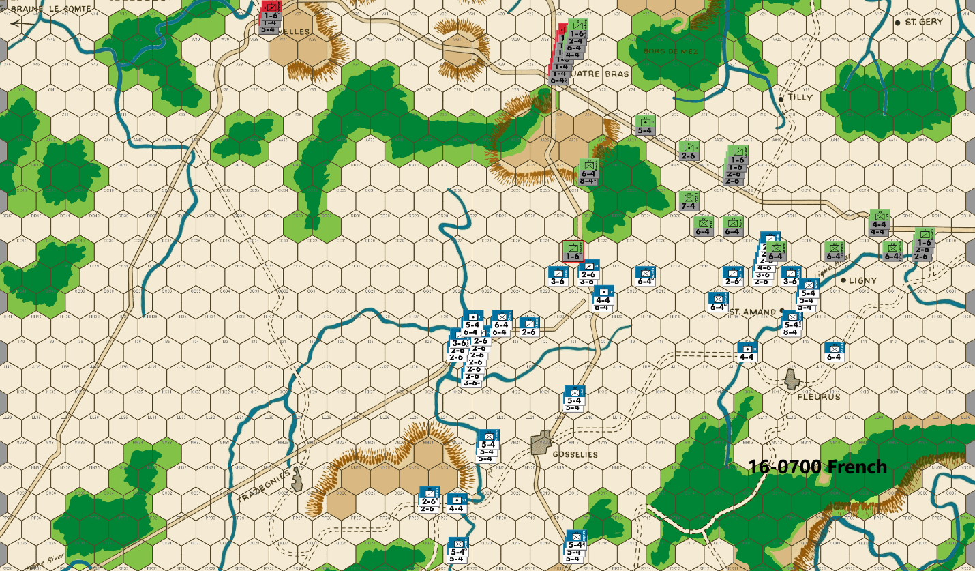
Bert: Well, Ed surprised me with his forward defense – it is something that I regularly do but I see most of the top players hang back out of range on the first turn. One difference is that I would have either stacked a second 6-factor unit at EE18 or put one at EE17. This would have forced me to soak off with a piece in order to make a 3-1 attack and I’m pretty sure I would have passed on it had it required a soak-off. I’m guessing that Ed wanted me to make this attack since I will be risking some valuable cavalry units in an exchange and/or a counterattack, so perhaps that’s why he set it up the way that he did. Since my early strategy is to cause attrition of the PAA and no soak off is necessary, I’ll oblige him and launch the attack this turn. Despite the risk of my cavalry units, I think that an early firefight in open terrain (no doubled positions) is to the French player’s advantage, so I will push for it. My guess is that if my boys score the D Elim result, Ed will fall back but an Exchange or D Back 2, will embolden him to possibly pursue this fight; we’ll see.
In general, I will almost always take 3-1 or higher attacks against non-doubled defenders and of course, every AV that is offered up – unless I sense a trap is being set or if the cost of soaking off is prohibitive. Doubled positions will be mostly (but not always – especially if they are strategically valuable) avoided due to the cost of an exchange result. I will always weigh the impact of low odds attacks and if I deem them worth the risk, those orders will be dispatched to the front lines. Many French players wait on making low odds (1-2 through 2-1) attacks once they feel the situation is a bit desperate. My approach is to always consider them early in the game, before the PAA has accumulated sufficient forces at the front line to effectively deal with an unfavorable outcome. If you do those attacks early (before the first day+ reinforcements reach the front lines), you can damage or break the PAA player’s positions to the point that they are forced out of their comfortable routine defensive positions. This exposes them to more attrition earlier in the game, which is what I aim for. Of course, these can lead to Attacker Eliminated results, which can greatly hurt the French player’s chances, so I don’t go crazy with them. I let the course of the game dictate when and if a low odds attack is warranted, rather than going into it with a set plan to automatically just commit to any particular attacks.
Elsewhere this turn, I’ve positioned lots of units that can push efficiently westward as originally planned, while also leaving open the opportunity to swing back to the east if I decide that a decisive firefight is unfolding there. I like to put the two infantry units at HH25 after my first move so they can get to DD29 on the second move, if they aren’t needed to be diverted to deal with some PAA shenanigans. My goal will be to project enough force to the woods to the southeast of Nivelles, that Ed can’t defend hex Z34 with a 6-factor unit without risking a 3-1 attack against it. This might lead to a push through the Z35 bottleneck more quickly than the PAA player is comfortable with. Against a more passive opening, the two units at KK20 would have moved to OO22 on this opening instead. I decided that I need them to project more strength to the potential firefight in the east.
Joe: Napoleon opens his campaign with a bit of a bang! That said, there are already a few clues as to French plans going forward.
In the West (Nivelles and the Braine le Comte Road): The Left Wing of La Armee du Nord begins its drive towards the northwest with what looks like a large mixed force of infantry and cavalry. However, initial dispositions suggest that Napoleon intends to launch this effort with an unusually sizeable number of horsemen (perhaps as much as 2/3rds of his available cavalry) in the French dash towards Nivelles and points west. Although circumstances might change, I personally have one minor nit with this choice of dispositions: In a nutshell, I personally believe that, should the French commander actually send all sixteen possible cavalry units (out of the army's total of twenty-four) northwest, then he could well find himself dangerously short of cavalry units on other fronts. In addition, once such a large mob of horsemen actually arrives in the Nivelles battle area, their one signal virtue, increased mobility, will quickly become irrelevant, especially if the battle lines in this sector devolve into a grinding stalemate, and the French forces are unable to breakout into the open ground north of the Samme River. If that were to happen, then our armchair Napoleon might well come to wish that he had held back a few more cavalry units in reserve to support his turn-to-turn operations against the Quatre Bras Gap and the Tilly Corridor.

In the Center: These first turn French dispositions seem to suggest that our armchair Napoleon intends to initially screen the Quatre Bras Heights while he presses his advantage in combat power (and unit count) against the left and right wings of the Allied line. This makes perfect sense since a major push directly up the center early on the first day will almost always end in a bloody French failure. In addition, I should note the fact that, had a stronger French infantry force remained in the center, and had two French 4-4s also moved to GG21 (or thereabouts) on this turn, then a prudent Allied player would have been obliged to treat the possibility of a French 1-2 versus Steinmetz (at AA27) on the 0900 game turn as a more credible threat, and would likely have had to position his Prussian infantry reserves accordingly.
In the East (the Ligny Plain): The French player, not surprisingly, advances his Right Wing north onto the Ligny Plain; he also decides to gamble on a 3-1 attack, with a force of pure cavalry, versus the a Prussian 6-4 on EE16. Needless to say, had the Allied commander swapped the positions of Pirch II and Langen, then such an attack would not have even been possible. But that raises the question: was the exposed position of this Prussian unit a mistake, or was it an aggressive Allied gambit? Maybe, it is actually possible to view it as a little bit of both. Certainly, the elimination, without compensation, of an additional Prussian 6-4 this early in the match would not be a trivial loss for the Allied commander. On the other hand, this audacious French move was not without its own share of downside risks: a D Elim (40% chance) would have been the only good result for the French player; alternatively, a DB2 (30% chance) would (as it turned out) have been irrelevant; while an exchange (30% chance) of three French cavalry units for a single Prussian 6-4 -- especially since no real French positional gain was to be had -- would have been a very welcome trade from the Allied player's standpoint. In addition, such an exchange would have made a blistering high odds Prussian counterattack against the surviving French horsemen near St. Amand exceedingly likely. Such a counterattack, if it were largely successful, could well have permanently crippled the French Right Wing's cavalry arm, and might even have shifted the initiative to the Allies in the east, at least temporarily. Finally, in order to gain his 3-1 odds, the French commander was obliged to strip away all of the French cavalry units that might otherwise have been able to threaten an early 0900 "right hook" crossing of the Ligne River at the FF11 ford: a tactical choice that inevitably would (and did) make the Allied 0700 fallback towards the Quatre Bras Gap and the Tilly Corridor much easier, whatever the ultimate outcome of this opening clash would have been. As things turned out, both sides escaped without suffering any real damage; so this first battle -- in spite of its potential risks for both sides -- pretty much ended in a draw.

16-0700 PAA
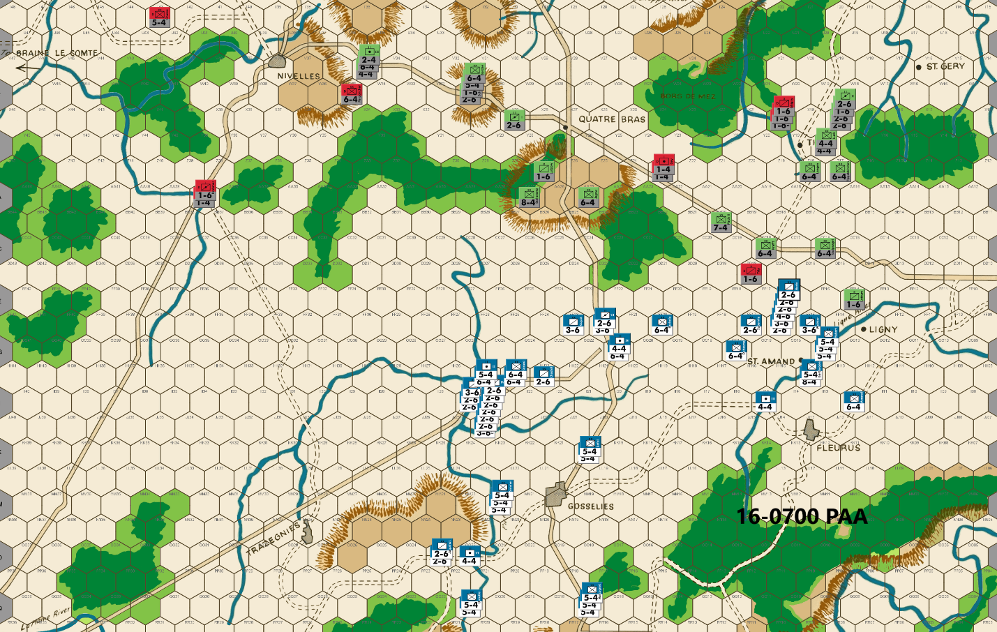
Ed: Bert took advantage of my map mistake and attacked at 3-1. The DB2 is pretty much a “no harm, no foul” result. For the sake of a good game, we both agreed that this is the best result. A DE (40%) would prematurely hurt the PAA, while the 30% exchange result would be favorable for the PAA.
I looked long and hard at counterattacking his cavalry lined up in the Ligny plains – three 5-1 attacks on 4 cavalry units. While the risk of a misfire in my attacks and losing two 6-4s in counterattacks was low, it was more than I wanted to take this early in the game. A second reason was the lack of French cavalry on my far-left flank allows me to hold a slightly more forward position than frequently is the case. I also note what I consider to be some minor positional weakness with the forces appearing to head for Nivelles. (e.g no cavalry at EE27) For this turn at least, I will play conservative and see how the game progresses
I thought about using a 6-4 at AA27 which is 3-1 proof but that would allow a 2-1 on the hex. So, I kept Steinmetz in his traditional position. I also position Prussians at W31, perhaps earlier than needed, but the French deployment indicates a large force heading toward Nivelles.
Joe: In the West (Nivelles and the Braine le Comte Road): The Allied player, totally cognizant of the danger posed by the Gallic juggernaut hurtling straight towards Nivelles, dispatches the first of several Prussian contingents west to reinforce the tiny force of Anglo-Allied units currently defending the forest approaches to Nivelles. On the whole, this Allied reaction seems both timely and -- at least for the next few turns -- adequate. However, since I am here to pick "nits," I will note that, if I was in command of the Allies, I would have moved Perponcher along the road to V35 and would have moved the Prussian units (currently on V35) to W34. This small change would allow the first arriving Prussian units to quickly deploy along the "34" forest hex file as a temporary block to early French cavalry infiltration into and through the eastern Nivelles forest barrier, while it would also free-up Perponcher to move, in three bounds (V35-T42-T46-V47), to ultimately occupy and, by so doing, also make hex V47 3-1 proof when attacked from two hexes. This move -- in my view, at least -- is advantageous because it would permit both the Anglo-Allied and the Prussian units in this sector to remain relatively concentrated; and, as an added benefit, it would also allow a sizeable portion of the incoming Anglo-Allied reinforcements (especially the 7-4s) to be deployed more flexibly when it came to the direct defense of Nivelles.
In the Center: Allied play in this sector is strictly "by the book;" to whit: Steinmetz immediately moves to take up his usual 3-1 proof (from three hexes) defensive station at AA27 on the Quatre Bras Heights, a cavalry (soak-off/delay) unit occupies Z27, and a Prussian 6-4 completes the Quatre Bras defense line by manning the easternmost crest hex at AA26. In addition, the Allied commander sets about concentrating on the beginnings of a significant Prussian reserve force in and around the hillock at W31: this position is critical during this phase of the game because any reserve units so situated will be able to reinforce either the Nivelles front or the Quatre Bras Gap in a single bound.
In the East (the Quatre Bras Gap and the Tilly Corridor): As was the case in the center, the Allied players’ moves in this sector are also strictly "textbook," and begin with a grudgingly slow, but economical (delay unit-wise) withdrawal back towards the open terrain of the Quatre Bras Gap and the Tilly Corridor. However, unlike in the previous turn, there are no attractive Allied targets -- other than a pair of delay units -- offered to the pursuing French. Moreover, since the Allied formations tasked with defending the two eastern forest corridors are certain to soon be separated by either terrain or French units (or both), it appears that preparations have been made to entrust a reinforced Prussian corps with the task of defending the soon-to-be isolated Tilly Corridor. I should probably note that there are actually several different Allied approaches to defending this narrow eastern forest corridor, but I tend to agree with this Allied player that a "strong" defense of this sector, while limiting Allied counterattacking options in the Quatre Bras Gap, is nonetheless the most flexible and economical option. That said, because the corps assigned to this mission will be -- perhaps for several campaign days -- virtually independent of most of the rest of the Prussian army, the Allied commander should take pains to ensure that this solo detachment will be both well-balanced (in unit types) and powerful enough (in combat strength) to offer serious resistance to any French force -- no matter how powerful -- that Napoleon might send north into the forest and river gap past Tilly and St. Gery, and towards the Dyle River bridges at Wavre farther north.

16-0900 French
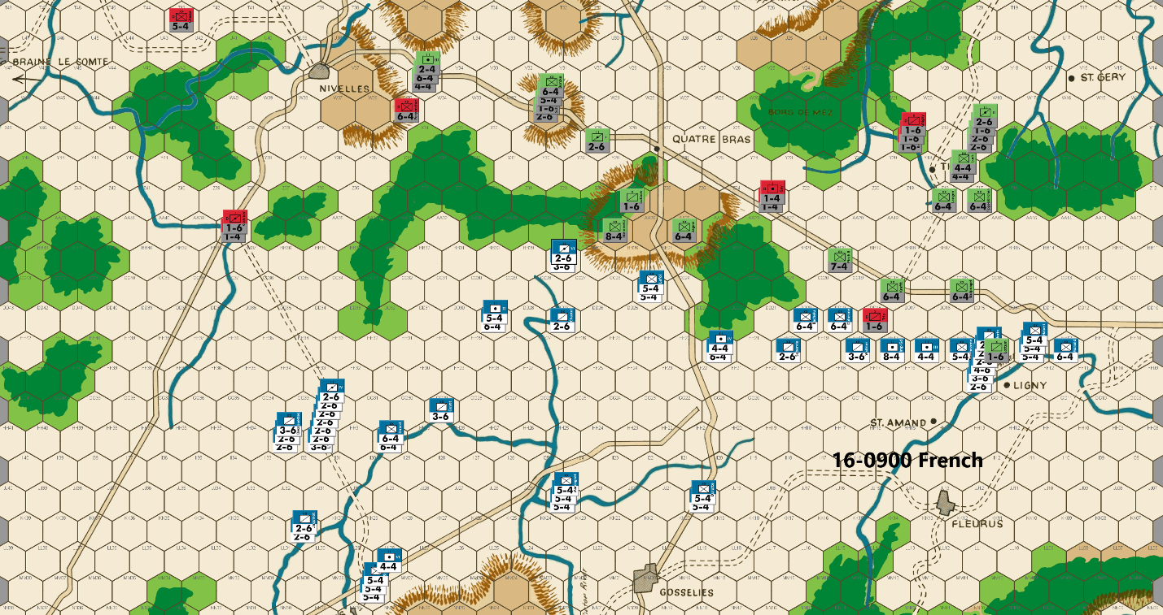
Bert: : I guess that Ed’s setup was not what he intended as he shared that EE16 was supposed to be his 7-factor unit (Pirch II) instead. That makes sense. The neutral D Back 2 result of my attack was probably the best outcome as a result of a mistaken placement of his unit. I still believe that the attack I made was the correct response as it allowed me to advance my units further north by an extra hex compared to a more passive first move.
I feel like it is a win for the French to get two or more PAA blocking units that can be AV’d on the first day turns of this game. I’ll happily take out those two sacrifices and then push forward across the board with the rest of my units. My goal with that side is to “try” to limit my blockers to one unit a turn, but that is not always possible and it gives up some space more quickly.
A few notes about the advancements and placements of my units. I like to get my western cavalry in position so that they can all (except for one unit) reach the road to Nivelles on turn 3, if I decide to use that. This allows me to threaten getting some units to AA40 next turn. Their position also threatens the front of the wooded hexes (not too big of a deal) and possibly a 3-1 attack vs hex AA35, should Ed have thought about positioning his Perponcher unit to defend there – now, I’m sure he won’t. The infantry units at HH30 are more efficiently placed compared to the typical placement of those units at II31, in my opinion. This is because they can reach hex Z35 on turn 4, if nothing is used to block them. The units at DD29 allow them to project force against both the woods to the west or the center hill on turn 3. Ideally, my threats in the west will get Ed to offer up a sacrificial unit to impede my progress on that front – I’d be fine with that as an outcome.
I intentionally advanced one unit into EE14 following the AV there. This is for the near zero chance that this will tempt Ed to come and attack me since that hex leaves no retreat route for my advanced unit. I’m quite certain he won’t take the bait, but I think the cost of any soak off plus the follow up attack(s) make that sacrifice well worth it to me. In addition, my advancing unit will be in a position to get to hex Y13 next turn, as a small side show to have Ed perhaps commit at least one unit to deal with the pest.
Joe: In the West (Nivelles and the Braine le Comte Road): Right on schedule, the first wave of French cavalry finally gallops up to within one turn's movement range of the primary road and forest gaps south of Nivelles. Those hard-marching French infantry units which were apparently committed to a western advance, on the other hand, are still strung out from two to three game turn's distant from the Nivelles battle area. Moreover, the fact that only two French infantry divisions (rather than four) will be within range of the southern edge of the Nivelles front on the 1300 game turn means that the French commander will likely have to delay a major push into the forest corridors for at least one, and maybe two extra game turns. And while as many as twenty-nine factors of French cavalry could conceivably show up on the Nivelles front as early as next turn, it is also likely that, until the first sizeable detachments of French infantry actually arrive in the battle area, these horsemen will represent more of a nuisance than a serious threat to the defenses of the Allied Right. And if all this weren't enough for the French player to worry about, there is also his knowledge of the impending arrival of sizeable numbers of Anglo-Allied reinforcements which means that the clock will soon begin to tick for Napoleon, at least when it comes to his operations in the west. Finally, I should also note that, along with everything else, the French player will soon also need to decide on a specific mission for the infantry stacks at JJ24 and DD29 and then commit these units accordingly.
In the Center (the Quatre Bras Heights): The assorted French units within one turn's march of AA27 currently total a little over fifty combat factors; this means that Steinmetz is stuck where he is on the Quatre Bras Heights for the time being, as even Pirch II (a 7-4) could currently be attacked by local French forces at 3-1 (from three hexes, with a soak-off) should this unit swap places with Steinmetz. The real question for Napoleon is: How long should he maintain a credible attacking force within striking distance of the Quatre Bras Heights, when it is highly likely that both wings of his army will be steadily advancing away from his center, and one, or both wings, could soon require reinforcements?
In the East (the Quatre Bras Gap and the Tilly Corridor): The French Right Wing crosses the Ligne River and advances towards the east-west primary road, picking off a couple of Allied delay units in the process. The absence of a French cavalry "right hook" through FF11 last turn, however, means that the French drive against the Tilly force will be a bit late in developing. Nonetheless, next turn, communications between the units in the Quatre Bras Gap and those in the Tilly Corridor -- barring a surprise (and foolhardy) Allied counterattack in this sector -- will probably be completely severed. Once that happens, the French player will have to make some difficult choices as to how he will divide and allocate the units of his Right Wing against both the Quatre Bras Gap and the Tilly Corridor. Moreover, this issue will only increase in importance once the split between these two fronts widens too far for the French units on the two fronts to lend direct support to each other. In essence, the French Right Wing (with help from the center) has enough combat power to continue to successfully push into both the Quatre Bras Gap and the Tilly Corridor; however, what it really needs -- at least in my view -- is at least three or four additional cavalry units from the mob of horsemen currently threatening Nivelles.

16-0900 PAA
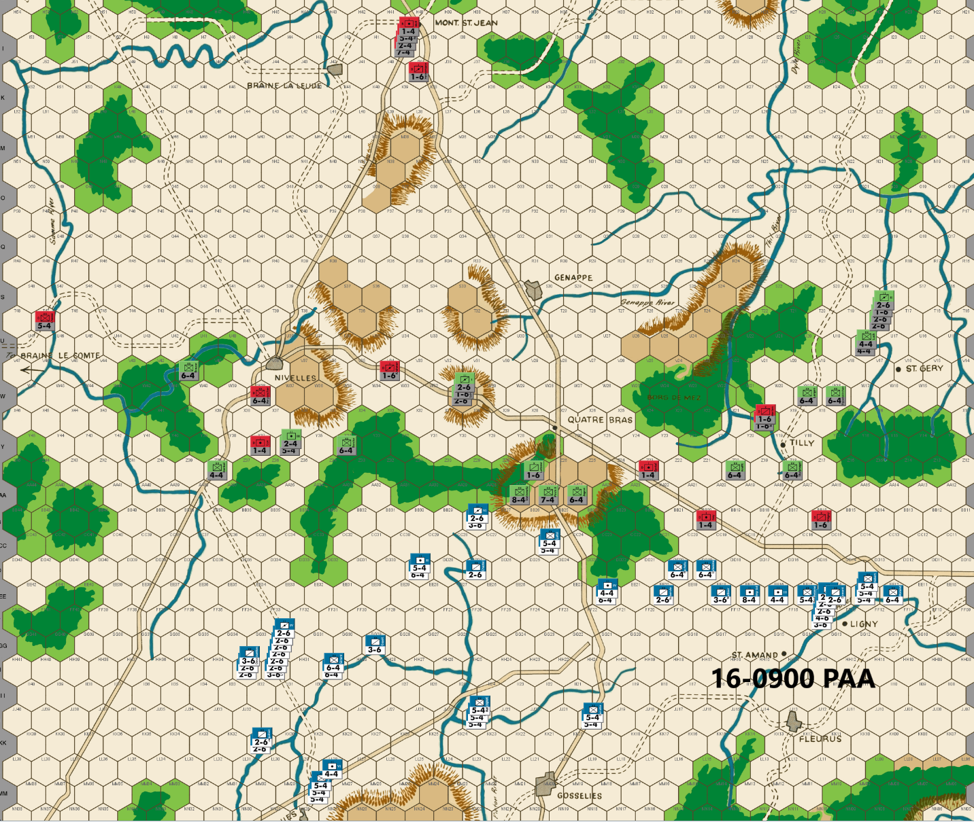
Ed: There is a large French force moving toward the Nevilles sector – 57 infantry and at least 29 cavalry factors. That is 44% of the total French combat strength, larger than I normally see. It appears the French are planning a major assault at Nivelles and points west. Chasse heads to the Samme River and when combined with the 11am arrival of Cooke can 3-1 proof the Samme River at V47/U47. Brause moves to V41 for subsequent defense of the river from V44. The rest of the Allied defense is pretty standard.
Joe: In the West (Nivelles and Points West): Given the meager assets at hand, the Allied commander does what he can to prepare for the coming French onslaught; unfortunately, his time is short: whatever he does, the Allied defense of Nivelles and the river line south of the Braine le Comte Road will soon come under steadily increasing enemy pressure as more and more French infantry arrive in the Nivelles battle area to reinforce their already-present cavalry brethren. Moreover, since it is now clear that our the French commander has decided to make a major effort (perhaps with as much as 90+ combat factors) against this sector and, to make matters even worse, that he has also positioned a substantial amount of French combat power within one turn's march of the edge of the eastern forest (e.g., the "33" hex file), any long-term Allied defense of the Nivelles position is almost certainly doomed. The sheer imbalance between the probable combat strengths of the two opposing forces (not to mention the Allied "non-cooperation" rule) makes the likelihood of an Allied victory vanishingly small. Therefore, the most reasonable goal for the Allied player should probably not be to actually defeat Napoleon's troops in this sector but, once battle is ultimately joined, to instead attempt to inflict a disproportionate amount of damage on the local French forces, while (hopefully) minimizing losses to the Allied "heavies." In addition, the PAA commander should also seek to give ground as grudgingly as possible. To that end, the longer the Allies can retain control of hexes Y39 and Z36, the longer they can avoid a "pitched" battle with the French, and the more time they will gain for their reinforcements to reach the front. Needless to say, the Allied player can sacrifice a delay unit or two to buy time, but no matter what he does, if he decides to fight, then battle could be joined as early as the 16 Jun 1500 game turn or, failing that, certainly no later than the 1700 game turn. Of course, the Allies can always attempt to avoid a major fight entirely, choosing instead to only expend sacrifice units in their attempt to slow the French advance to a crawl while the local Allied units slowly fall back towards Nivelles, and then to positions behind the river line that runs immediately to its west and north. Unfortunately, this approach poses its own problems: first, It allows the French Left Wing to spread and thin the Allied defense in the west at absolutely no cost in materiel or time; second, once his troops are through the forest gaps, the French commander might well be able to detach units, without serious risk, from his Nivelles force and back towards the center, likely in plenty of time to support a late-day drive against Quatre Bras.
In the Center (the Quatre Bras Heights): The French player continues to maintain a local force strong enough (50 combat factors) to maintain the pin against Steinmetz (at AA27); nonetheless, the deteriorating PAA situation at the Nivelles front may soon oblige the Allied commander to shift Jagow from AA25 (and, if he's feeling optimistic or lucky, Pirch II from AA26, as well) to a reserve position at W31. Fortunately, Kraft is within range of AA25, so the garrison on the Heights need not be weakened too much; at least, not yet.
In the East (the Quatre Bras Gap and the Tilly Corridor): Delay remains the Allied order of the day, as two units are again sacrificed to slow the French advance in this sector. Fortunately, the Allies still have a decent local inventory of potential delay units, so barring a sudden switch to low-odds attacks, French progress against the Gap and the Tilly Corridor should continue at its current "glacial" pace. Once these two fronts are split, however, it will be interesting to see how the French commander decides to apportion his infantry and cavalry between the two sectors over the course of the next couple of game turns. At least in the case of the Tilly Corridor, the presence of a reinforced Prussian corps lurking in the background should give the French player pause; and if he does decide to push into the Corridor, twenty-seven factors of "bloodthirsty" Prussians should cause him to rule out sending any but a strong mixed infantry/cavalry contingent north towards Wavre.

16-1100 French
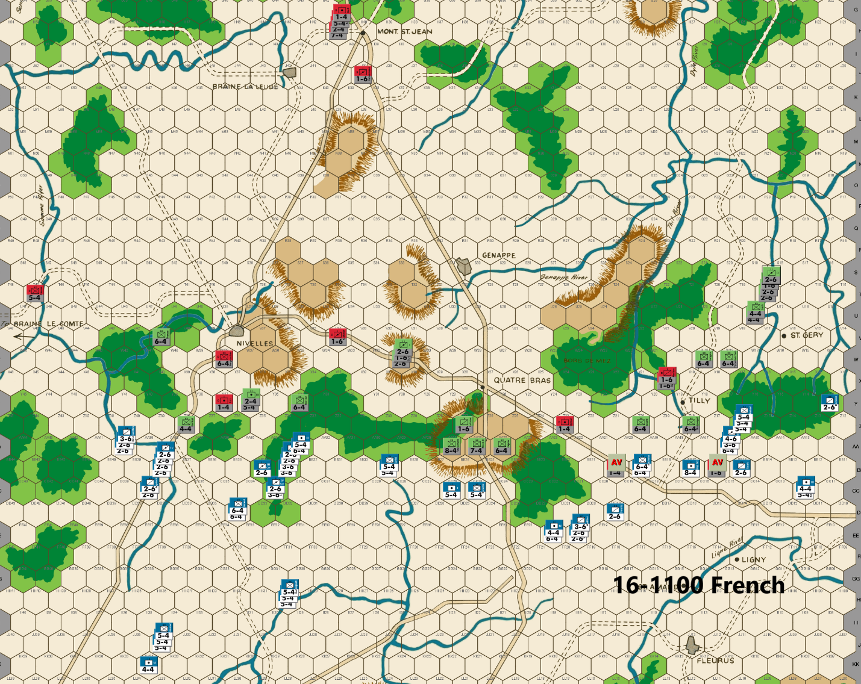
Bert: This turn is yielding me two additional blocking units, which makes me happy. I’m continuing with my strategy of trying to put pressure on Ed’s defense across the board. I’ll note a couple of items with Ed’s move that could have been done differently. He has utilized the excellent PAA tactic of exposing an infantry unit to only one hex of attack at less than 3-1 odds, multiple times already. See hexes Z18 and Z20 as an example this turn. I think a unit at Y17 could have accomplished the same benefit to keep me from putting units in Z16. In the west, he put a Prussian unit (Brause) at V41, which I think should have been the AA unit (Preponcher) instead. The reason is that I expect that Ed will strongly consider an attack against my units in the woods hexes near AA34, and Brause is not within range of aiding that attack on this coming turn. Ed doesn’t have enough AA units to conduct that attack, so any attack will have to be solely a Prussian operation, other than perhaps an AA unit soaking off. Having Brause positioned out of range, limits his ability to make an optimal attack.
I’m willing to expose Dormont to a 3-1 attack at Y13 due to the chance of an exchange result, and I’ve put some units within range so that I would be able to counterattack his exposed cavalry units if he takes that attack. The units can easily get back to the main front if that is not needed.
My forces are light near Tilly & Quatre Bras, but I think that this is not all bad as Ed has pretty much committed four “heavy” (4-factor or higher infantry units) Prussian units to the Nivelles region and at least four to the Tilly corridor region. As a result, he is light himself in terms of being able to counterattack my units in any one of those areas. I have enough force within range to keep Steinmetz garrisoning AA27, to keep it 3-1 proof, for at least one more turn. I expect at least one more turn of Ed offering up blocking units in those areas. I should be able to split the two areas from one another by next turn and then, depending on what Ed commits to where, I can focus on which direction I’ll concentrate the bulk of my central and eastern forces.
The real action for the coming turn or two is likely to be on the western front. My commitment to keep Ed out of Z34 on his previous turn has allowed me to establish a decent foothold into the woods hexes to the southeast of Nivelles. I did not include a cavalry unit in hex AA33 because that would make a counterattack easier for Ed to make. I’m hoping to force a fight that will hopefully lead to more PAA attrition OR have him fail to defend the Y row hexes with anything significant and fall back. Ideally, this would allow me to get through the bottleneck hex of Z35 before his reinforcements can reach that front as I’ve previously noted as an early goal for the French. In case he decides on the counterattack, I’ve moved a couple of additional infantry units to BB29 so they are available to assist my units already in those woods if needed. Ideally, they’ll return back to the Quatre Bras front. I’m really not sure what he’s going to do to deal with the threat, but I look forward to his response.
Finally, my cavalry units within range of Braine Le Comte are unlikely to try anything of significance until my infantry units get in range to assist in an attack. Those units want to project a threat in that direction to keep defenders tied up in that area while also staying within range of assisting any attacks that get ordered elsewhere on the Nivelles front. I’m guessing that I’m going to need pretty much all hands-on deck for the battle to break through to Nivelles, so Ed probably won’t be too worried about my units committing towards Braine Le Comte. An overly aggressive PAA player might try an attack against my western most units, but that would be risky with the limited retreat hexes behind any attackers. As a result, I don’t expect Ed to consider that as an option.
Joe: This is clearly the calm before the storm: in a very real sense, the preceding moves have simply been prologue: now the "real" game is about to begin!
In the West (Nivelles and the Braine le Comte Road): The French player continues to concentrate his forces against the Allied western defenses, while continuing to eschew any real combat. To be fair, until the French infantry begins to arrive in the battle area in some strength next turn, there is really very little that the cavalry can safely do on its own besides threatening an unopposed crossing of the western Samme River. Attempting to push into the forest gaps would be foolhardy without strong infantry support. That said, I do have one "nit" with this turn's French cavalry move: I think that at least one 2-6 should have moved to BB36. AA37 is a natural Allied delay position, and a convenient sacrifice unit (the 1-4) is suspiciously close-by. Other than that one lapse, the rest of the French move seems to be very effective: a sizeable contingent of French infantry is finally closing on the Nivelles battle area, and French units from the center have moved to establish threatening positions all along the eastern forest copse's "33" hex row. This last is no small thing as it accomplishes two different objectives: first, it sets the stage for a French advance into the eastern forest corridor; and second, in spite of the western shift in the French center, units with sufficient combat power to pin Steinmetz at AA27 still remain within range of this key hex, thanks to the ten factors of French cavalry positioned at BB33. Now, all that remains is for Napoleon's troops to force open the mouth of the eastern corridor (at Z35), and the western corridor (at Y38), then the stage will be set for the Emperor to finally launch the all out French assault towards Nivelles that he has gone to such lengths to prepare for.
On a somewhat off-topic, but related subject for those observers who are perplexed by the amount of French combat power that has been committed to the Nivelles campaign in this game, I offer the following answer: " Go big, or don't go at all!" This French player, like yours truly, clearly believes that a first day success in the west is an essential prerequisite (but not a guarantee) of a French victory. And since a) the dangerously-constricted forest terrain south of Nivelles is particularly unfavorable to the attacker, and b) the PAA player will almost certainly be able -- if he feels feisty -- to get in the first set of attacks against the advancing French, it only makes sense that any attacking force attempting to capture Nivelles -- especially from a skillful and determined enemy -- absolutely has to be powerful (and numerous) enough to absorb one or more rounds of adverse combat results, and still be able to continue to attack.
In the Center (the Quatre Bras Heights): As is typical during these early game turns, not much of dramatic significance -- besides a noticeable, but subtle shift of some French units to the west -- is actually happening in the center. The one minor tactical development on this front is that the French player continues to thin the force besieging the Quatre Bras Heights; however, his doing so incurs surprisingly little risk of an Allied surprise attack, as Blucher's units on the Heights are too weak to attack on their own, and the Prussian reserves -- presently clustered around W31 -- are almost certain to all move west within a turn or two. Looking ahead, the French units in the center may be able to continue to pin Steinmetz for a little longer, but, at some point (very likely within the next turn or two), the cavalry on EE20 and DD19 -- at the very least -- will probably have to be redeployed to support the Prussian drives against the Quatre Bras Gap and the Tilly Corridor.
In the East (the Quatre Bras Gap and the Tilly Corridor): The latest French move in this sector has largely been dictated by the Allied player's careful placement of two delay units. In addition, besides the two sacrificial blockers, the French player also again had the opportunity to take several low-odds attacks (1-2s up to 2-1s, each from a single hex) against a pair of exposed Prussian 6-4s that were deployed to support the flanks of this turn's two delay units. Wisely, in my view, the French commander declines to take either of these gambles and, instead, contents himself with taking the two easy Allied offerings. Finally, this French move, while not particularly exciting, is nonetheless significant because it effectively drives a wedge between the Allied units deployed in the Quatre Bras Gap and points west, and those in the Tilly Corridor. Moreover, this splitting of the eastern sector into two separate fronts (Quatre Bras and Tilly) inevitably poses an intriguing new challenge for the French commander: given the size and total combat power of his force, and the limited number of cavalry units locally available to him, how should he divide the units of the French Right Wing into two balanced and effective forces, each of which will need to be optimized for its own independent and very different operations against the PAA defenders in the Quatre Bras Gap and against those in the Tilly Corridor?

16-1100 PAA
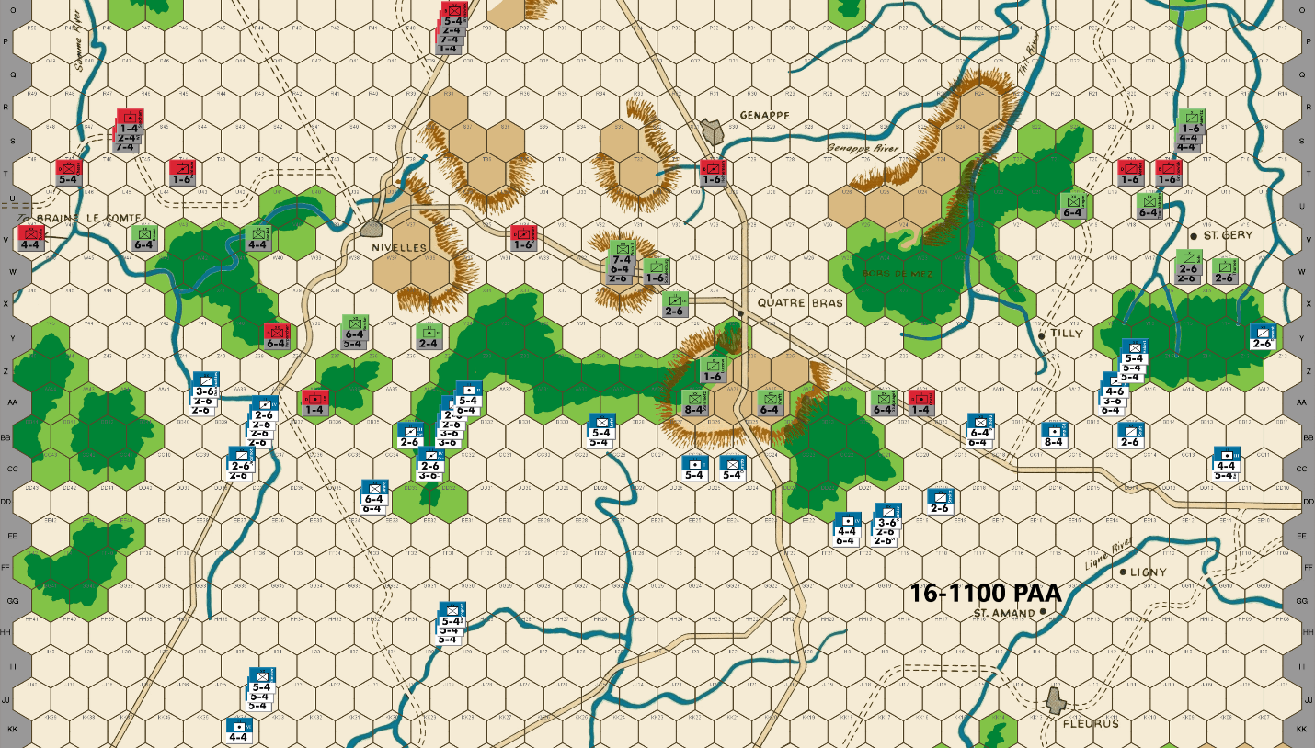
Ed: The Allies primary defense in the early turns relies heavily on 1-6 blockers. The Prussians only have five until the Fourth Corps arrives on the 18th. As here, they typically expend two of those in the first few turns and want to preserve the rest for soak offs later in the game. That means the PAA will need to judiciously use the thirteen Anglo-Allies they have prior to the 16-1700 reinforcements arriving at the front.
In the Nivelles sector, the French are assembling a greatly superior number of units and combat factors compared to the small Allied forces. I expect strong threats against the river defenses west of Nivelles and in the center south of Nivelles. But the PAA has some advantages. The French infantry is arriving piece meal at the front up to the 16-1500 turn. The Samme River can be 3-1 proofed blocking the French in the far west. The woods south of Nivelles constrict the French advance reducing their numerical superiority. The name of the game here is to delay the French juggernaut while avoiding any extended combat.
As a result, I am using a blocker at AA39 and Y35. Prussians move to W31 within striking distance of any French units attacking on Y35, hoping to discourage an attack on Y35.
In the center we offer the standard blocker unit defense. In the Tilly sector, I withdraw with my typical force to conserve the precious Anglo-Allied “1” units. It will be interesting to see how much the French send down the Tilly corridor, given the smaller than usual force in this half of the board.
Joe: The Allied moves this turn have now begun to take on the familiar "delay and retreat" pattern that -- barring French low-odds surprises -- tends to characterize an experienced PAA player's actions during the first day's turns of a typical highly-competitive WATERLOO game.
In the West (Nivelles and the Braine le Comte Road): On the whole, this is a very solid Allied move. The sacrifice unit at AA37 shields the Anglo-Allied 6-4 (Perponcher) at Y39 from anything but a French 1-1 attack (by pure cavalry, at that) for a full turn and, because of this, the Y39 hex can be preserved for possible use as a delay position next turn; as an added benefit of this, the French commander -- should he wish it -- will not be able to occupy AA37 with anything but cavalry, and then only after an attack from the river hex at AA38. But that is not even the most interesting of the French commander's problems: a little farther east, the PAA player has stationed a 2-4 arty sacrifice/delay unit at Y35 (indirectly supported by the eleven factor flanking stack, all at Y37), apparently in hopes of blocking the northern end of the eastern forest corridor for one more turn; this unit is clearly intended to be seen as a "poison pawn," because at least some of the French units attacking it will -- once the initial battle is resolved -- immediately find themselves vulnerable to an Allied surrounded counterattack. In addition, the supporting stack at Y37 denies the French commander the easy capture of Z36, unless, that is, he is willing to accept a low-odds battle in order to get it. Unfortunately, promising though the plan to use the 2-4 sacrifice unit as bait might be, the PAA commander has a problem. It turns out that, in order to make this threat of a surrounded counterattack truly credible (and not just a semi-bluff), he absolutely needs to have two small Prussian units that can both reach Z36 (even if Z35 is enemy occupied) on the 1300 Allied player turn: one to attack and one to soak-off. And that really is the rub: while there are several Prussian 1-6s and 2-6s near Quatre Bras and clustered around the W31 hillock, there is actually only one suitable Prussian unit (the 2-6 at W31) that meets this movement requirement. What this actually makes clear is that the Allied player -- assuming, of course, that he is really not keen on sacrificing Henkel (a 4-4) or some even larger Prussian unit -- simply has no way to retain post-combat control of Z36, and this in turn means that an attack against the 2-4 blocker, while certainly still risky for the French, is not nearly as problematic as it would be if an Allied unit were to occupy Z36 at the end of the 1300 game turn. And since we're on the topic of potential attacks and counterattacks, it should also be noted that, although the Prussian reserves in and around W31 are probably not all optimally situated for the defense of Nivelles at present, they are still positioned well enough to make early counterattacks against French incursions in the western sector a viable option for the Allied player, even if the arrival in the Nivelles battle area of the first batch of Anglo-Allied reinforcements is effectively two game turns away. Now for some unfair criticism: In spite of the Allied player having made a generally first rate move in this challenging battle area, I have still managed to find a couple of "nits" to pick; to whit: first up, Chasse's mission (being positioned, as he is, at T47) is so unclear as to be a total mystery to me (why, for instance, is this unit on T47 and not on some other hex?); the second "nit" is, I confess, a rehash of a subject upon which I have previously commented: e.g., my strong view that Perponcher (and not a Prussian unit like Brause) should have been used to defend the Samme River west of Nivelles, a deployment that would have allowed the only Allied 6-4 in the game to both stack and fight along with the other Anglo-Allied units in the far west: something that is impossible for any Prussian unit in this sector because of the PAA noncooperation rules. Looking towards Nivelles, Division Brause, or even Henkel, could easily have taken the place of the Anglo-Allied Perponcher at Y39; as for the rest of the Prussian reinforcements in the Nivelles battle space: these units, by operating together in a relatively compact geographical area, are able to coordinate and execute -- because there would be no rule restrictions against their stacking or fighting together -- both offensive and defensive operations much more effectively.
In the Center (the Quatre Bras Heights): The PAA player -- because of the recent developments on other fronts -- decides to reduce the garrison on the Heights to the bare minimum requirement of Prussian combat units. And, although this course of action carries with it a modest amount of strategic risk, it is nonetheless hard to argue with the Allied commander's decisions in this sector: clearly, a fight is coming, and it is glaringly obvious that that fight will be at Nivelles and not at Quatre Bras. As a final thought: the only minor change that I would have made to the PAA player's 0900 move, would have been to dispatch Lutzow (currently at Z27) "hot footing" it towards Nivelles, and then, just to be prudent, I would have replaced him at Z27 with Schulenberg.
In the East (the Quatre Bras Gap and the Tilly Corridor): The Allied defense in the Quatre Bras Gap is straight out of the WATERLOO "textbook," and I wouldn't change a thing. On the other hand, when it come to the Tilly Corridor I would definitely have handled things on this front a little bit differently, if only because the French player's intentions in this sector are still -- at least to me -- unclear. To be fair, most of this player's PAA move is fine. However, because it is possible that the French player might forgo a Tilly drive completely (a mistake, in my view) or, alternatively, that he might fake a push into the Tilly Corridor for a turn or two before suddenly backtracking to consolidate all of his forces against Quatre Bras, I personally prefer different positions for a few of the Allied units in order to prepare for just such a possibility. In a nutshell then, the single change in unit dispostions that I would make for Tilly is this: Instead of all moving to S18, I would move Kampfen, Luck and Marwitz one hex further north to hex R19. That's it; that's my only adjustment. And while I would be the first to admit that this is not much of an alteration, the subtle advantage of this simple change is that, if a powerful French detachment does not immediately begin a serious push into the Tilly Corridor, then some or all of the units at R19 can be sent west to straddle the Thil River on the 1300 game turn; so that, on the 1500 turn, they would be in a position either to continue covering the Tilly Corridor or, alternatively, to quick march west towards Quatre Bras.

16-1300 French
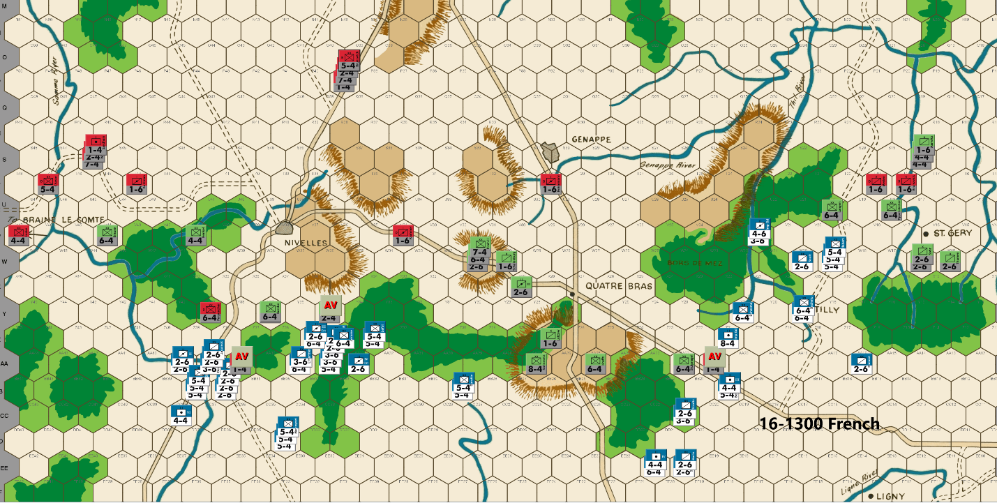
Bert: I was pleasantly surprised, for the most part, to see that Ed chose not to attack my units at Z34 & Z35 this past turn. His strong defensive position has made it certain that I won’t have an easy road ahead to fully break through the Nivelles bottlenecks as I like to call them. The good news, however, is that I am able to safely position my units this turn without any fear that a DB2 result would result in my unit(s) being lost. Establishing footholds in Z36, Y39 and Y40 are an important step in breaking down the PAAs position near Nivelles.
The bad news for me is that Ed was able to secure his positions across the entire front by offering up only a single blocking unit. That’s smart and effective play on his part.
My units are not in much of a position to threaten Braine Le Comte this turn but depending on what happens with the battle in front of Nivelles, I can quickly reposition my units to threaten the city prior to his 6/17 reinforcements arrival. That is currently the plan, but it will be scuttled if I prefer to keep my units engaged in a broad front battle at Nivelles instead. Ed is running low on Prussian units that can be used to soak off and while he has several Anglo-Allied units available and more on the way, I don’t think he’ll want to keep a fight going unless the dice yield uneven results for his side. Let me get those negative thoughts out of my head as quickly as possible!
When I first made this move, I was so very tempted to launch a 1-1 attack vs Steinmetz position at hex AA27 on the center hilltop. I didn’t see any reason for Ed to keep that piece in that hex this past turn as he could have held the hilltop with the same two units but he would not have risked the downside of a DB2 result with one of his key pieces by flipflopping their defensive hexes. I normally don’t like to take reckless low odds attacks with the French when playing Waterloo, but those attacks are almost certainly necessary at some point, among evenly matched players to swing the balance. I mainly look for opportunities where success can break a position pretty effectively or if the unit is pinned and my low odds attack has it surrounded, like Steinmetz is when it’s at AA27.
Since I haven’t lost a piece yet, and the fact that minimal PAA units are in range to deal with a poor outcome (from the PAA player’s perspective), I was feeling rather strongly that this was the time to make such an attack, even if it meant risking 16 factors… In the end, I decided that it was better to wait a turn before making that attack. I’ve positioned enough units within range, so that AA27 won’t be 3-1 proof with just a 6-4 defending. This is intentional because I want to keep Steinmetz in that hex if I’m going to take a low odds attack against it. There is a chance that the hill defense gets withdrawn on Ed’s move, but I doubt it. If it does, I’ll probably look for an opportunity to attack Steinmetz at low odds when he’s not doubled on an upcoming turn. Of course, I’ll miss out on a DB2 result eliminating him, but it won’t cause me to risk the 16 factors, only 8.
I have no intention of pushing the battle in the Tilly corridor because he has too many defenders and I know that Quatre Bras should be my target for the combined center/eastern flank. Of course, Ed hopefully doesn’t know that I'm not going to be fighting heavily in the Tilly corridor.
My hope is that a relatively small French force can keep the rather significant number of PAA defenders tied up. If my units were withdrawn from that corridor to the Quatre Bras area, they would be standing around waiting another turn or two as Ed offers up blocking sacrifice units. It would allow his Tilly corridor defenders to start repositioning towards the defense in the center. I’m hoping to possibly draw Ed into launching an attack that costs him a soak off unit or like I said, keep enough force to pose a big enough threat to keep his units engaged in defending against a possible attack by my boys. I don’t expect to attack there unless he offers an easy target, or I see an opportunity to break his position with a low odds attack. Of course, his current position is not optimal for getting his Prussian defenders on the other side of the Thil River without being exposed to some sort of attack, so I guess I should never say never when it comes to ordering something to cause him angst.
I’m quite certain that we will have some action on either Ed’s coming move or on my next turn for sure, unless Ed shocks me and decides to fall back without giving me a shot at his line of main defenders.
Joe: As expected, things are finally heating up around Nivelles. I will say that, in view of Bert's first turn 3-1 attack versus Langen on the Ligny Plains (using a force of pure cavalry, to boot) I wasn't really too surprised that -- in order to clear the eastern forest corridor -- he decided to risk getting hit by a couple of surrounded Allied counterattacks last turn. In all honesty, its hard to fault his logic: with the first batch of Anglo-Allied reinforcements about to enter the battle space, delaying his attack would only have made his move against Nivelles more dangerous than it already was.
In the West (Nivelles and the Braine le Comte Road): This, in my view, is a particularly strong French move -- both tactically and strategically -- that does real damage to the Allied position immediately south of Nivelles. For starters, the French commander, as should be expected, picks off the Allied delay unit at AA37, and then advances three cavalry units after combat: this advance, by the way, is actually more important than it looks because it allows the French player to threaten a move with cavalry into Z37 next turn. Of far more importance, however, is Napoleon's decision to expose several of his units to surrounded PAA counterattacks by moving them into T34 and T35 in order to AV the Prussian 2-4 (on Y35). This French attack, although risky, actually makes a lot of sense. The hard fact is that this Prussian 2-4, by occupying Y35, poses a serious obstacle to French offensive plans on this front: first, because it blocks the north end of the eastern forest corridor; and second, because it also -- along with the Prussian stack at Y37 -- prevents the French from occupying the critically important Z36 hex. Of course, it now remains to be seen just how the PAA commander will respond to this audacious and troublesome French move.
In the Center (the Quatre Bras Heights): The strategic "die has been cast" in the west, so the French commander decides to strip off almost all of the units that had, until now, been pinning Steinmetz on the Heights at AA27and send them marching west towards Nivelles, leaving only enough local combat power behind to be able to threaten a 3-1 attack against a Prussian defensively line composed exclusively of doubled 2-6s, or, alternatively, robust enough to be able to advance in relative safety should the PAA player suddenly opt -- at some later point in the game -- to fall back in the center, completely abandoning the Heights in the process. Although this reduction in local French combat strength is hardly a surprise, it does finally remove any doubt that this sector -- at least in the eyes of this French player -- is now little more than a strategic "sideshow."
In the East (the Quatre Bras Gap and the Tilly Corridor): This sector has now been split into two very different fronts, and each of them presents the French player with its own set of opportunities and challenges.
The Quatre Bras Gap: The constricted terrain on this front -- regardless of the total combat power of the local French contingent -- invariably slows the attacker's advance north into the Gap to a hex or two a turn. Nonetheless, the French player should be satisfied with his situation on this front : first, because the Allied commander -- if, as is likely, he opts to reinforce Nivelles -- will then no longer have anywhere close to sufficient local combat power with which to mount any kind of plausible counterattack into the Gap; and second, because the PAA player is also rapidly running out of room in which to deploy his delay units. In view of these facts, a methodical French advance seems to be in order, especially since -- no matter what the Allied player does on this front -- the northern end of the Gap is virtually certain to come under threat of a French attack in only two more game turns. And, assuming that most of the available Prussian reserves have been committed to the fight at Nivelles and are no longer within supporting distance of the center, during the next few game turns, then it is possible that the scene might be set for L'Armee du Nord to simply walk into Quatre Bras unopposed sometime on the morning of the 17th of June.
The Tilly Corridor: The "bare bones" tactical approach that L'Armee du Nord is employing in its advance against the sacrifice/delay-based Allied resistance in the Quatre Bras Gap -- at least at this stage in the campaign -- seems somehow less like a protracted battle, and more like an unexciting game of "whack a mole". However, this is not the case when it comes to the French commander's conduct of his offensive against the PAA defenders in the Tilly Corridor. This is because, unlike the Quatre Bras Gap, the much longer Tilly Corridor is clogged, for more than half of its length, with a maze of forest and river hexes, and even when the forests are left behind, as the French drive north towards Wavre, there are still rivers running north-south and east-west that act as both barriers to movement, and as force-multipliers for the Corridor's defenders. Needless-to-say, because of this difficult terrain, French progress can often be painfully slow, even against a token force of Allied defenders; against the reinforced and flexible IIIrd Prussian Corps (of twenty-nine combat factors) defending the Corridor in this particular instance, however, it is both tricky and dangerous. Thus, it is not surprising that the initial French moves into the southern end of the Corridor have been cautious. Clearly, Napoleon's initial advance into this sector was organized so as to deny the Allied player any attractive opportunities for an early counterattack against the French vanguard, while, at the same time, leaving French options completely open. This explains why Bachelu and Morand are positioned on the "switch" Y19 hex, between Quatre Bras and Tilly -- to be ready in case the PAA reserves near W31 do not actually march west towards Nivelles on this turn -- and why Habert, Hulot and Jeannin were moved to W19: a position that can only be attacked from two hexes, and that will also leave any Allied attackers vulnerable to a powerful French counterstroke. Finally, the move of the two "heavy" cavalry units to V22 -- while no doubt a minor bother to the PAA -- is probably "over kill." The mission of these two units was apparently to draw at least one, or maybe more, Prussian units east to block the (unlikely) possibility of French cavalry infiltrating through the Borz de Mez, but this was probably a task that did not require the use of a pair of "heavy" cavalry units (a 4-6 and 3-6 to be exact), but probably could just as easily have been accomplished using one or two of the much more numerous 2-6s.

16-1300 PAA
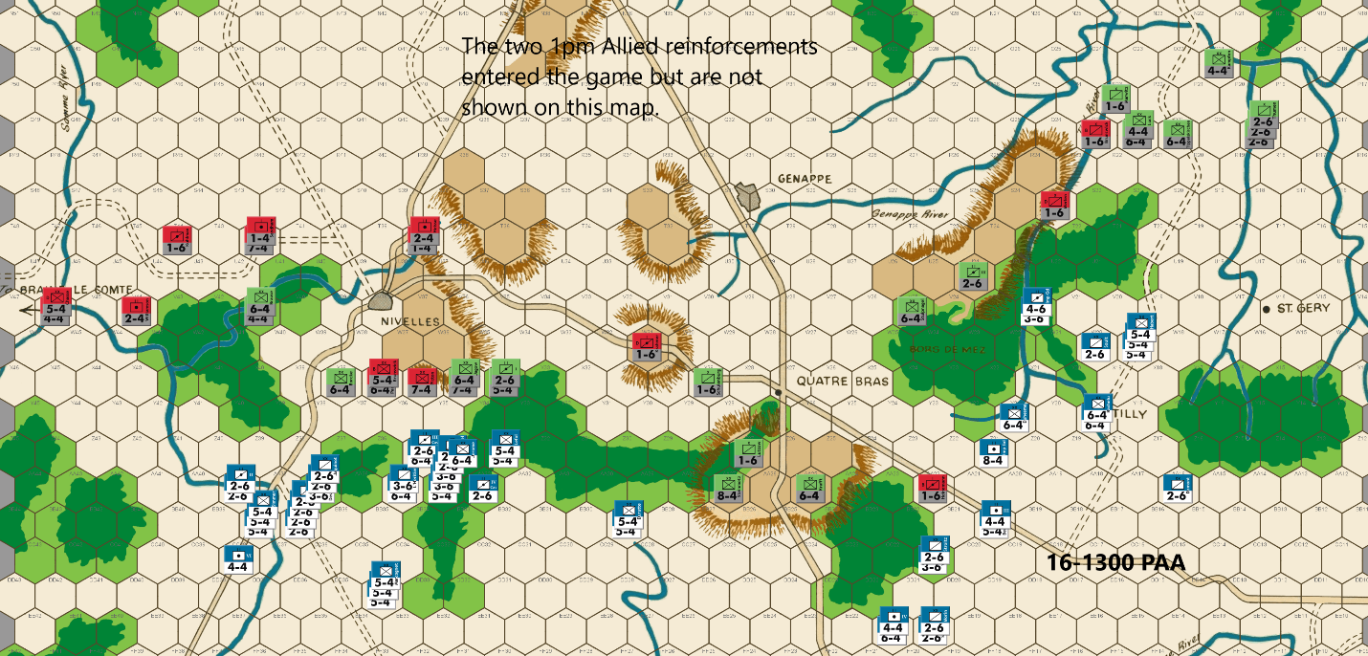
Ed: My hopes were dashed when the French attacked Y35. This is not that surprising, and I think the right move. Unfortunately, I don’t see a good counterattack. One problem for any PAA attack is that it more quickly consumes the precious supply of 1-6s. Instead, I deploy an array of “heavies” along the X-file row. This is an awkward area for French attacks since they do not occupy Y39 & Z36. By my count, the French will only be able to get a single 3-1 or a 4-1 attack. An exchange on Picton will cost the French two units. Perponcher and Brunswick are at X37 to increase the probability of French soak off losses should they attack. Pirch II and Jagow are at X35 to increase the likelihood that at least one will remain to assure any French soak off from Y34 will die. And finally, the 1st HA and II FA are stacked at X 34 to prevent a 3-1 on both units in that hex.
Because the French far outnumber the PAA, Napoleon might just decide to combine low odds attacks with a 3-1 in an attempt to deplete the Allied forces. The two units at V41 are not needed for defense of the Samme River and add to the potential counterattack force next turn if a worthwhile target presents itself. Most likely I will withdraw next turn. Barring a successful low odds attack vs Borcke at X38, this alignment will delay the French for a turn irrespective of any attack results on his left flank.
Since the French did not occupy BB21 or Y24, one blocker at AA22 holds the Quatre Bras gap. I keep Steinmetz at AA27 to prevent a 2-1 possibility against a 6-4. Prussian units are sent to block French penetration of the Bors De Mez Forest. And the withdrawal continues in the Tilly Corridor.
Joe: In the West (Nivelles and the Brain le Comte Road): In the far west, Cooke and Chasse move to straddle the fork in the Samme River at V46, a hex from which they will be able to switch east or west of the river in one game turn. In addition, several of the 1100 Anglo-Allied reinforcements move to within one bound of the north-south Nivelles primary road and, hence, within reach of the Nivelles battle space on their next turn. A little farther to the east, French cavalry, as expected, picks off the delay unit at AA37 and then advances after combat; far more problematic for the Allies, however, is Napoleon's decision to gamble on the Nivelles front by risking an early attack against the 2-4 at Y35. This attack neatly puts the Allied player on the horns of a dilemma: An immediate PAA surrounded counterattack is certainly one possible response to this French move, but with no economical way to retain post-combat possession of Z36, such an aggressive and risky Allied line would be highly speculative. On the other hand, the failure to mount a counterattack would oblige the Allies to fall back towards Nivelles, thus opening up this front to a large-scale French advance. And although both PAA options have advantages and disadvantages -- in this instance, at least -- the French player's gamble pays off, and there is no Allied counterstroke. There are, of course, several reasonable explanations for why the Allied player chose to end this skirmish in the way that he did: it could have been because of the Allied commander's valid worry that his battle line would, on the next turn, have been exposed to a devastating French counterattack from three hexes, or it could have been because of his legitimate concern that -- regardless of the outcomes of the inevitable French counterattacks -- the potential cost in PAA exchange losses and/or soak-off units from his own counterstroke would just have been too high. Whatever his reasoning, the Allied player chooses discretion over valor and declines to rebuke the foolhardy French vanguard, opting to fall back towards Nivelles instead. And given the PAA units available for this operation, the fallback does allow reserves to come up which substantially reinforce the new Allied battle line. Here I do have one "nit" to pick with the Allied deployment, however, and that is the decision to place Picton at X36. As this 7-4 is currently positioned, the French can launch an early assault against this unit from two hexes on their 1500 player turn at 3-1, with two soak-offs, and the attackers would not incur any risk of a surrounded PAA counterattack. However, if X36 had been left unoccupied, then a 1500 French attack could realistically only be launched from Y34 and Y35 against the units in X35, and that would leave both French attacking stacks with no retreat, should the Allied commander decide to punish their impetuousness with a counterattack of his own. That said, this temporary respite should only last for a single game turn, and by 1700, the western wing of L'Armee du Nord -- regardless of whether or not the Allies have launched a preemptive strike on their 1500 player turn -- should be in a position, with virtually all of its local strength now present in the immediate Nivelles battle space, to assault the entire PAA line, from one end to another. The good news for the PAA player, such as it is, is that the early morning Anglo-Allied reinforcements are at last beginning to arrive in the Nivelles battle space; the bad news is that Napoleon's Left Wing, having stolen a march on the Allies without any real cost, will be able to start the real fight for Nivelles at least one turn earlier than usual. Finally, as one last tiny "nit:" I personally would have moved Krahmer (at W31) to W32 -- this change is negligible, as he can still reach the Quatre Bras Gap next turn -- but it does leave W31 open to Prussian occupation.
In the Center (the Quatre Bras Heights): Even though the French strength in this sector has been reduced to near irrelevance, the Allied player is still obliged to maintain some sort of defense line on the Heights. That said, the PAA commander decides to content himself with a minimal response to the French move, and only dispatches Stulpnagel and the IIIrd Corps Horse Arty to block the French cavalry attempting to infiltrate through the Borz de Mez. This move, in my view -- especially given the unfolding developments farther west -- seems a little too passive, all things considered. For my own part, I would have gambled on a move of Stulpnagel and Lutzow to W31. While it would be tempting to move Steinmetz to W31 and Stulpnagel to AA27, this could well end up being a wasted move, if the French commander shifts units back to the center. The only other change I would have made would have been to move Schulenberg to reinforce the IIIrd Corps Horse Artillery at U24, in order to help thwart the plans of the pair of sneaky French horsemen at V22. In addition, this position also sets up for either a move northeast onto the Thil River (and into the Tilly Corridor), or southwest back to the Quatre Bras Gap
In the East (the Quatre Bras Gap and the Tilly Corridor): At this point, the PAA move in the Quatre Bras Gap virtually makes itself; and this means that -- probably for the next couple of game turns, at least -- the only front really worth commenting on will be that of the Tilly Corridor.
The Tilly Corridor: On the whole, this turn's PAA move is both solid and flexible, and the only change that I might conceivably make would be to shift Kampfen one hex east to O20 from O21; other than that, I wouldn't change a thing. Now, turning to the foe: Even with late afternoon fast approaching, Napoleon's plans for the Tilly Corridor are still unclear. Looking ahead a turn or two, the French commander's present dispositions do suggest that he plans to continue his push farther north into the Corridor with a mixed force of thirty-eight factors, or so. On the other hand, these early French moves into the Corridor could just as easily be a feint, designed to tie down the Allied units in the Tilly Corridor for as long as possible. In fact, it's just as likely that the French player might really have no intention of driving north towards Wavre; and that, instead, he might actually be quite chary of detaching so much combat power from the current force covering the Quatre Bras Gap, particularly at this stage in the campaign. In any case, since both French options appear to be equally plausible, it looks like it will probably be at least one more game turn before Napoleon's intentions for the Tilly front really become clear.

16-1500 French
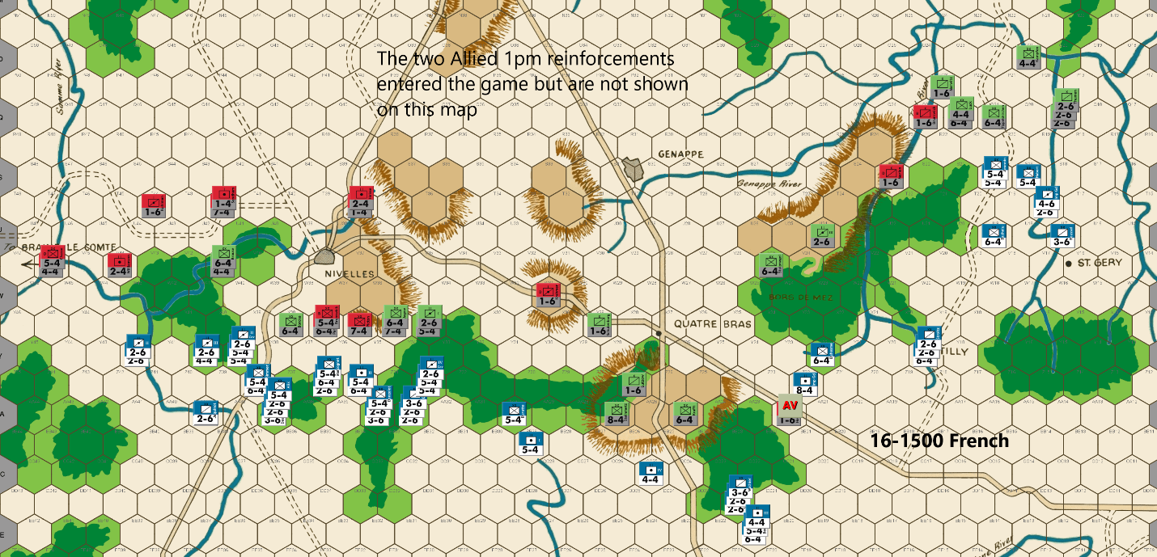
Bert: I was pleasantly surprised, for the most part, to see that Ed chose not to attack my units at Z34 & Z35 this past turn. His strong defensive position has made it certain that I won’t have an easy road ahead to fully break through the Nivelles bottlenecks as I like to call them. The good news, however, is that I am able to safely position my units this turn without any fear that a DB2 result would result in my unit(s) being lost. Establishing footholds in Z36, Y39 and Y40 are an important step in breaking down the PAAs position near Nivelles.
The bad news for me is that Ed was able to secure his positions across the entire front by offering up only a single blocking unit. That’s smart and effective play on his part.
My units are not in much of a position to threaten Braine Le Comte this turn but depending on what happens with the battle in front of Nivelles, I can quickly reposition my units to threaten the city prior to his 6/17 reinforcements arrival. That is currently the plan, but it will be scuttled if I prefer to keep my units engaged in a broad front battle at Nivelles instead. Ed is running low on Prussian units that can be used to soak off and while he has several Anglo-Allied units available and more on the way, I don’t think he’ll want to keep a fight going unless the dice yield uneven results for his side. Let me get those negative thoughts out of my head as quickly as possible!
When I first made this move, I was so very tempted to launch a 1-1 attack vs Steinmetz position at hex AA27 on the center hilltop. I didn’t see any reason for Ed to keep that piece in that hex this past turn as he could have held the hilltop with the same two units but he would not have risked the downside of a DB2 result with one of his key pieces by flipflopping their defensive hexes. I normally don’t like to take reckless low odds attacks with the French when playing Waterloo, but those attacks are almost certainly necessary at some point, among evenly matched players to swing the balance. I mainly look for opportunities where success can break a position pretty effectively or if the unit is pinned and my low odds attack has it surrounded, like Steinmetz is when it’s at AA27.
Since I haven’t lost a piece yet, and the fact that minimal PAA units are in range to deal with a poor outcome (from the PAA player’s perspective), I was feeling rather strongly that this was the time to make such an attack, even if it meant risking 16 factors… In the end, I decided that it was better to wait a turn before making that attack. I’ve positioned enough units within range, so that AA27 won’t be 3-1 proof with just a 6-4 defending. This is intentional because I want to keep Steinmetz in that hex if I’m going to take a low odds attack against it. There is a chance that the hill defense gets withdrawn on Ed’s move, but I doubt it. If it does, I’ll probably look for an opportunity to attack Steinmetz at low odds when he’s not doubled on an upcoming turn. Of course, I’ll miss out on a DB2 result eliminating him, but it won’t cause me to risk the 16 factors, only 8.
I have no intention of pushing the battle in the Tilly corridor because he has too many defenders and I know that Quatre Bras should be my target for the combined center/eastern flank. Of course, Ed hopefully doesn’t know that I'm not going to be fighting heavily in the Tilly corridor.
My hope is that a relatively small French force can keep the rather significant number of PAA defenders tied up. If my units were withdrawn from that corridor to the Quatre Bras area, they would be standing around waiting another turn or two as Ed offers up blocking sacrifice units. It would allow his Tilly corridor defenders to start repositioning towards the defense in the center. I’m hoping to possibly draw Ed into launching an attack that costs him a soak off unit or like I said, keep enough force to pose a big enough threat to keep his units engaged in defending against a possible attack by my boys. I don’t expect to attack there unless he offers an easy target, or I see an opportunity to break his position with a low odds attack. Of course, his current position is not optimal for getting his Prussian defenders on the other side of the Thil River without being exposed to some sort of attack, so I guess I should never say never when it comes to ordering something to cause him angst.
I’m quite certain that we will have some action on either Ed’s coming move or on my next turn for sure, unless Ed shocks me and decides to fall back without giving me a shot at his line of main defenders.
Joe: In the West (Nivelles and the Braine le Comte Road): Napoleon once wryly observed: "He that makes war and has never made a mistake, has not made war very long." Such is my view of the current French move. In the preceding game turns, this French commander's play has been audacious, tactically flexible, and precise; and, because of that approach, he has been able to apply relentless pressure on the PAA defense across the entire game map. Nowhere is that truer than here on the Nivelles front where the Left Wing of L'Armee du Nord has managed -- through a combination of bluff and rapid maneuver, and at absolutely no cost -- to gain one full game turn, and possibly two, on the Allies. The present French situation -- at least in my view -- could hardly be better: the Allied defenders are stretched thin to cover Quatre Bras, Nivelles and the Tilly Corridor, while the French force in the west, all by itself, currently numbers over one hundred combat factors, and includes fully two-thirds of the Emperor's cavalry. Now, with all of these factors working in Napoleon's favor, it would seem to be the perfect time to really press this French battlefield advantage. Unfortunately, this latest move -- in stark contrast to those that have preceded it -- is the first that has taken a noticeably more conservative and even cautious line, and thus, has allowed the Allied commander to either fall back completely unmolested, or, alternatively (assuming he is so inclined) to strike back at L'Armee du Nord in the west -- without an unacceptable amount of risk -- before the French hoards can debauch out of the forest corridors and onto the open ground immediately south of Nivelles. In any case, although there are a couple of positional "tweaks" that I would personally have made to this French move, the majority of these are, admittedly, as much a matter of personal style, as anything else. That said, my main problem with the French player's approach on this turn is that, although he has been presented with a rare opportunity to launch an early attack against an Anglo-Allied 7-4 (in this case, Picton) in the open at 3-1 -- granted, with two soak-offs required -- he has declined the 70% chance to eliminate this powerful unit while it was exposed and not doubled. Needless-to-say, such an opportunity could arise again in the next few turns -- always depending, of course, on the future actions of the PAA commander -- but the fact remains that attacking a 7-4 in the open is virtually always going to be considerably less risky than assaulting the same unit later on when it is doubled. Moreover, in addition to the likely destruction (whether through DE or Exchange) of Picton, launching this speculative attack would have been immediately advantageous to the French for two other reasons: first, it would have forced the Allied units defending in front of Nivelles to either counterattack or to withdraw north to a hex row that -- at least at its western end -- would have had river and forest hexes immediately to their rear; and second, it would have allowed several of the French units, presently stuck in the eastern forest copse, to directly enter the fight for Nivelles, by moving into Z34 on this turn, without the risk of being surrounded because of forest hexes.
In the Center (the Quatre Bras Heights): Interestingly enough, this front has suddenly become a lot more promising for the commander of L'Armee du Nord. Two positional adjustments have effected this change: first, the French player, no doubt hoping to force an early PAA withdrawal from the Quatre Bras Heights, has taken pains to position his units so as to restore the pin on Steinmetz at AA27; and second, he has moved additional French reinforcements into DD22 and EE21 which, as a result, has established a nicely-balanced reserve that can switch either to attack the Heights, or back to support operations in the Gap.
In the East (the Quatre Bras Gap and the Tilly Corridor):
The Quatre Bras Gap: The action on this front proceeds as expected, with another Allied delay unit being eliminated as the French advance methodically ever deeper into the Gap. Next turn, Napoleon will at last be able to position a stack at AA23 with which to threaten a concentric attack (from AA24, BB24 and BB25) versus AA25: such a move should unhinge the Quatre Bras Heights defense, and, by so doing, finally force the PAA to give up the "lynch pin" of the Allied center.

The Tilly Corridor: If, as is my view, the Emperor has been a bit overcautious in the far west, he just might have been a bit overly-aggressive in the far east. In truth, the dispositions of the vanguard units of the French Tilly expedition literally beg for an Allied spoiling attack. And while it is certainly reasonable for the IIIrd Prussian Corps to continue its withdrawal on this front; it is just as reasonable for the PAA commander to choose precisely this moment to turn and fight. That said, if the Tilly Prussians do decide to suddenly wheel around and strike back at their pursuers, then there is only one attack option available to the PAA commander that I would personally choose: a 5-1 versus Habert, from R19 and R20, with a post-combat advance by Marwitz into S19. Admittedly, even a DE result would not cripple this French contingent, but the loss of a 5-4 might oblige the French either to rush reinforcements northeast to shore up their Tilly detachment or, alternatively, to pull this force back, at least for a turn. And, even in the worst case scenario, if the French were to substantially reinforce their Tilly contingent, then the units of the Prussian IIIrd Corps, rather than continue the fight, could simply resume their retreat until they were able to take shelter behind the Thil and Genappe Rivers.

16-1500 PAA
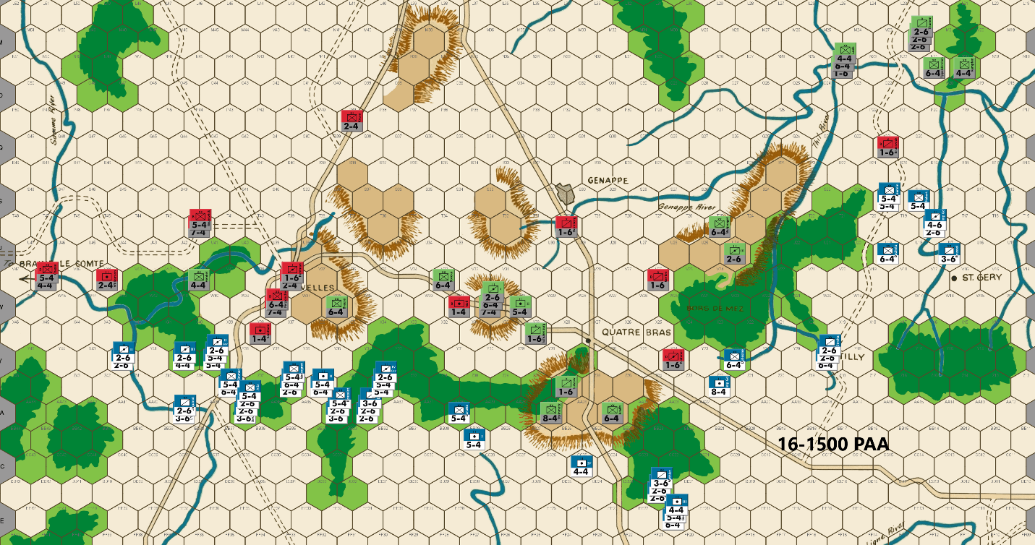
Ed: In the Nivelles theater of operations, the French follow what I think is the more prudent course which is to position for favorable attacks next turn. I follow through with my strategy – block the French and avoid any serious confrontation against a greatly superior force. Perponcher and Picton are at W38 to discourage the French from occupying the position. If they don’t, it will cost them a turn’s delay. I expect the French to move into the hex, but at least it will improve the odds of causing casualties against the required soak off.
I debated placing two 6-4s at W36 to discourage a low odds attack. In the end, I decided to go with one infantry in order to position the second 6-4 better to defend the Quatre Bras gap along with other withdrawing Prussians.
In the far west, I keep sufficient “heavies” available to 3-1 proof the Samme River against an expected serious threat next turn from French infantry and cavalry.
Sadly, I have to spend a blocker in the Tilly Corridor because I was not able to get an infantry in position to defend the Thil River against the advancing French infantry. I really hate giving up 3 blockers in one turn.
Joe: In the West (Nivelles and the Braine le Comte Road): West of Nivelles, the defensive predicament of Williamson (a 2-4), north of the Samme River is temporarily ignored by the French player -- at least for the time being -- as he does not bother to deploy even a token cavalry force of three to seven factors on the primary road hex at Z38; had he done so, this small contingent, if unnoticed by the PAA player, would have been enough -- when combined with the French cavalry at Y42 and AA39 -- to stage a sudden surprise 3-1 nuisance raid against Williamson's position at V44. Needless-to-say, the Allied commander is cognizant of the French threat to the Samme River, and so moves to rectify this problem by sending Alten (a 7-4) and Brunswick (a 5-4) west to replace the vulnerable 2-4. Farther east, the Allied units in the Nivelles sector actually catch a welcome break, as the French player opts not to press his advantages in tempo and combat power by immediately attacking through the eastern forest corridor on this game turn; but instead elects to cautiously deploy his units into the northern forest hexes in preparation for an all-out attack against the opposing PAA battle line on the 1700 game turn. However, this temporary absence of offensive pressure from the French Left Wing, creates an unusual situation in which control of the near-term trajectory of the action in the west, unexpectedly flips to the PAA commander at Nivelles; the question suddenly becomes: what should he do right now? In basic strategic terms, the Allied player really only has four viable options: a) he can selectively counterattack the advancing French (probably at Y39 and Z36); b) he can sit tight and reinforce his line along the X hex row; c) he can hybridize options "a" and "b," and attack Y39 from X39 (making sure to leave a post-combat sacrifice at Y38), while, at the same time, he reinforces the PAA line along the X hex row; or d) he can essentially "throw in the towel" when it comes to a protracted fight for Nivelles and, instead, pull the local Anglo-Allied contingent back to the W36 ridge hex and beyond, while leaving a delay unit at X38, and while also sending the Prussians quick-marching back towards the center and a possible battle at Quatre Bras. Somewhat unexpectedly, given my own experience competing against this Allied player, he chooses Option "d". And while somewhat surprising, this decision to temporarily avoid battle -- although it is far and away the most passive of the four alternatives -- does have a compelling pair of advantages which is probably what convinced the PAA player to decide in its favor; to wit: it is, indisputably, both the least risky, and the most economical -- at least in terms of immediate PAA casualties -- of any of these four Allied Nivelles defensive plans. Unfortunately, along with this "delay and fallback" strategy's advantages, there are also a couple of potential disadvantages which are really too important, not to be considered. The first of these is the "time/terrain problem." What this refers to is simply the close relationship between the terrain on different sections of the map board, and the rate (in game turns) at which L'Armee du Nord is able to traverse those different map sections in its march north towards the Brussels Roads victory hexes. This rate of advance is critically important because the French Army starts in the south and, as a general rule, the southern half of the game map -- thanks to a landscape cluttered with forests and rivers, as well as with a few critically-sited ridge lines -- severely limits and channels the initial French advance into a small number of predictable avenues and, by so doing, heavily favors the PAA defenders, especially during the early turns of a typical game. Since the northern half of the map board tends to be much friendlier to the French player than to his PAA foe, it stands to reason that the earlier in the game that L'Armee du Nord can push the Allies off of the southern and onto the northern half of the game map, the better its chances for victory will be. And there's the real defect in relying too heavily of the "delay and fallback strategy:" sacrificing delay units can slow the advance of the French Army, but only combat can actually halt it, even if only temporarily. One handy, if crude way for players to actually assess this game metric is for them to check to see how far north on the game map the French Army has advanced by the morning of 18 June: if it is attacking near Mont. Ste. Jean, then Napoleon's prospects for victory are probably pretty good; on the other hand, if L'Armee du Nord is still fighting on or near the "Genappe - Nivelles Line," then the PAA will most likely have the edge. The second disadvantage of an Allied over-reliance on a "delay and fall back" strategy is the "comparative casualties’ problem." In a nutshell, this refers to the different capacities of the French and PAA armies to each absorb battlefield casualties as the game progresses. By way of explanation, the French Army starts play with fifty units and receives no reinforcements for the balance of the game; the Allies, on the other hand, begin the game (assuming no unit removals) with thirty-five units and, over the course of the next fifteen game turns, receive forty-three more units as reinforcements. What this means is that, even accounting for Allied unit removals and for accumulating losses due to the steady drain of sacrifice/delay units, mutual battlefield attrition will -- assuming that Allied casualties do not reach catastrophic levels -- almost always do more long-term damage to the French than to the Allies, because -- if one does the math -- each PAA unit represents a smaller percentage of the Allied total combat strength than each French unit does. Finally, so far as the Allied player's execution of this strategy is concerned, I will offer only one caution (which doesn't even rise to the level of a "nit") concerning just a single part of this Allied move, and that is this: the positioning of Perponcher and Picton at W38, while appealing because of the fact that their combined combat factors guarantee the elimination of a 2-6 soak-off should the French player decide to occupy X37 in strength, is nonetheless, not without risk; on the contrary, it should be noted that Picton can be attacked at a basic 1-1 (30/40 risk/reward with a 5-4 and 2-6), and Perponcher at a basic 1-2 (30/20 risk/reward with a 3-6) and that these attacks would still allow the French player, regardless of the final outcomes of these two low-odds attacks, to retain post- combat control of X36 with a 5-4.
In the Center (the Quatre Bras Gap): Things may finally be about to heat up on what, hitherto, has been a comparatively uneventful front. As expected, the local French commander has restored the pin against Steinmetz at AA27; and, at the same time, he has increased pressure on the Heights by maintaining swing stacks at DD22 and EE21. It will no doubt come as a big disappointment to him when he discovers that the Prussian units seconded to Nivelles earlier in the game, are now quick marching back to the center. Next turn, the French will almost certainly occupy AA23, and that will then make a 3-1 concentric attack against AA25 possible on the 1900 game turn. However, although AA25 cannot be made 3-1 proof as long as Steinmetz is pinned at AA27, the Allies can still make this troublesome hex virtually impervious to immediate capture by garrisoning it, either with two 6-4s or with a 6-4 and 7-4; in addition, as an emergency alternative, the French can also temporarily be kept out of AA25 simply by the PAA completely abandoning the hex, while, at the same time, heavily garrisoning AA26 and Z25, instead. This stratagem is guaranteed to prevent the French capture of AA25, at least for a single turn, and depending on the French commander's appetite for risk, maybe longer.
In the East (the Quatre Bras Gap and the Tilly Corridor): Another turn in the Gap, another delay unit sacrificed. Of course, since the Allies have almost run out of Gap to delay in, this sector shows every sign of heating up in the next turn or two.
The Tilly Corridor: In my previous comments, I acknowledged that, although my personal inclination was to launch a surprise 5-1 attack against Habert along with a post-combat advance by Marwitz into S19, I also admitted that such an attack was not without some risk and that, because of that fact the decision on whether to attack or to continue to fall back was really a "coin toss" for the PAA player. However, now that it is clear that Marshal Blucher has ordered the Ist and IInd Prussian Corps back to the center in order to concentrate at Quatre Bras, I've changed my mind! I now consider the attack against Habert to be the best possible option on this front. Moreover, I also believe that to insure that -- in the event that the French want to fight it out deep in the Corridor -- the IIIrd Corps will actually have enough staying power for a protracted fight, that Merlen should shift onto the Thil at Q23, and that Stulpnagel should move onto the Thil at R23.

16-1700 French
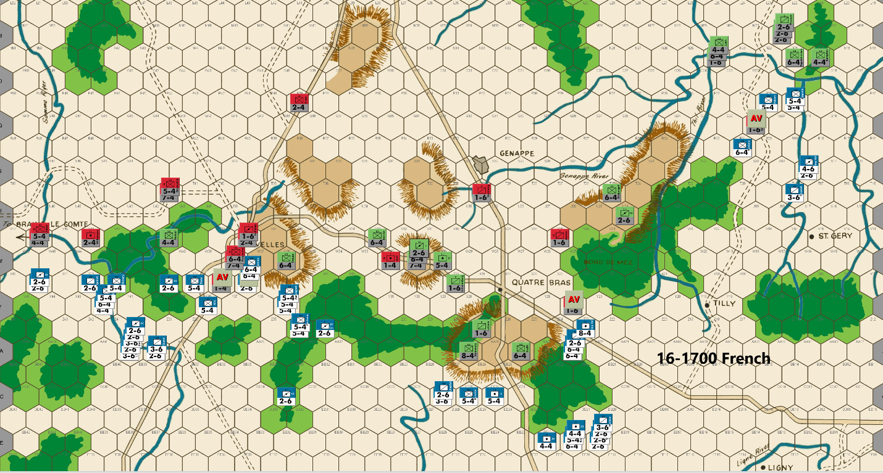
Bert: I guess that I ended up getting shocked when I saw that Ed fell back in the Nivelles region without initiating the fight for that area. He has protected his army, which is almost never a bad strategy for the PAA in this game, but he has allowed me to gain control of the Y row of hexes with little to no cost. This is important because it allows me units to have a retreat route on any attack he makes from here forward. I feel fortunate to break through the Nivelles bottlenecks without losing a unit. Of course, I didn’t get a decent chance to kill any of his big units either… so I’ll have to deal with a lot of them in the upcoming mid and end game.
Getting units into hex X37 is important to my French position this turn, so I’m offering up a cavalry as my first lost unit in the game to take it and try to hold it. The hex offers nice protection for my unit at Y39 because W39 leaves no place for the PAA units to retreat from, should he attack from there. More importantly, X37 makes it challenging for Ed to hold the Nivelles hilltop on the next turn, without him attacking me. By losing my soak off unit but leaving a formidable stack of two 6-factor units in that hex, I’m putting pressure on Ed to get him to fall back a hex further than he intended on this coming turn. He hasn’t shown the desire to fight for ground yet (nothing wrong that as I noted above), so I’d be surprised if he’ll want to do so for this hex; we’ll see.
Further to the west, I’ve shifted a significant force to a position to threaten Ed’s ability to hold Braine Le Comte through the 0700 6/17 turn. I’m expecting Ed to offer Williamson as a sacrifice on hex V45 this coming turn, which will screen the west side of the river so that I can only attack from one hex. I’ve tried to prevent him from blocking me from hex W44, as this might allow me to breach the river the following turn. Getting to kill an extra PAA blocking unit is good by itself, but I’d like even more of a gain from this position. I’m not sure if my threat is enough to draw his units at T42 westward to deal with my foray. Worst case, I can easily swing most of my threatening units back towards Nivelles if a fight breaks out near there or a better attack opportunity arises.
In the center, I’ve shifted some of the cavalry, that were initially dispatched to the west to assist in breaking through the bottlenecks, back eastward. They haven’t missed much action in the center and their mobility will have them arriving back there just in time for when I’ll need them.
Last turn, I wrote that I would probably be launching a low odds attack against Steinmetz this turn…, but I decided that with Ed’s significant shift of Prussians back to the flexible center position, the center hill is not as vulnerable as it was last turn. I expected the fight to happen in the west and since it hasn’t, I decided I should not tempt fate by making that low odds attack when his unit is doubled, and he has reinforcement in position to mostly plug any resulting hole.
I’m a bit worried that Ed might launch an attack vs my weak position at Z23 & AA23. With his 38 Prussian factors now in range of those hexes, he can get something like a 3-1 vs my 8-factor Imperial Guards unit and a 6-1 vs my cavalry unit while it would only cost him a single soak off unit. With Borcke & Stulpnagel both slightly out of range of my units in that area, that attack would almost certainly require Ed to give up the doubled hilltop hexes this turn. It’s possible he makes that attack, but that would seem to be out of character for the way Ed is playing this game so far.
Finally, I did not expect Ed to offer me another ‘free’ blocking unit in the Tilly Corridor. That was enough to keep my units engaged with this “mostly a feint” for another turn. What is nice about keeping my French forces in that area as a threat or nuisance, is that Ed committed 5 units to the east side of the Dyle River on this turn. If I’m going to be attacking anywhere in that area, I suspect it will be to swing my units westward so that they can fight to cross the Thil River and then hook up with my forces that will eventually (HOPEFULLY!) breakthrough in the Quatre Bras area. If he wants to offer up any additional blocking units northward, I’ll probably chase and take them, but with his 5 units in that direction, I don’t expect that to happen.
Joe: In the West (Nivelles and the Braine le Comte Road): The French move in this sector virtually makes itself this time around. Because Napoleon's Left Wing is at least one and maybe even two game turns ahead of schedule in the west, the French player has the surplus combat assets and the extra time available with which to both mount a credible (if perfunctory) threat against the PAA Samme River defenses, and to also aggressively push north, with comparative safety, towards the main western primary road junction. In the case of the push towards Nivelles, the French commander chooses the conservative approach and -- in order to deny the PAA commander uncontested control of W38 (as a delay hex next turn) -- occupies X37 with two 6-4s and a sacrificial 2-6 soak-off. I should note, at this point, that although I personally would have been sorely tempted to take a chance on a pair of speculative low odds (a 1-1 and 1-2) attacks against Picton and Perponcher (in W38), I cannot fault this French player for making the more prudent play, especially considering the mob of Prussians still lurking around W31. That said, the only small "nit" that I could find to pick with this French move concerns the position of the III Corps Horse Artillery: it accomplishes virtually nothing in its present hex (X40), but had it been moved to Y38, then it would have increased the combat factors available with which to attack V44 (from forty-three to forty-five factors). More to the point, this small juggling of combat power, while not inconveniencing the French commander in the slightest, would, nonetheless, have added yet another niggling little worry to the Allied player's already challenging defensive problems in the far west.
In the center (the Quatre Bras Heights): The French contingent in front of the Quatre Bras Heights continues to pin Steinmetz at AA27, while its central reserve at EE20 and EE21 makes ready to threaten future action against the Heights. Such action, were it to come, would probably either take the form of a head-on low-odds assault, or -- if the French player is willing to wait two more game turns -- a concentric 3-1 attack against AA25; an assault which would also require the direct support of units from the French force already deep within the Quatre Bras Gap.
In the East (the Quatre Bras Gap and the Tilly Corridor): The French continue to advance into the Gap at their usual pace of one hex per turn, eliminating yet another Allied sacrifice/delay unit as they go. The one major situational change this turn, is that the path has at last been pried open for the French to occupy AA23 next turn. Now, "like the dog that, after years of chasing cars, finally catches one," it will be interesting to see what the French player actually decides to do with his new-found possession of this critical hex.
The Tilly Corridor: The Tilly Corridor can, for both players, be a very tricky and dangerous front in which to campaign; however, it can be particularly so for a French expedition that neither enjoys a significant numerical, nor a large combat strength advantage over the Allied force defending in this challenging sector. In view of that fact, this raid north towards Wavre has been astonishingly successful; especially since the French detachment conducting it is actually numerically inferior to, and enjoys only a very small advantage in combat power when compared to its foe: a reinforced Prussian corps. Be that as it may, through a combination of audacity and maneuver, this French detachment -- without incurring any losses -- seems to have succeeded in driving its more numerous Allied adversaries out of the Corridor and across the Thil and Genappe Rivers. If the Allies continue their retreat, and do not wheel around to take advantage of their second opportunity for a 5-1 attack versus Habert -- then this will be a signal accomplishment that, I think, nicely illustrates the validity of Frederick the Great's famous dictum: "L'Audace, l'audace, toujours l'audace."

16-1700 PAA
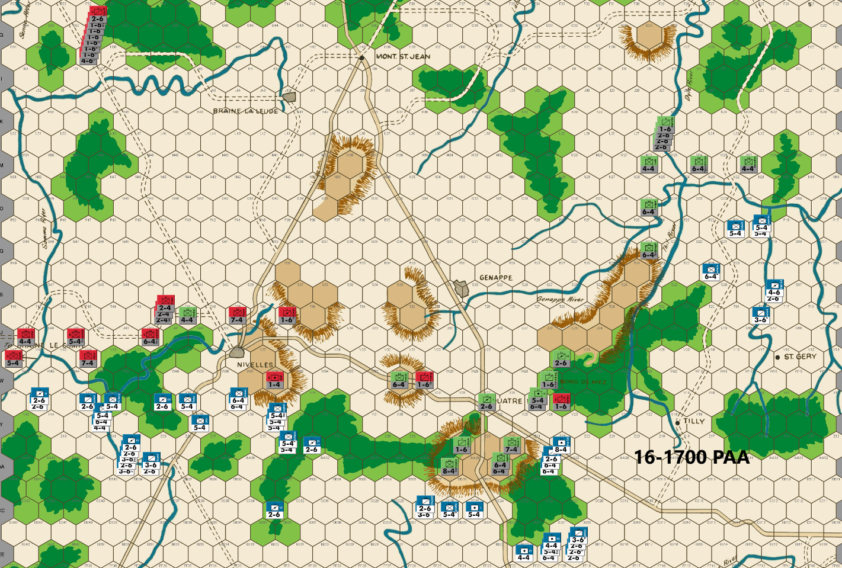
Ed: My goal in the west is to 3-1 proof the Samme River keeping U47 out of a French ZOC so as to bring the 17-0700 reinforcements on the Braine Le Compte Road. As expected, Bert threatens the Samme River now that he has broken into the open south of Nivelles, but with only 43 factors rather than the 45 I anticipated. That means only one infantry flanker is needed for Alten rather than two. This frees up Henkel to begin the slow migration east to join up with his Prussian brethren. I note that Bert has a 5-4 infantry X42 who could move to W42 next turn. Three 2-4 units move within range to support a surround attack if he does.
An Anglo-Allied blocker is used southeast of Nivelles at W36 along with a typical river defense. I decided not to deploy a Prussian 6-4 at V36 hoping to cause a soak off loss from V37. I cannot afford to lose any infantry to lucky low odds attacks.
Steinmetz is again pinned to AA27, given the array of French attackers within range. I double up on AA25 to prevent any 3-1 advance on the hex which is my standard defense against this French deployment. I would not attack this hex as the French because of the exchange and Prussian surround counterattack risks. We will see how bold Bert is. The French did not occupy Y23, which surprised me. It allows me to place a blocker at X24. Any French attackers at Y24 can be hit with a surround attack and have to soak off vs 11 factors at X25. If they do not attack from Y24, I gain another turn of delay in the gap. I’m guessing Bert will move into the hex since I don’t think he will want to lose a tempo.
I use a typical defense in the Tilly Corridor with 3-1 proof river defenses. I’m doubtful that the French will push north with such a weak force. I expect they will mostly threaten the Thil & Dyle Rivers to keep significant Prussians from the central front. We will have to yield the Thil River however, once the Quatre Bras forest gaps are breached. I do not expect any low odds attacks here.
Joe: In the West (Nivelles and the Braine le Comte Road): With Nivelles about to fall to the French, the western Samme River has become the PAA main line of resistance in the west. Fortunately, the Allied commander has (barely) enough local forces to render this line pretty much secure -- always barring low-odds attacks, of course -- until the Anglo-Allied Cavalry Reserve and the 17 June 0700 Braine le Comte reinforcements can arrive on the scene. This line, however, is probably not his primary concern: the main problem confronting the PAA player -- at least in my view -- is actually the speed at which the French Left Wing is advancing on the Nivelles front; which is to say: once the Allied sacrifice at W36 is cleared (followed by an automatic advance after combat), then the French will be able to begin pushing east along the primary road back towards the center; this eastern advance should quickly render the continued PAA defense of the Quatre Bras position untenable, and will require -- in order to conserve both regular combat and soak-off/delay units -- an early Allied withdrawal north to the Genappe-Nivelles defense line.

In the Center (the Quatre Bras Heights): As expected, the Prussians have fortified the Quatre Bras Heights as well as they could, so we should soon see exactly how much appetite for risk the French commander actually has. Unfortunately for the Prussian defenders, after strongly garrisoning AA25 and Z25, there were not enough units left to effectively garrison AA26 as well; this means that the French player could theoretically attack the eastern end of the Heights at a cost of a single soak-off. However, all is not as meets the eye. In point of fact, since such an attack would leave any surviving French units at AA24 exposed to a Prussian surrounded counterattack -- unless, that is, one or more French units also occupied Y24 -- it is highly likely that the Imp. Gd. Foot Arty would be posted to that hex with orders to attack Merlen at 8-1, while a 2-6 came along for the 1-6 soak-off against X25.
In the East (the Quatre Bras Gap and the Tilly Corridor):
The Quatre Bras Gap: The Allied move on this front is pure "textbook" WATERLOO. Schulenberg is set up for a soak-off/surround move to X24, should the French venture into Y24 without any flank protection. The main goal of this threat, of course, is to discourage an attack against Merlen from Y24 and, by so doing, to preserve X25 as a delay hex next turn.
The Tilly Corridor: The Allied player makes the same questionable choice that he made on the last turn and again declines to rebuke the impetuous French with a surprise against their vanguard; instead, he chooses to continue his retreat across the Thil and Genappe Rivers. This is an unforced error, in my opinion: the French player has again exposed his advancing column to a Prussian counterstroke: a surprise attack that -- in my view, at least -- has now, because of the absence of any local French reinforcements in the Corridor, become irresistible, especially since Stulpnagel and the III Corps Hrs. Arty can both move to straddle the Thil River at R23 and S23, respectively. Granted, it is always prudent -- because of the remoteness of this front -- for the Allied player to conduct operations in the Tilly Corridor with a great deal of care; however, when circumstances are such that an attack can be launched with a minimum of risk, then I think that it should be done. Besides, the rare opportunity to chase the French back down the Corridor for a turn or two is just too appealing to turn down.

16-1900 French
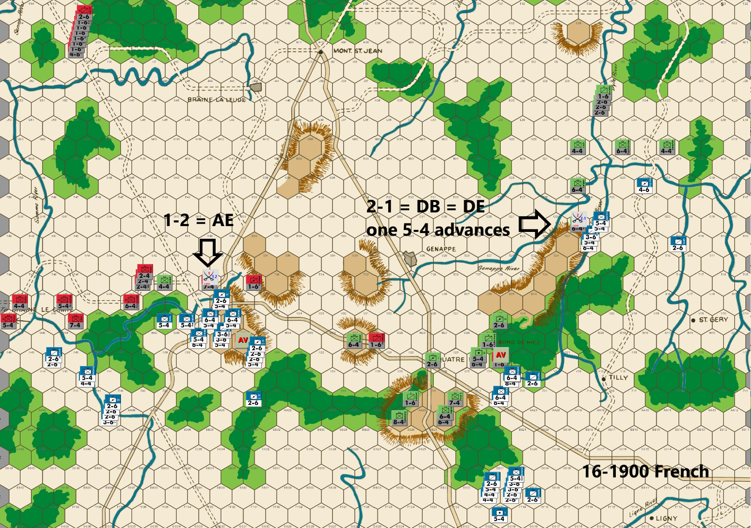
Bert: Ed’s move has me more confident that he’s playing the PAA side with no plans to attack me unless he can do so with virtually no risk of a loss to his army. This is one version of a defense that I have played the PAA side with successfully. The premise is that you don’t want to lose any PAA units via a counterattack, including soak offs, so that there are more pieces that the French has to fight through during the game. This can be a winning strategy, especially if your opponent doesn’t spread your defensive units out across the board. The best way to counter this is to take some chances when you have an opportunity to severely disrupt the defensive flow.
In case you haven’t noticed, I think that now is the time to take a couple of chances. Despite my earlier comments, I won’t be taking a low odds shot against the center hill. Ed has shifted his forces over the last two moves so that what was a brittle position that might have been broken had I taken the attack two turns back, it is now one of his strongest positions on the board.
I have probably played Waterloo close to 100 games over the years. I don’t recall a PAA commander committing so much defensive force to the Braine Le Comte area in any of those games, ever! Yes, I projected a lot of force in that direction for a possible attack, but the response has been overwhelming and so I’m not going to push a losing position. By moving BOTH the 5-4 and 7-4 westward to defend the V45 side of the river, and what I think is a misplacement of Moll at W36 instead of V37, Ed has left his 7-4 at T39 particularly vulnerable to a low odds attack. I think Moll at V37 and Brause at V35 would have been a better defensive position for Ed. Anyway, I determined almost immediately upon seeing his move, that I would be attacking T39 on my move since both the defenders to the west and the 5PM reinforcements are two turns away from helping to fight for that river bend. If I manage to get lucky and breakthrough there, it will leave us fighting in open ground, which strongly favors the French side, especially this early in the game. I struggled with making it a 1-2, 1-1 or 2-1. In the end, I decided that the 1-2 was enough of a gamble. This is especially once I realized that I could flood the potential attacker retreat hexes with 11 or more factors so that Ed will be forced to retreat Donzelot to V36, if an AR is rolled. This will take away the optimum delay hex that Ed would like to utilize. I’ll be even happier with a DB2, to advance across the river or an Exchange took take out one of the major defensive pieces. The AE risk seems well worth it. I just don’t know if I should have fully committed to break the river with a higher odds attack that would have made a D Elim outcome, a possibility…
In the center, I’m mostly repositioning my units so I can force a fight through the Y24 gap southwest of Quatre Bras. If I’m right about Ed not wanting to actually engage in a counterattack that might cost him a unit or more, I feel like I can be aggressive since I feel like my progress is too slow in this area. Frankly, it is due to Ed’s play with a small assist by me not taking the low odds attack when his units were two turns to the west.
My strategy in the Tilly Corridor has been a hot mess. I could probably play it safe but Ed has made what I believe is another positional mistake that has made a low odds attack just too tempting to pass up. Positioning Stulpnagel at Q24 instead of R24 has made a frontal attack against that piece a surrounded attack due to the river behind those men. I debated what odds made the most sense for this attack and here I settled on the 2-1 attack that I’m making. Once again, Ed is quite strong to the north of here but his position is vulnerable if I can eliminate his defender. The risk of losing 24 factors on the 10% chance is daunting, and could lead to a lot of regret, but I have always felt that the French player has to take a few low odds attacks in this game against a strong PAA player and the upside for this attack tells me that this is one of those times. If I’m successful (a DB2 or D Elim especially), I could easily see Ed finally give up the center hill as he’ll need to reposition units to deal with a critical breakthrough. If I get the A Elim result, I think that this will toughen Ed’s resolve to make me fight for the Quatre Bras area for multiple turns. I guess that makes this the definition of a critical attack!
Joe: In the West (Nivelles and the Braine le Comte Road): The French Left Wing, having captured Nivelles with negligible losses, attempts a low-odds "attack from the march" assault against T39, either to break the Anglo-Allied defense north of Nivelles or, failing that, to at least eliminate Picton with an Exchange. Unfortunately for the French player -- as will tend to happen when the odds are 60/40 against -- the attack misfires, in this case with an A Elim, and his attempt at a surprise "bold stroke" comes to naught. Speaking for myself, I usually don't care for this particular attack, either because the opportunity to make it will usually not occur this early in the game, and the Anglo-Allied Cavalry Reserve will have already come up to the front, or because there will often be enough Prussian combat power at W31 (and in the west) to launch a counter attack (with soak-off) from T38 and S39 against a lone 2-6. Moreover, even if both the 5-4 and the 2-6 advance, then the Anglo-Allies will usually be able to attack the 5-4 at 3-1 (surrounded) while the Prussians take care of the 2-6. In this specific instance, however, because of how early it is in the game, the Allied commander has literally no reserves available for such a counterattack, so this speculative gamble actually makes a lot of sense. That said, I really only have one "nit," and one major criticism regarding this turn's French move. In so far as the "nit" is concerned: it appears that the the IV Cav. Hrse. Arty is completely wasted at Z34. Regarding my single major criticism: I believe that, given the surplus of French combat units currently available on this front, the French player should have continued to maintain a mixed infantry/cavalry force of at least forty-two factors within range of V44, in order to tie down as many Anglo-Allied units as possible, just in case his low-odds attack should actually meet with success.
In the Center (the Quatre Bras Heights): With the strong possibility of a major fight coming in the Gap in the next turn or two, the French player -- wisely, I think -- concentrates virtually all of the units directly threatening the Heights (some thirty-seven combat factors) -- into switch positions (EE21, EE20, EE19 and FF20) from which this entire contingent can now "fork" both the Heights and the Gap.
In the West (the Quatre Bras Gap and the Tilly Corridor):
The Quatre Bras Gap: Still keeping to his strategy of methodical and careful advance in the Gap, the French player eliminates the Allied sacrifice at X24, but because of the very real possibility of a Prussian counterattack, opts to bolster his battle line in the Gap just in case Blucher finally decides to strike back. This response, in my view is an error: purely from a tactical standpoint, I believe that it would have been more effective -- in terms of offensive pressure -- if the French player had maintained his threat against AA25, by leaving the stack of fourteen factors at AA23 unmoved, and if he had also shifted the 6-4 stacked with the Imp. Gd. Foot Arty one hex to the southwest at Z23. With this deployment, French options in the center would have remained open, and none of the French units in this new line (except for the 2-6 on AA23) would have been any more vulnerable, than they are now, to attacks at odds greater than 4-1.
The Tilly Corridor: The French player's decision to gamble on a highly speculative 2-1 attack against a doubled Prussian 6-4 on this game turn -- although strongly implied by his already-demonstrated appetite for risk-taking on the Tilly front -- still took me completely by surprise! Granted, Division Stulpnagel -- with his back to the Gennape River -- cannot retreat, and his predicament does improve the positive outcome bias of this 2-1 attack from 20% to 40%; nonetheless, the unpleasant truth of all this for the French commander is that any combat result other than a DB2, D Elim, or AB2 would have been absolutely crippling to virtually any of his future offensive prospects in the Corridor. And yet, in spite of this risk, the French player still commits the bulk of his Tilly contingent to this highly dangerous attack, and comes away with a complete victory that not only destroys Stulpnagel at no cost, but that also completely disrupts the PAA commander's defensive plans for both the Tilly and the Quatre Bras fronts. And, although this is an attack, that -- because of the previous success of French operations in this sector -- I, personally, would almost never be tempted to make, I do have to acknowledge that -- at least in this case -- its outcome turned out, quite literally, to be a "game changer!"

16-1900 PAA
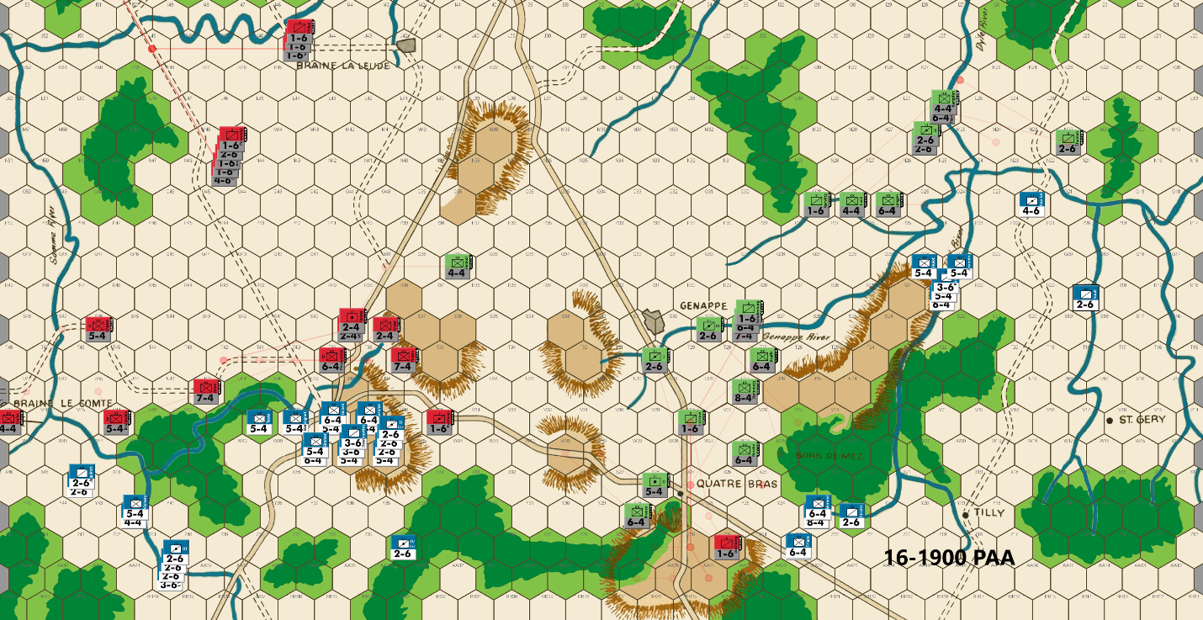
Ed: Bert maintains a threat against the Samme River and advances in the open ground south of Nivelles. I was not expecting his 1-2 attack across the river against my 7-4. Fortunately, the dice gods favored me with an AE. I’m stretched thin on this front and have to make some tradeoffs. I prioritize the defense east of Nivelles leaving T41 undefended. Of course, the French can advance adjacent to T41, but I can attack any such units from doubled terrain.
I move a 7-4 to T37 and a blocker to V35 to hold as much territory as possible. The 7-4 is vulnerable to a low odds attack and I need a credible counterattack to dissuade Bert. Thus, Henkel moves to a position where he could join in with the two infantries west of Quatre Bras in a surround counterattack. This is the best I can come up with.
Bert’s surprise 2-1 attack across the Thiel River was successful, forcing me to withdraw units to defend against the new threat and yield the Quatre Bras sector. I deploy a blocker and 3-1 proof infantry to hold as much of Quatre Bras real estate as I can.
In the far east, I defend the eastern branch of the Genappe River with a single 2-6 which can be attacked at 3-1. I don’t expect Bert will reverse course now that he has breached the Thil River. I would not in his shoes as I think these French units are more valuable aiding the attack on Genappe. There is also the risk of an exchange if he attacks. But Bert has already surprised me, so we shall see.
Joe: In the West (Nivelles and the Braine le Comte Road): The PAA commander is treated to a scare this turn, as the French player launches a surprise low-odds (1-2) attack against Picton at T39; luckily for the Allies, the French gamble misfires, and the unlucky attackers (a 5-4 and 2-6) are both sent to "dead pile" by an A Elim result. Somewhat surprisingly, although this French gamble fails, it nonetheless appears to have "rattled" the PAA player a little, as his response seems both "too much" and "too little" at the same time. Too much, because a number of Allied units have just been moved (e.g., Alten, Brunswick, Chasse and Henkel, to be specific), but will very likely have to backtrack -- because of renewed French threats against the western Samme River-- on their very next turn. Too little because, if the PAA commander was truly concerned about another low-odds attack against T39, then he would have been better served to stack Picton and Perponcher together in T39, and to then cover the block at T37 with Brause. Finally, although this is a bit of a "nit," I personally think that the three local Anglo-Allied 2-4s should have been split up between T42, O39 and S38 (instead of S38 and S39) if, for no other reason than to disperse these soak-off/delay units across a wider arc of the Allied front.
In the Center (the Quatre Bras Heights): It is not often that a battle in a remote section of the map -- well-removed from the Allied center -- directly affects the strategic situation at Quatre Bras, but this seems to be one of those times. In point of fact, the French defeat of Stulpnagel, along with their accompanying breaking of the southern Thil River line deep in the Tilly Corridor, appears to have provoked something akin to a general panic among the PAA forces on both fronts. In the case of Quatre Bras, Marshal Blucher has ordered a general retreat off of the Heights and towards the western Genappe River, ostensibly in a move to intercept the French units presently astride or across the Thil should they attempt to move west. A sacrifice/delay unit has been left behind at Z25 to slow the pursuit of the French in the center. This Prussian response -- at least in my opinion -- seems to be a bit overdone. If I had been Blucher, I would have held onto the Heights with 6-4s at AA27 and AA25, and a 7-4 at Z25, with, of course, a 1-6 at Z27. Most of the remaining Prussian units would have been sent racing north, with those that were able to, moving to straddle the Genappe River so that they could shift to either bank, depending on the actions of French units on the Tilly front. Finally, my reason for holding on the Heights for another game turn is simple: If the French player decides he is keen to press his battlefield advantage with a couple of low-odds attacks, then it is my preference that he test his luck against doubled rather basic strength Prussian defenders.
In the East (the Quatre Bras Gap and the Tilly Corridor):
The Quatre Bras Gap: This sector has now, for all intents and purposes, merged with the Heights. A single 3-1 proof Prussian 6-4 defends at W26, but, assuming that he survives, he will be retreating north, next turn, once the French capture and consolidate their hold on the Heights. In the case of my alternative defense, the Gap is blocked by a single sacrificial 1-6 at X25.
The Tilly Corridor: The success of the surprise French attack against the Thil River defense line has completely upended the situation in the Tilly sector. This unexpected change in strategic direction strongly suggests that the French commander has decided to alter the focus of his campaign and now intends to move his force across the Thil and to then establish a bridgehead across the western Genappe before Allied reinforcements can be moved to block him. Given this reasonable appraisal of the French Tilly commander's intentions, the Allied player scrambles to shift his units onto and across the Dyle, so that they can then move to support the Prussians from Quatre Bras in their efforts to prevent the Genappe River defense line from being broken on the morning of the 17th. A Prussian 2-6 is left behind at M22 to discourage a nuisance raid by the small band of French cavalry that are present on this front. The problem with this Allied assessment of French intentions is that, until the Tilly French actually commit to a western drive by actually crossing to the west bank of the Thil River, a resumption of their northern push towards Wavre cannot be completely ruled out. Certainly, the paucity of French cavalry in this sector would seem to make such a drive unlikely, but you never know. In fact, as a general rule, and having been "gobsmacked" more times than I can remember, over the years, I now always operate under the assumption that if a player has surprised me once, then I assume that he will find a way to do so again. That said, my own Allied approach to the very real problem of determining French intentions on the Tilly front -- at least in this situation -- would be to initially send a couple of cavalry units west to support the Prussians marching east from Quatre Bras, but to otherwise hold my regular defensive positions behind the Dyle and eastern Genappe Rivers, at least until the French commander on the Tilly front has definitely committed to one offensive objective or the other.

17-0700 French
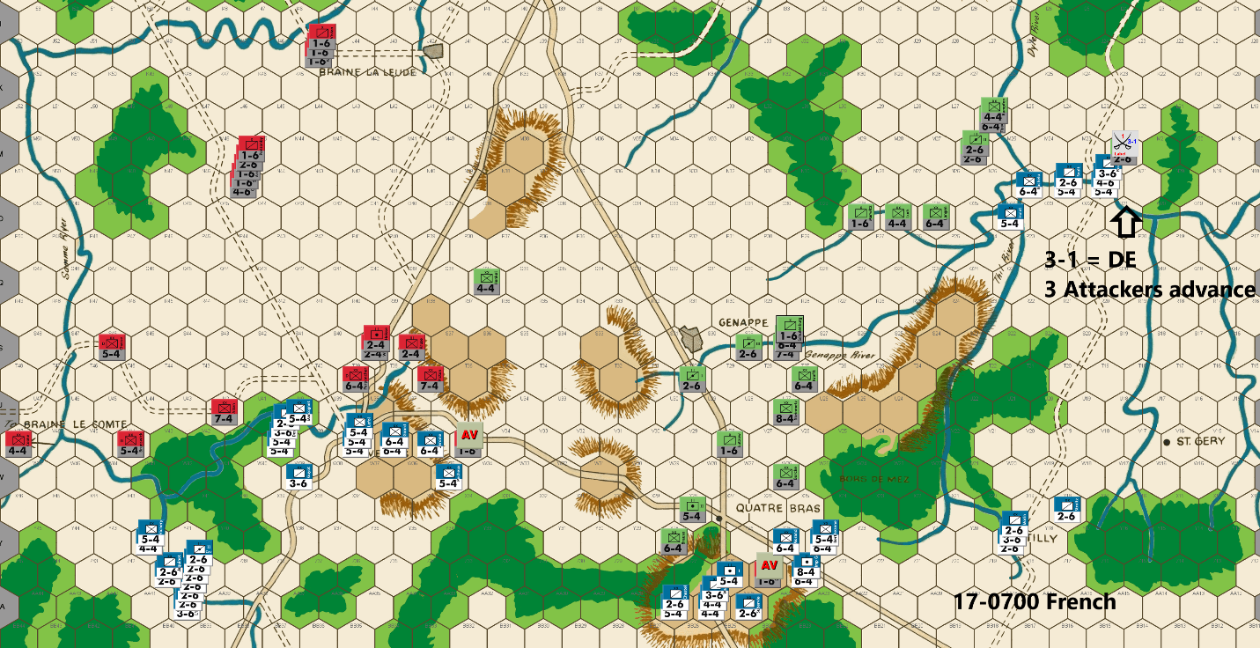
Bert: Morning has broken here in Belgium. Reports have come in that Ney’s attempt to break the river north of Nivelles has been easily repulsed. The news from the east was much more to Napoleon’s liking as Grouchy’s assault to breach the Thil River, was a rousing success. Interestingly, the defensive position of hex Q24 versus R24 turned out to be critical as there was no available retreat route for the DB2 result that was rolled. An attack against R24 would have been at 1-1 odds at best and would have left Stulpnagel with a safe retreat route. I’m quite certain that the attack would not have been ordered under those circumstances.
Overnight, the PAA commander responded to these brazen attacks by sticking to his “no counterattack” strategy and more importantly, withdrawing from the center heights to the south of Quatre Bras. Overall, the French high command is pleased with that outcome of the operation because getting that withdrawal was the expected response should the Thil River attack be successful. I personally, would have left a minimal force to hold the hill one more turn and possibly force me to risk an exchange result against a doubled defender, but I understand Ed’s decision in this case – especially since I’ve shown that I’ll take “reckless” attacks.
To be fair, I don’t think my attack was all that reckless. As I’ve explained a couple of times, the French player almost certainly must take and win a couple of low odds attacks relatively early in the game against a strong PAA player, which Ed certainly is. My thought is that when I take my low odds attacks, they should be done to yield a great result and not just some random kill in a non-critical point of the map where there are a bunch of defenders to respond with their own counterattack. My Thil River attack fit the ‘chance to yield a great result’ description almost perfectly. The fact that Ed allowed it to be a surround attack made my decision easier. So yes, I got a lucky result…, but as happened with the similar attack versus T39, sometimes your timely low odds attacks are crushed, but sometimes they get paid off.
Despite successfully crossing the Thil River last turn, I didn’t see a great option for exploiting that attack by joining up with the main force coming through the Quatre Bras pathway. As previously noted, my general strategy in this game is to try and keep Ed spread out over as much as the board as is reasonable and a good way to do that is to order the Tilly Corridor force to head northward instead. The good fortune on my risky attack mucked up Ed’s strong defensive positions that had the north nicely sealed up. Now, the weakened position looks potentially exploitable. At a minimum, I should be able to keep his forces spread out as his advantage is getting to go toe-to-toe with me in a confined space and I would like to avoid that for as long as possible.
My northward move is happy to find a 3-1 attack against Thumen. I was a bit surprised to see Ed allow me to get that attack. M22 is a tough hex to defend because on a DB2 result, I will choose to retreat the defender to M21 via L22 – a zig-zag retreat. My infantry unit will advance into the hex, basically pinning his cavalry unit as the surrounding wooded hexes prevent him from escaping a likely follow-up attack. If I get the exchange, I’d rather lose the 5-factor infantry unit and keep my Imperial Guard Artillery piece on the board, especially with its extra movement factors. The almost guaranteed taking out of Thumen will open up a path to Wavre in the next couple of turns or force Ed to offer up additional Prussian targets to impede that thrust.
Elsewhere this turn, I’m content to take what was given to me in terms of the two blocking units. I saw a couple of quite tempting low odds targets this turn, but I decided to not push my luck against either of them. These are what I looked at, but decided not to pursue:
- The most tempting was a 1-1 or 2-1 surrounded vs Cooke near Braine le Comte. My preferred defensive position at this point of the game as the PAA would be to place the unit at U47, where a 2-1 is not possible and a DB2 doesn’t cause elimination.
- 1-1 (or a 1-2 or a 2-1) vs Picton at T37. The PAA is a bit brittle right now and taking out that piece at a relatively low cost would make the next couple of turns quite tough.
There are a couple of places on the board that I am trying to maximize the advantage of the movement ability of my horse units.
- I put several units to threaten Braine le Comte while still having the ability to join attacks at Nivelles. Since I chose not to take the low odds attack vs Cooke in the far west, it means that the PAA reinforcements are going to be coming down that road from Braine le Comte instead of Hal. This threat is still part of my attempt to continue to tie up some Anglo-Allied units as the deal with my far western forces and might let me dispose of an extra blocking unit along the way.
- Less threatening are the units I moved to the Tilly area. They are a couple of turns away from being able to help the heroes that broke the Thil River, but that position lets them get a start that way, if I chose to, while still allowing them to be within range to swing back to the main force that will almost certainly be dealing with more blocking units the next turn or two.
My one interesting choice that I made was to potentially sacrifice an infantry unit by occupying U40 with it. This placement partially blocks the defensive shuffle from U42 to T39 that the PAA commander likes to employ. If Ed is willing to put a sacrificial unit at U39, it would cut off a retreat by Marcognet. While Ed can muster enough force to take a 5-1 attack against my unit, to do so will mildly compromise his ability to get to the prime defensive hexes (T36 in particular) on the following turn with a 7-4 unit. Ed can use the Prussians to fill that gap, but they are dealing with their own mess in the center. If he takes a less than 5-1 odds attack, he runs the risk of an exchange and since he can’t really have one of his 5-factor units join this attack without soaking against V40 (He doesn’t have a small soak off unit within range of V40!), an exchange will cost him an even bigger unit or multiple units. My best guess is that Ed will take a 5-1 against my unit but won’t give up a piece to guarantee it being surrounded.
Joe: In the West (Nivelles and the Braine le Comte Road): With one exception, this is a generally effective French move: it blends a nice mix of positional menace with a reasonably aggressive continuation of the French offensive. Consider, for instance, that the units at AA40, Z41 and Y40 (which total twenty-eight factors) threaten the Allied 4-4 at V47 with a surrounded 3-1; and that, in concert with the 3-6 at W38, they also threaten a 3-1 versus a single 5-4 at V44. Looking east to the Nivelles area: A pair of units clear away the PAA delay unit at V35, while the lion's share of the French infantry deploys in and around Nivelles as a ready reserve for a potential fight to the north or east. On the other hand, there is one odd feature of this move that stands out; and that is this: because the PAA commander has seen fit (mistakenly, in my view) to completely empty T41 -- choosing to begin moving the Prussian 4-4 that previously occupied that hex east towards Blucher's command in the center -- the French player has decided to respond to this suddenly unguarded stretch of the Allied line by pushing a single 5-4 forward into the forest/river hex at U40. And although this is certainly an interesting and aggressive move, I suspect that because of the availability of local PAA reserves units and the immanent arrival of a large contingent of Anglo-Allied cavalry reinforcements, it may turn out to be a bit more speculative, and a lot less pressurizing than the French commander thinks it is. Of course, it needs to be admitted that this advanced unit absolutely does require that the Allied commander forcefully respond to it, and this at a time when PAA units are widely dispersed and defensively a bit over-stretched. In light of that, this French gambit might actually have made a lot more sense were it not for the failure of other distant French units to push west towards Quatre Bras, after their shocking victory against the Prussians on the Thil River. However, since these Tilly French did not move to threaten the western Genappe defense line but, instead, pivoted to the north, Blucher's Quatre Bras Prussians have been able to rush desperately-needed reinforcements west -- just in the nick of time -- to bolster the Anglo-Allies at Nivelles. And this, at least in my opinion, is the strategic development that -- when combined with the natural robustness of an adequately manned PAA Samme-Nivelles defensive position -- converts the advance of Marcognet from an interesting tactical ploy into a futile sacrifice. In any case, although the adventuresome French unit in question cannot be ignored and will most certainly be attacked because of the threat it poses to PAA defenders in T39; the real question for the French player should probably have been: how difficult will it actually be for the Allied player to organize such an attack, and at what odds? And to my mind, the answer to the first question is "not very," and to the second is "pretty good." Now, with all that said, there are a couple of adjustments that, were I the French player, I would be very tempted to make to this move; to whit: a) I would forgo the move into U40 because, at least to me, it doesn't appear like it is going to be that difficult for the PAA to mount an attack at 3-1, or better odds, and therefore, that the nuisance value of the move is transitory, at best; b) I would replace the stack in V40 with two 6-4s and the 2-6; and c) the newly freed-up 3-6 would go to W39, and the two now spare 5-4s would move, along with Marcognet at V37.
In the Center (the Quatre Bras Heights and Gap): With the Allied position around Quatre Bras slowly crumbling, the French commander decides to play it safe and attacks only the sacrifice/delay unit at Z25. In addition, because of the unexpected French success farther to the east last turn, the Emperor detaches four cavalry units from his center reserve, and sends them galloping north into the Tilly Corridor as reinforcements for his victorious subordinate. And while the French player's careful approach this turn may not be dramatic, it nonetheless appears completely reasonable, especially since it is highly likely that Napoleon, because he is already gambling on dangerous moves at Nivelles and in the Tilly Corridor, sees no compelling reason to risk the possibility of additional French casualties by launching low-odds attacks against the Prussian 6-4s at V26 and Y28.
In the East (the Tilly Corridor): In what is becoming a pattern, the latest French move produces yet another big surprise! Rather than capitalizing on his successful assault against the PAA defense of the Thil River line by pushing southwest in order to threaten a crossing of the western Genappe River and, at the same time, to also reestablish contact with the advancing French center, this Tilly commander chooses to pivot northeast and move the bulk of his forces to the banks of the eastern Genappe. In support of that move, he also launches a surprise attack against the doubled Prussian 2-6 guarding the N22 ford (and, naturally, scores another DE). On the whole, this is -- at least in my view -- an unexpected but quite interesting move that manages to radiate threats in all directions. To be honest, while the 3-1 assault against a doubled 2-6 -- with the 30% risk of exchanging a 5-4 -- is somewhat questionable, the rest of the move, notwithstanding its indirect effect on events at Nivelles, is actually quite solid. And now that this French expedition's two major weaknesses -- a paucity of cavalry (only three units) and limited combat power (thirty combat factors) -- both seem about to be rectified with fresh cavalry reinforcements, this newly strengthened force should be able to "play hob" with the Allied defense along the entire length of the Dyle River.

17-0700 PAA
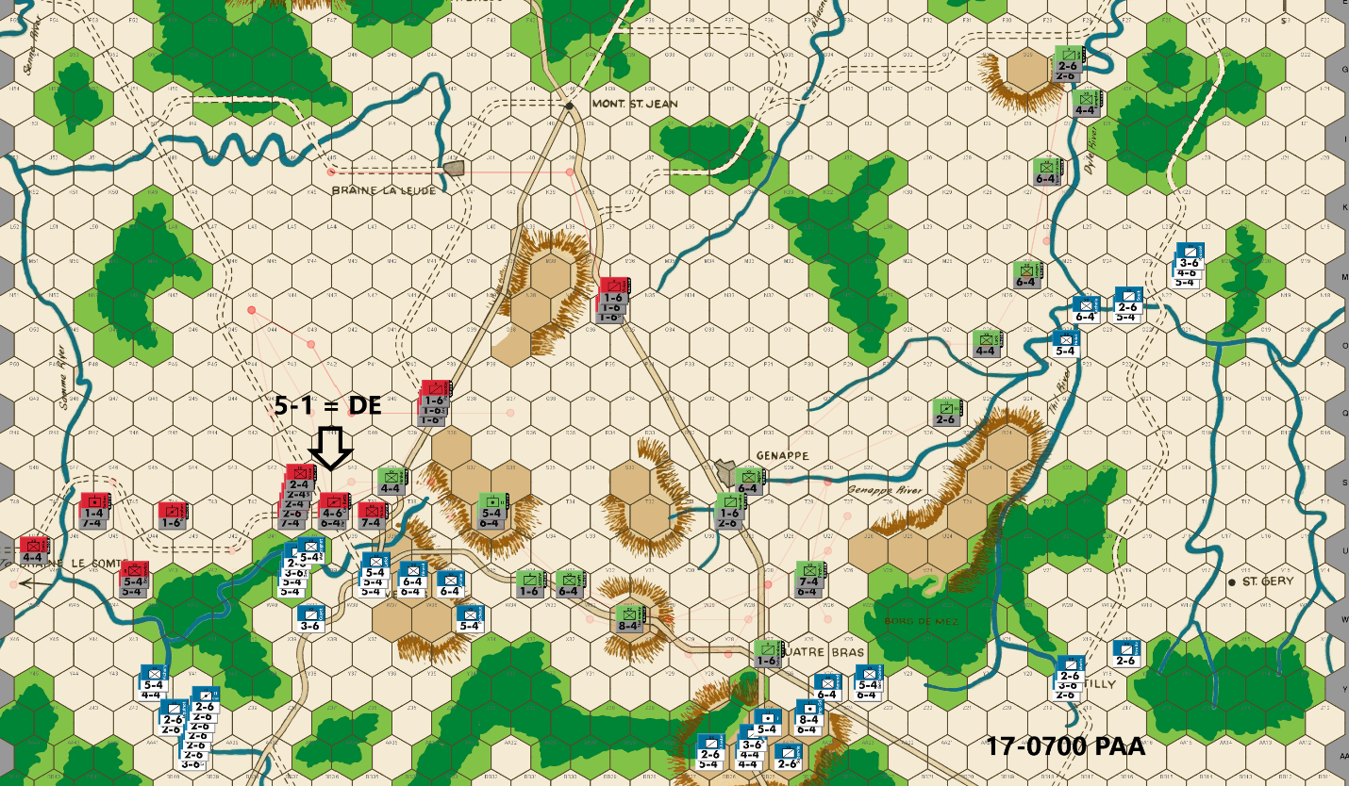
Ed: Bert has 28 factors within range of attacking across the Samme River against V47. He has 31 factors counting the cavalry on the road at W39 within range of attacking V44. (Sometimes players overlook units on the road to Nivelles.) And he has an infantry on the river at U40 that must be dealt with. I can attack it from double positions, so I’m not sure why he left such an appealing target for me to hit.
V44 must be protected as a French penetration here this early in the game would be a serious problem. The only good option is to double stack Chasse with Brunswick (making a pair of 5-4s) to 3-1 proof that hex. I think Clinton (7-4) is more valuable near Nivelles than protecting V47. So that leaves means Chasse (4-4) who will need to move U47 to be 3-1 proof. The French can now occupy W46 and gain the western side of the Samme River. But that is dangerous ground for them as they are subject to surround attacks with their backs to the board edge.
I want a 5-1 attack (the best I can do) against the French infantry at U40 so there is no risk of an exchange. That means leaving V41 open to French occupation. That is not desirable but less dangerous than it might look at first glance. The adjacent woods block any French support on their shoulders if they want to advance. And they are fairly easy to contain.
My attack on the French infantry at U40 is a success as I get the DE. I double stack infantry at T36 to deter a low odds attack and have more units for potential counterattack.
Bert has some options in this sector next turn. He can advance on the western Samme River. He can occupy V41 and/or attack any of my defenders at T39 to T41. Given the recent turns, I anticipate an aggressive response. He has taken a couple of hits in this sector, but he still has a very large force. And this is the best I could come up with.
At Quatre Bras, I use the typical blocker and 3-1 proof infantry. I have several infantry choices – a 6-4, a 7-4, or a double stack. I don’t want to give him a 2-1 possibility and decide on a 6-4 and 7-4. Of course, that leaves open the possibility of the Imp Gd FA taking a 1-2.
Bert deals me another surprise in the Tilly Corridor by switching his attack northward with a 3-1 on my doubled cavalry unit. Although I would not have switched directions with the Tilly force, it is hard to argue with his success as the result is DE. Drat. At this point, I don’t know if the French are serious about continuing north or simply were looking to create Allied casualties. In any case, a pair of 6-4s 3-1 proof the Dyle River while a pair of 2-6s and a 4-4 move north to await any French advance.
Joe: In the West (Nivelles and the Braine le Comte Road): I confess that I was a bit skeptical about several key aspects of last turn's Allied moves on this front (e.g. especially those of Alten, Perponcher, Chasse and Henkel) and, although the French have suffered a minor reversal at U40, and things seem to have temporarily stabilized along most of the Samme-Nivelles front, I still see several potential problems for the PAA going forward. First, the one hex fallback of Cooke, although prudent, now leaves the river hex at W46 undefended; this is not a game changer, but it does give the French player the opportunity to lengthen the front by sending a relatively small (twelve to fifteen factors) mixed infantry/cavalry detachment north to threaten nuisance raids along the west bank of the Samme River, if it is not blocked. Second, any unsupported Allied unit at U42 that is smaller than a 6-4 is now vulnerable to a 3-1 attack, unlikely as such an attack might actually be. Third, any unit at T39 smaller than Steinmetz (an 8-4) is now also vulnerable to a 3-1 (soak-offs, or not). Fourth, and by far the most worrisome, the hillock at T36 will be vulnerable to a 3-1 -- unless defended by Steinmetz -- as early as the 1100 game turn. Fifth, the Prussian units that are currently propping up the Allied defense at T36, and along the Nivelles-Quatre Bras primary road, will soon -- because of the steady offensive progress of the French center -- have to withdraw east to take up the defense of the western Genappe line. And finally, because of French progress on the Nivelles front, and in the center, it looks like Napoleon will likely gain full control of the Nivelles-Quatre Bras primary road, at least one, and maybe two turns earlier than usual.
In the Center: The situation in and around Quatre Bras is deteriorating rapidly and, had the Tilly French not switched their focus back to a push against the eastern Genappe and points north, might already be in crisis. The only real good news on this front is that the area around Quatre Bras can still be effectively screened with a single sacrifice/delay unit, but that will change next turn. Unfortunately, that -- at least in my view -- is not the most concerning problem on this front, as it turns out that, because of Blucher's heavy commitment of Prussian units to the defense of the west, literally none of the small number of remaining Prussian "heavies" that were not sent west, have actually been moved to S27 and S28 in anticipation of the coming battle along the Genappe River line. In short, Jagow at S30, and IIIrd Corps Horse Arty at Q26, although helpful, are simply not going to be enough. That said, I would have definitely made a few changes to this move: going from west to east, I would have sent all of the same units west, except for one 6-4, and I would also have taken a chance on a French low-odds attack by posting only a single 3-1 proof blocker, instead of two, at V27. The few units that were left would have been moved onto the Genappe River. In any case, the present situation will have to be corrected, and soon, as viable single hex delay positions are on the verge of disappearing in the center.
In the East (the Tilly Corridor): Although it’s hard to tell from turn to turn with this particular French player, it looks like his attention is currently fixed on the northern Dyle and Wavre river crossings; on the other hand, given what has already transpired in this sector: who knows? For the time being, at least, the Dyle River line seems relatively secure, and I personally wouldn't change a thing on this front. Moreover, when it comes to current and future PAA defensive dispositions along the Dyle, the Allies enjoy another advantage besides the "force-multiplier effect" of the river line: in the far north, there is a large copse of woods just south of Wavre and east of the Dyle River that -- because of its associated movement penalties -- makes things a lot easier for the Prussian units defending along this stretch of the river. Regrettably, the current stalemate on this front is probably only temporary: once the French Tilly contingent receives its cavalry reinforcements, then these defenders will probably need cavalry reinforcements of their own. And as a final note of interest, the eastern French contingent currently numbers only thirty factors (which is insufficient for a 3-1 against a doubled 6-4); however, the four French cavalry units that are now galloping north to join their Tilly comrades-in-arms will dramatically change that calculus. Hopefully, if and when that fight happens, it will occur on the Dyle, and not on the La Lasne River.

17-0900 French
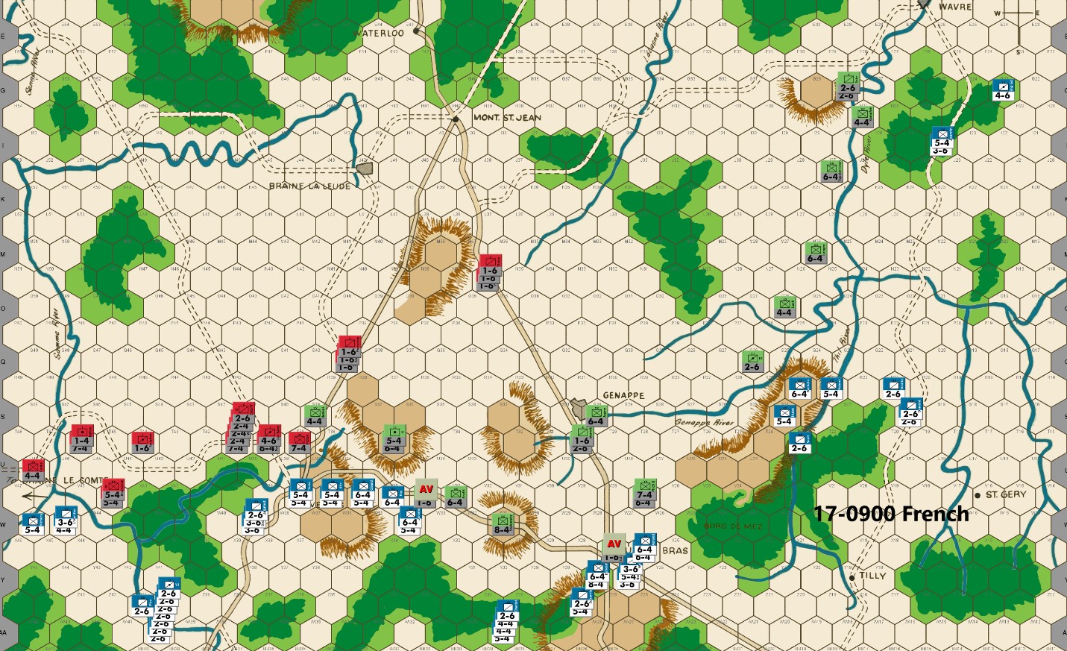
Bert: Ed finally conducted an attack! Naturally, it was one which did not require a soak off nor did it risk an exchange. In hindsight, my move to allow that attack was a mistake by me. Somehow, I miscounted the units and thought that he was going to have to include a 1-factor unit in the attack or he would have to put a unit in U39 to prevent a counterattack. I think I had anticipated one of the Anglo-Allied 2-factor units being used to screen V34, but that was easily handled by a Prussian unit instead. The plan was for me to follow up his attack with an attack of my own vs the 1-factor unit and a soak off. The idea being to continue to try and maximize attrition for the PAA side as he would have been forced to attack again, costing more soak offs to hold the river line. Anyway, the dice properly punished me for my mistake and didn’t bail me out with the 30% chance of a DR result! The only good news is that I think the Prussians are a bigger threat for most counterattacking and so every time one of those units are used as a screening unit instead of an Anglo-Allied unit, that is a tiny win for the boys in blue.
At this point, I’m going to remain patient with the attack to break through the river and T36 hilltop defense line. I expect to get sacrifice units to feed on and focus on getting the main sector forces to sync up. With Ed’s defense spread out across much of the board, I’m hoping it will be difficult for Ed to hold the row T defense along with the Genappe River line.
Speaking of that river line, my swinging of my forces back and forth in the Tilly corridor is probably making some dizzy! I’ve shifted a heavy chunk of my force that attacked northward last turn to swing back across the Thil River. If my calculations are correct, I should be able to breach the eastern portion of the Genappe River next turn as the III Horse Artillery unit is the only unit that Ed can defend with at Q26. An early breach of that river line is usually a good outcome for the French player.
I haven’t given up on forcing Ed to defend all the way to Wavre as 12 factors are still heading that way. That’s enough to get a 3-1 attack vs a lone 2-6 defender behind a river. I’ve dispatched three additional cavalry units to do any of these possible missions:
• Head to Wavre
• Added to the Genappe River attack force
• Force the defense to still cover the the southern portion of the Dyle River
• Get recalled back to the main front
I really don’t know what their orders will be since it continues to depend on how the PAA commander sets his defensive positions. I just like having my cavalry using their movement factors to spread things out instead of just sitting behind my heavy infantry as they plod forward, often a hex row at a time.
One interesting positioning choice I made this turn was to put some units at AA29. Their purpose is to make hex Y31 less than an optimal defensive hex for the PAA next turn. That hex is often filled with a 6-factor unit on this coming turn, to combine with Steinmetz holding W31. Typically, Y31 would only be able to be attacked from Y30 and the French can’t get a 3-1 attack against it. My placement at AA29 makes a 3-1 or more attack possible and so it hopefully breaks that defensive position and forces Ed to employ plan B (whatever that is) instead.
Finally, now that his 0700 reinforcements have arrived, Ed allowed me to breach the river near Braine le Comte. Keeping with my overall strategy of spreading out the PAA as much as possible, I’m committing forces to try and traverse the river over the next couple of turns. I doubt that Ed will worry enough to launch a counterattack there, but if he does, it will likely cost him a soak off unit, which is fine by me. Ideally, he will once again need to have some of his units tied up to deal with my forces making that incursion.
Joe: In the West (Nivelles and the Braine le Comte Road): Starting with a look at the situation in the far west, the Allied voluntary abandonment of hex V47, has allowed the French to establish a narrow bridgehead across the Samme River at W46. This is a feeble threat, at best. However, while it is unlikely that the local French commander will be foolish enough to make a major effort in this area -- notwithstanding the eighteen factors of cavalry positioned one move away at AA40 and Z41 -- it is also unlikely that he will fail, at least for the time being, to maintain some version of this threat in order to draw a few more Allied units than usual toward this position, and away from the center. To that end, I have one "nit" to pick with this French move, I think that it would have been better to have posted the 4-4 and 3-6 along with Vichery in W46; this move is a bit more threatening (even if it is mainly bluster) and might succeed in drawing a more serious response from the PAA commander than the 5-4 would, by itself. Interestingly enough, the French player has also seen fit to deploy eight factors of cavalry at W39, a position from which these units can actually strike as far west as V44. This means that, at a time in the game when the far west should be getting steadily less relevant to the planning of both players, the Allies still find themselves under pressure from their foe. Briefly looking farther east to the area around Nivelles, we see that the main body of the Left Wing of L'Armee du Nord has continued its methodical push east along the Nivelles-Quatre Bras Road and has picked-off a single PAA delay unit in the process. Of more interest, however, is the situation pretty much in the middle of the Nivelles battle space. There, a 3-1 counterattack (with two soak-offs) against Cav. Batts in T38 has -- because of the earlier Allied assault against Marcognet now become possible, but the French player (wisely, I think) declines this uneven contest, as he also does with the same type of 3-1 attack versus Picton at T39. In point of fact, the risk of a protracted (and crippling) attrition battle is far too great in both of these instances. A far better (and safer) target -- with no river at an advancing attacker's back -- is the increasingly exposed hillock at T36. Quite understandably, the PAA commander is also aware of both the increasing vulnerability of this position, and of the obvious tactical advantage its uncomplicated terrain offers to an attacker, and responds accordingly; to whit: he garrisons the hillock with two Prussian units (for a total of eleven combat factors, doubled) in hopes of retaining his hold on the position (if only temporarily), even if one of the two defenders is either retreated or eliminated by combat. In theory, this Allied defensive ploy (or something similar) should be enough to dissuade the French player from attacking for at least another couple of turns. Nevertheless, once advancing elements from the French Left Wing finally meet-up with units from the French Center signifying that the Nivelles- Quatre Bras Road is completely in French hands (probably on or about the 1300 game turn), then the likelihood of an attack against the PAA defenders at either T36 or T32 -- regardless of the PAA player's actions -- will increase exponentially.
In the Center (Quatre Bras): Action in the center follows a now familiar pattern: the French push north across the Heights, and through the Quatre Bras Gap until they encounter an Allied delay unit, which they promptly eliminate. The only thing that makes this particular French move a little different from previous moves is that, in this case, a lone stack separates from the main body and detours into an out-of-the-way AA29. The reason for this move -- although I strongly suspect that it won't be necessary in this particular game -- is to set up an attack against Y31, should the Allied player attempt to establish a block in the center, with Steinmetz at W31, and a 6-4 or 7-4 at Y31. Disappointingly for the French player, however, is the fact that the PAA player could well have a completely different blocking move up his sleeve. It turns out that, because the French stacks at Y27 and Z27 total only twenty-one factors (and cannot be reinforced once they move into Y28 and X28), and assuming also that the Allied player is willing to risk a basic 2-1 from the Imp. Gd. Foot Arty, Duhesme and Subervie against his only 8-4, then he can block French western movement off the Heights -- at least for a turn -- by posting a 3-1 proof Steinmetz at X29. [I should note, at this point, that the fact that these two French stacks totaled precisely twenty-one factors, and that the Imp. Gd. Foot Arty was present -- a unit, let's face it, that was born to exchange against Steinmetz -- set my "Spidey Sense" to tingling about this situation: I couldn't help but wonder if this wasn't a devious French gambit to lure Steinmetz into the open where he could be attacked at 2-1; but, in any case, more on that later.] Finally, in terms of changes, I think Berthezene is wasted at Y26 (the two 3-6s on that hex are adequate in this situation) and would have been better placed at Z27.
In the East: The record of the French expedition into the Tilly Corridor has, thus far, been a saga of successful gambles, punctuated by unexpected plot twists. And, as we probably should expect by now, the current French move stubbornly sticks to that story line. Which is to say: This French commander -- clearly the most audacious and luckiest of Napoleon's subordinates -- who began his Tilly campaign by aggressively driving north into the Corridor in spite of being numerically outnumbered by the Prussians to his front, yet who did not hesitate or waver: instead, just when it looked like the road to Wavre was his ultimate goal, he chose to suddenly wheel the majority of his units west to attack and successfully break the Prussian defense of the Thil River, without losses; and then, after a victory that miraculously cleared a path along which he could have moved to reunite his small force with the French center, he suddenly pivoted and marched north yet again; this time to attack and break the Allied defense of the eastern Genappe, again without any losses. In view of this prologue, it is probably no surprise that this French commander's latest move has turned out to be both unorthodox and unexpected; and because he is no stranger to risk, and has been tempted -- at various times in this campaign -- to move both to the west and to the north, he decides to split his small force into two unequally-sized detachments, and to then do both. The larger contingent -- composed of a mix of infantry and cavalry (totaling eighteen factors, exactly enough to attack a single Prussian 6-4 in the open) -- pushes west towards the French units now debouching out of the Quatre Bras Gap; the smaller group -- also a mix of infantry and cavalry (totaling twelve factors, exactly enough to attack an exposed 4-4, or a doubled 2-6) -- races north towards Wavre and its nearby Dyle River bridges. Finally, there is the matter of the cavalry units dispatched from the center, just last turn, and obviously intending to join-up with one or both of the two now separate Tilly contingents at some point in the future. As things currently stand, the ultimate mission of these cavalry reinforcements -- originally four units, but now paired back to three, and presently positioned at S20 and R21 -- is not yet clear, but a reasonable assumption is that they are probably intended to aid the small French contingent attempting to raid the Dyle crossings around Wavre. And speaking of Wavre, I personally believe that Jeannin and Roussel would have been better positioned one hex back at J24, and that the Imp. Gd. Hrs. Arty should have stopped in J23. These units, when operating by themselves, are both relatively weak and extremely "brittle" when it comes their performance on the battlefield: the previous combat results in this sector notwithstanding, a single exchange -- assuming that there are no additional units to absorb losses -- would severely reduce the usefulness of this contingent when operating as an independent force; moreover, deploying these units to their alternate hexes would allow the cavalry reinforcements to close up -- if that is the French player's intention -- to within one bound of these units' new positions; and last ,but not least, by positioning in these alternate hexes, all three of these units would be able to reach all of the Dyle River hexes from J26 to N24.

17-0900 PAA
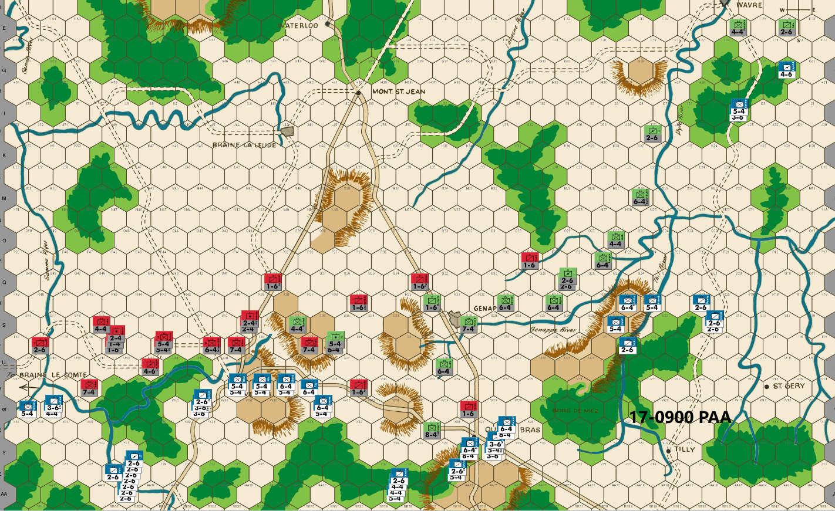
Ed: In the west, I am no longer that concerned about holding the western side of the Samme River. Any French there will be vulnerable to surround attacks because of the board edge. Estorf moves so as to block the 5-4 infantry perched on the river. I don’t think Bert will want to risk a 2-1 attack as AB is AE and an exchange is favorable to the Allied cause. I anticipate he will cross the river, however, to lengthen the Allied defensive perimeter. Clinton 3-1 proofs V44 while other units move east toward Nivelles where the real action will start soon.
The French can get a 3-1 vs T39, but it will cost them soak offs and potentially a doubled exchange. It is also into the teeth of the Anglo-Allies strength. I don’t think Bert will risk it. Picton 3-1 proofs the very valuable T36 hex.
On the central front, Bert only has 7 factors at Z27. That means Steinmetz at X29 is 3-1 proof and blocks a westward move. Bert can take a low odds attack but any Y28 will be eliminated if it is an attacker retreat. I doubt Bert will want to take the risk. This allows me to 3-1 proof the rest of the central front with a blocker at W28.
Bert surprises me – nothing new here – by splitting his eastern forces. Some reverse march to aid in the Genappe River advance while three units head north to keep my Prussians busy. In the Tilly Corridor, I block the small French contingent with 3-1 proof positions. I give up on trying to guess his intentions and will simply deal with what I see.
Joe: In the West (Nivelles and the Braine le Comte Road): On the whole, I am generally impressed with the overall PAA move on this front: it is generally robust, flexible and well-balanced. I like the fact, for instance, that the French nuisance raid against W46 has been economically blocked by Estroff at T47, and that Clinton's detour to V45, eliminates the possibility (slim as it was) of a 3-1 versus this hex. I do have one "nit" about this move, however: I personally think -- granted, this comes out of an abundance of caution -- that it would have been prudent to leave one of the two 5-4s at T46, just in case. Looking farther east, the rest of the Allied line looks quite solid, and also looks both awkward and expensive for the French to attack. T39 remains vulnerable but is, nonetheless, about as strong as can reasonably be expected with a single 7-4 defending it. And looking a little farther to the east, the "problem" hex, T36, is happily 3-1 proof -- at least for this turn -- so opportunities for French mischief against this position have been temporarily stifled. Of course, positioning Steinmetz (who was within range) would have been a lot more economical, but that change would also have required the expenditure of three, rather than two sacrifice/delay units this turn, so there is that. [On the subject of Steinmetz: I admit that positioning this powerful unit at X29 garnered a 9 out of 10 on the "cuteness" scale (I know because I've done it myself); however, I also worry that this move is a 5 out of 10 on the "danger" scale and, considering this French player's willingness to risk a lot more to accomplish less (e.g., the Thil River attack), this move seems risky, in the extreme.]
In the Center: In view of the fact that Prussian units totaling twenty-three combat factors are presently shoring up the Anglo-Allies in the west and preserving a 1-6 delay unit by blocking in the center, this move accomplishes about as much as could reasonably be expected. Needless to say, the Genappe line will come under serious pressure on the 1100 game turn, and those twenty-three Prussian combat factors are soon going to be desperately needed on the Prussian side of the Nivelles-Genappe line, but, for time being, the Prussian center is holding without them.
In the East: Being, by nature, a "worry wort," I confess that, at present, I am considerably more concerned about this front than I am about the west or center. While I may be wrong, I don't think that I would have chosen this momment to shift Langen and Luck west towards the Genappe line. On the contrary, I personally think that it would probably have been a bit more prudent to have left Langen at O26, Tippelskirchen at M26, and Luck at J27, at least until the French player's plans for his three fast approaching cavalry units have been revealed. The other major "nit" that I have concerns the Prussian block at E24: because of the possibility of Roussel switching east to reinforce the Imp. Gd. Hrs. Arty, I would definitely have positioned both Sohr and the II Corps Hrs. Arty at E24. Granted, a French 3-1 against Sohr is an attack that I probably wouldn't make -- especially with reinforcements on the way -- but, then again, this is the very same French commander who did not flinch at the thought of exchanging a 5-4 for an Allied 2-6 earlier in this game.

17-1100 French
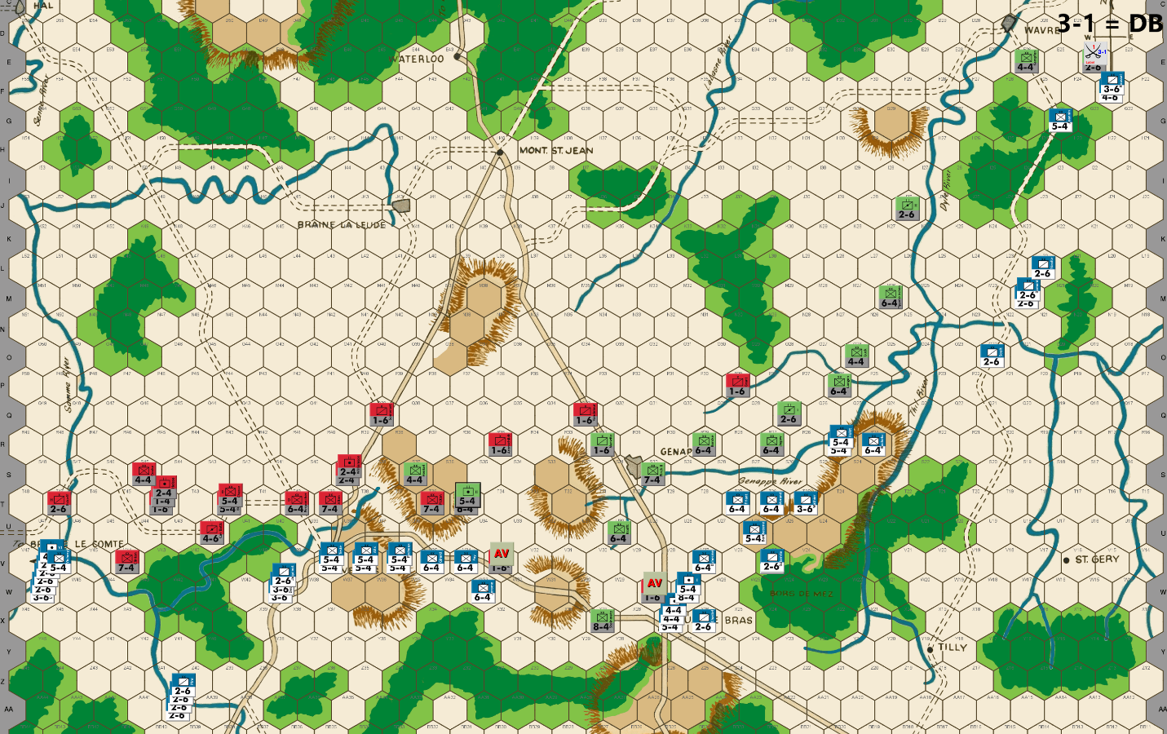
Bert: As we approach the middle of day 2 of this campaign and I assess the board position, I have to be pleased. My strategy was to stretch out the PAA across the board and the French army is literally conducting operations from the far western edge of the board, where a contingent of forces have breached the Samme River to the far eastern edge of the board, where some wayward troops (they were supposed to be just a feint!) are conducting an attack near Wavre. In the center, I am breaching the eastern portion of the Genappe River (whether or not this succeeds will depend on Ed’s appetite to counterattack) and I’m about to push the PAA back to the row T defense line. My center forces should be hooking up with one another by next turn.
Despite that long French line, Ed was able to adeptly position his units to expose only two units to AV attacks this turn. I’ll settle for them along with my 3-1 attack near Wavre. Regarding that attack, since I love to attrit the PAA units and because my army has minimal losses to date, I am OK with risking an exchange of a valuable 3-6 piece for one of his Prussian 2-6s. This is especially worth it, in my opinion, where Ed’s position is strung out so much that losing a piece will make his defensive position even more precarious. Of course, there is also the 40% chance that the dice will deliver me a clean D Elim result on that attack.
I’ve dispatched some more cavalry to the direction of Wavre. As usual, their mobility could allow me to redirect them as needed. As the French player, I like to have my mobile pieces on the move to project my forces in a threatening manner as opposed to just sitting stacked behind the heavies, waiting to be deployed one at a time as sacrificial soak offs.
I have two interesting points that I want to share that I considered for this move. First, my stack of units that started this turn in the woods at AA29. I was going to move some of those units northward through the woods, mainly to continue to threaten W31 as a viable defensive position. Since my Nivelles forces are closing in on that hill from the west, I realized that I’d have more flexibility to have those units threaten the W31 area and the Genappe River if I marched them around the woods to Quatre Bras instead. ‘Hexes matter’ is one of my mantras when playing the AH classic games and this was a case of that in action. Those units look much more useful to me by being on the road junction so that they can aid whichever direction I need them to on the next turn instead of them being slogging through the woods at Z30.
The second point is how I deployed my units to attempt to breach the eastern portion of the Genappe River. I decided it was best to have two units on the river line instead of just one since, if they both survive Ed’s turn, they will give me the option to have one unit soak off while the other unit can break a potentially doubled river defensive position, should that opportunity arise. Of course, it is not wise to be using a heavy infantry unit to soak off on a regular basis, but having ‘the option’, is better than not having it. In addition, I pondered where to position the adjacent 6-4 infantry unit. Since Ed could counterattack my units on the river from three hexes, the 6-4 unit could only force one of those hexes to cost him a soak off. Since I stacked two defenders in the same hex, any 3-1 or greater attack would require a soak off against the other defender, but it would also force Ed to attack from at least two of the three hexes adjacent to my stack. By putting my 6-4 at R24 instead of S25, I am making sure that Ed can’t use Marwitz to soak against both the extra 5-4 and the 6-4 in the same attack. Of course, Ed could just attack from Q26 and R26, but that brings whatever units end up stacked at R26, closer to a significant number of my units. Finally, just in case, my 6-4 (Bachelu) could easily move to N24 on my next turn and add to my Tilly/Wavre contingent of units. I expect Ed to fall back and not counterattack me there, but I can’t be sure of that of course.
Finally, today is the first day that I got to read the latest of Joe’s awesome commentary on our game. I want to note that I didn’t intentionally become passive on the 16-1500 turn. I did what most of us do – I made a mistake or had a blind eye to the situation in front of me! Frankly, I didn’t see the opportunity for the 3-1 attack versus Picton on that turn. Joe is absolutely correct that missing the opportunity of a 70% chance to take out one of the key pieces was a big mistake by me, especially with me looking to cause the PAA side attrition every chance that I get. It would have been well worth the two soak-off units. So, while I hope that everyone reading this is taking something away from our endeavor that will improve their play and enjoyment of this classic; I can assure you that as a participant in the game, I too am learning. I hope to not miss an opportunity like that again!

Joe: Well, it looks like we're finally getting to "crunch" time on the Nivelles-Genappe Line. That said, this next turn should finally see the French take complete control of the east-west primary road; and after that -- given Bert's avowed distaste for doubled exchanges -- we could either see a continuation of the current methodical grind forward, or, alternatively, we could also see a sudden switch to "Katy bar the door" time!
THE FRENCH:
In the West (Nivelles and the Braine le Comte Road): In spite of the fact that the Left Wing of L'Armee du Nord has -- thus far, at least -- suffered literally all of the combat losses sustained by the French Army (fourteen factors at this point in the game), it has, nonetheless, continued to push forward relentlessly against the PAA right, while also applying offensive pressure against the entire length of the enemy line from the Braine le Comte Road to the T36 hillock east of Nivelles. This French force has succeeded thus far, because it has continually probed for weaknesses in the Allied position, and when a weakness has been found, it has quickly been exploited. Moreover, the positive fruits of this French strategy can already be seen in its opportunistic expansion of the Samme River bridgehead at W46 into V46; in the credible offensive threats radiated by the French cavalry stacks at W46, AA40 and W39; and even in the seemingly unstoppable hex-by-hex eastward march of the Left Wing's infantry along the Nivelle-Quatre Bras Road, at a time when the threat of an Allied attack should be increasingly plausible. All of these elements yield strategic benefits that, when taken together, a) limit Allied movement options, b) pin PAA units in place, and c) hamstring the ability of the Allied player to act offensively. And it is these outcomes, not the odd battlefield success that -- in my view, at least -- actually contribute to a player's operational mastery in the long term! Now, having said all that, the actual point of this brief rant is to emphasize two basic truths underpinning French operations in the west: the first is that, if the initial contingent dispatched to fight on this front is large enough (both numerically and in combat power), then local combat losses -- assuming that they are not truly excessive -- should not significantly degrade the offensive power of the surviving units assigned to this battle space; the second is that ongoing offensive operations by the French in this sector, should rarely depend on low-odds gambles, or on daring maneuvers or gambits as a necessary prerequisite for their overall success. In this particular game, for example, the French commander has only resorted to a couple of carefully considered positional gambles and, not surprisingly, has been treated to both favorable and unfavorable outcomes as a result; on the other hand, the one and only French low-odds attack that was attempted on this front, failed spectacularly. All this, by the way, is not to suggest that the French player should never take chances, but only that his risk taking should be both sparing and carefully thought out. Remember, while there is nothing wrong with a player being prudent; it is also that being a player who consistently eschews risk-taking is predictable, and predictability is exploitable. Now looking ahead to next turn, I expect that the key question for the French player will be whether to attack the units at T36 (T39 is out of the question because of the stacked 7-4s and also because of the soak-offs required), or whether he will wait another turn. If he attacks next turn (which is a weak maybe, in my opinion), then it is unlikely that he will try for any combination of attacks (1-1 or 1-2/3-1) that might yield an advance: this is because, to safely advance, he needs to be able to strongly occupy both T35 and T36 orT37 and T36 at the end of combat, otherwise either his flank units or his advanced units would be vulnerable to a surrounded counterattack. That said, waiting another turn might be the better move, if only because T32 (if not occupied by Steinmetz) might open up to a 3-1 attack. In any case, we'll know soon enough. Last but not least, I have only one minor "nit" to pick, when it comes to this French move: I think that the effectiveness of the cavalry threat would be modestly increased if the two 3-6s at VV39 were swapped for two of the 2-6s at AA40. Other than that single tweak, I wouldn't change a thing.
In the Center: The general outlines of this turn's French operations in the center are -- except for one glaring surprise -- pretty much "textbook" WATERLOO play. For starters, the Allied sacrifice/delay unit at W28 is eliminated, while those French units that are able, close up to the Allied defensive line farther north. South of the Heights, the French stack at AA29 -- suddenly finding itself without a job -- counter-marches east to regain the north-south Gosselies-Quatre Bras primary road, and then continues north to rejoin other friendly units in-and-around the now French-occupied town of Quatre Bras. On the eastern side of this battle space, the contingent recently detached from the Tilly expedition -- begins a push against an undefended section of the Genappe River -- by establishing a bridgehead at R25 with two 5-4 infantry units. Now, putting all that aside, its time to discuss something completely different: the one player decision that was truly surprising about this French move -- the thing that left me initially gobsmacked -- and it was not, interestingly enough, something that the French commander did, but rather, it was something that he did not do. In a nutshell, the same French player who previously had not flinched at the thought of attacking a doubled Prussian 6-4 at 2-1, suddenly seems to have become uncharacteristically cautious and risk-averse; and even though he controlled several stacks of French units that all began their move in a position from which they could move to attack -- at either 1-1 or 2-1 -- an exposed Steinmetz at X29, he studiously declined the opportunity, and instead moved the potential attackers away, completely bypassing the Prussian 8-4's position. So, if I have any serious "nits" to pick with this move, this is it. Not only did the French player have enough units in position to safely make a reasonable low-odds attack, but they were also even the "right" units with which to do so, as one of them was the French 8-4. And surely, if the Imp. Gd. Foot Arty actually has a divinely-ordained purpose in this game, it has to be as the trade in an equal factor exchange against a basic strength Steinmetz. Admittedly, an A Elim on a 1-1 or 2-1 attack (at a cost of either eight or sixteen factors) would have been painful; however, neither adverse outcome would have been fatal; and for that reason, I think that some type of low-odds attack should have been made. [A quick note on player psychology: On the one hand, this sudden Gallic restraint has to be a relief to the Allied commander; on the other hand, since it is unlikely that this particular adversary has suddenly become timid, it suggests something else: that this French player may have decided that he has now accrued enough of a strategic advantage that he can afford to dial back his risk-taking, at least for the time being. And even when a player disagrees with his opponent;s assessment of the game, it is nevertheless useful -- at least in my opinion -- to have a sense as to just how his opponent views his situation as the game progresses.] Finally, there is only one other change that I would have been tempted to make (and that only if Steinmetz had not been attacked) which would have been to post the Imp. Gd. Foot Arty, along with a single 2-6, at Z27; and that's only because I dislike surprises.
In the East (the Tilly Corridor and the Road to Wavre): The situation in the east just gets better and better for the French. Granted, the recent 3-1 attack versus Sohr only yielded a DB2, but the PAA defense of Wavre and the Dyle River Bridges is problematic because the Allies have a "numbers" problem: the PAA only have two units (for a total of six factors) presently in the Wavre battle area, and have only one unit, the 2-6 at J27, that would be able to reach the Wavre area in a single move; this should help shore up this position for one more turn, but after that, this sector will probably to be abandoned in order to conserve units. Moreover, help is probably not on the way as any additional Allied reinforcements would require three or more turns to reach their brethren already present on the eastern Dyle. In the case of the French, they start out with both a numerical edge, and an advantage in combat power (three units totaling twelve factors); but wait, it gets better: four 2-6 cavalry are only two moves away from the Wavre front, and when they arrive, the Allied defense will be swamped. Moreover, with a force of seven units, now totaling twenty factors, these eastern French units will now be able to attack a basic 4-4 or a doubled 2-6 at 5-1, and an exposed 6-4 at 3-1. What happens after the Dyle is breached will really depend on how successful the PAA commander is in extricating his surviving units: one goal of the Allied player will definitely be to try to get a unit across the eastern La Lasne River and into A34, one way or another; however, because of the combat power and mobility of the French contingent on the Wavre front, the PAA commander will also have to worry about the possibility of a French pivot away from the La Lasne River and the narrow forest gap at Rosieres, and towards a battle in the west, with the ultimate goal of either making a dash for the La Lasne River ford at H34 or, alternatively, of chasing up whatever is still remaining of the Allied Dyle defense line.

17-1100 PAA
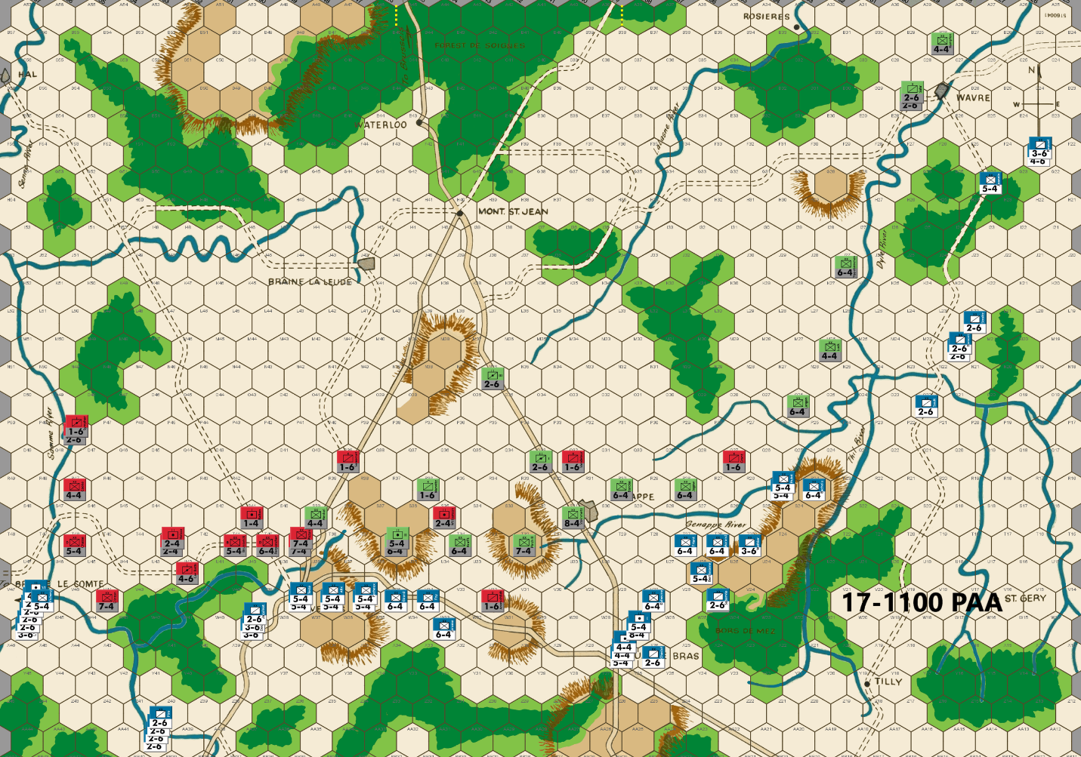
Ed: In the west as I mentioned previously, the French are vulnerable if they do advance on the western side of the Samme River. I defend along the eastern side of the river. I station two cavalry units astride the river able to undouble the defense of the leading edge of any such advance. Cooke (4-4) defends at R47. Cav Batts (4-6) is at U42, where he can join in on an attack across the Samme River if needed. If the units were reversed, Cooke would not be within range.
At Nivelles, I place two 7-4s at T39 to prevent any advance after combat barring a low odds attack success. I stationed double infantry at T36 for the same reason. Unfortunately, I don’t have a pair of 6-4s, so one is a 5-4. Bert can 3-1 the 5-4 from two hexes and soak off from T37 so I don’t have a surround counterattack. He could also attack from three hexes at 4-1 with a soak off. That would give me a surround attack on his units at T37. I don’t think he will want to do that. And lastly, he could attack at 1-2 and a 3-1 attempting to advance into the hex after combat. This last attack if successful would be damaging and very well be Bert’s choice. But this is the best I can muster and will simply have to await the French choice.
In the center, I use a blocker and otherwise defend behind the Genappe River. I don’t expect an attack here on my doubled defenders.
In the northeast, I made a blunder on the last turn allowing the 3-1 attack on Sohr near Wavre. I have no idea why I didn’t see that attack possibility, but I didn’t. Fortunately, the DB result saved Sohr and allowed me to defend as I had planned. I am able to 3-1 proof the river except A26 and B26. His cavalry can and likely will move onto the river at B26. With more cavalry on the way from the south, I cannot hold this river line. My 4-4 infantry will withdraw to B32 astride the LaLasne River where it is 3-1 proof before withdrawing behind the river. My two cavalries along with the infantry in the south will begin their withdrawal to the LaLasne River. This and the threat of the Prussian Fourth Corps entering the game on the 18th in the French rear should keep any French out of Brussels. Bert has surprised me enough that I won’t try to guess what he will do. I’ll try to be prepared for any action he decides on.
Joe: In the West (Nivelles and the Braine le Comte Road): The Allied player does some serious unit shuffling and manages -- thanks to a bit of help from Blucher's Prussians -- to organize a reasonably formidable defense line that stretches all the way from the Samme River to the hillock at T36. Starting in the far west, the Allied situation in this area is a little complicated, so it is probably not surprising that the PAA player decides -- with an abundance of caution -- that stringing units along the eastern bank of an exposed section of the Samme is a sensible response to the threat posed by the (twenty factor) mob of French infantry and cavalry clustered at V46 and W47; moreover, he also decides that -- given the French investment in combat power -- this precaution is probably reasonably economical in terms of units committed to this task. As a nice welcoming touch, two Allied cavalry units are positioned to straddle the river just out range of the foe's cavalry at P48; this way, if the French player actually does take leave of his senses and decides to raid north along the west bank of the Samme River, there will be a couple of PAA units already across the river that will be able to support friendly attackers by cancelling the cross-river defensive multiplier for any French units in the neighborhood. However, as exciting as the idea of a French raid towards Hal may be, the more likely development will probably be his partial or total abandonment of the bridgehead at W46 and V46; because whatever else happens, these French raiders are going to be needed elsewhere, and probably sooner, rather than later. That said, and as interesting as this far western sideshow has been so far, the real action is only a turn or two away, and that is almost certainly going to take place somewhere in the gap between the Samme and Genappe Rivers. The good news for the Allies, both in this sector and in the center, is that none of the PAA "heavies" have been eliminated: the presence of all four 7-4s and the 8-4 really make organizing a defense a lot easier during this critical phase of the game. And on while we're on the topic of the Allied defense: as I noted earlier, the most obvious and, in fact, the only realistic candidate for an early French attack is probably the two-unit Prussian stack on T36, and even this objective seems iffy as an early target. Of course, whatever else happens, the block at V32 will be eliminated next turn, and that will clear the way for the French to then add T32 and T34 to their list of potential targets, to go along with T36.
In the Center: Here the Allies get a modest breather as Blucher's line of Prussians -- stretching from S34 to R28 are all 3-1 proof. Unfortunately, the unlucky destruction of Division Stulpnagel on the Thil has exposed the eastern section of the Genappe line to French attack at least two turns earlier than usual. The sacrifice/delay unit at Q27 temporarily protects the flank of Division Jagow, but it is an absolute certainty that the French will be across the Genappe, in strength, next turn, and that will allow the French player to put O30 and P30 under the same kind of pressure as the rapidly crumbling Genappe line. In addition, Langen, Luck and Tippelskirchen are all soon going to have to abandon their positions on the Dyle River and fall back, almost certainly towards the La Lasne line. Besides the slow collapse of the Dyle and Genappe River defenses, there is one other aspect of the Prussian situation in the center that is worrisome, and that is the strong possibility that one or both of the Prussian 2-6s presently parked on the Quatre Bras- Mont. Ste. Jean Road, may have to abandon the center in order to dash east to help defend the La Lasne River against marauding French cavalry from Wavre. Such a move is not as trivial as it looks because these units typically play a crucial role (mainly as soak-offs) when it comes to any Prussian battles in the center.
In the East (Wavre and the Dyle River Bridges): What can I say? The PAA player only really has a couple of options in this sector, and neither offers more than a temporary fix. That said, the option chosen on this front is probably the best one available, as it discourages an immediate French assault since both the cavalry stack at D28 and Kampfen are safe from 3-1 attacks for one more turn. Unfortunately, next turn, Kampfen is probably going to have to retreat to B32 so that he can then move, on the following turn, through Rosieres to A34. The goal of this move is to (hopefully) close the "back door" path to the eastern Brussels Road exit hex. To accomplish this, however, will probably require the sacrifice of a 2-6 at B29 in order to prevent Kampfen from having to dodge at least one low-odds French attack before he can make his escape. Good times, if you're the French!

17-1300 French
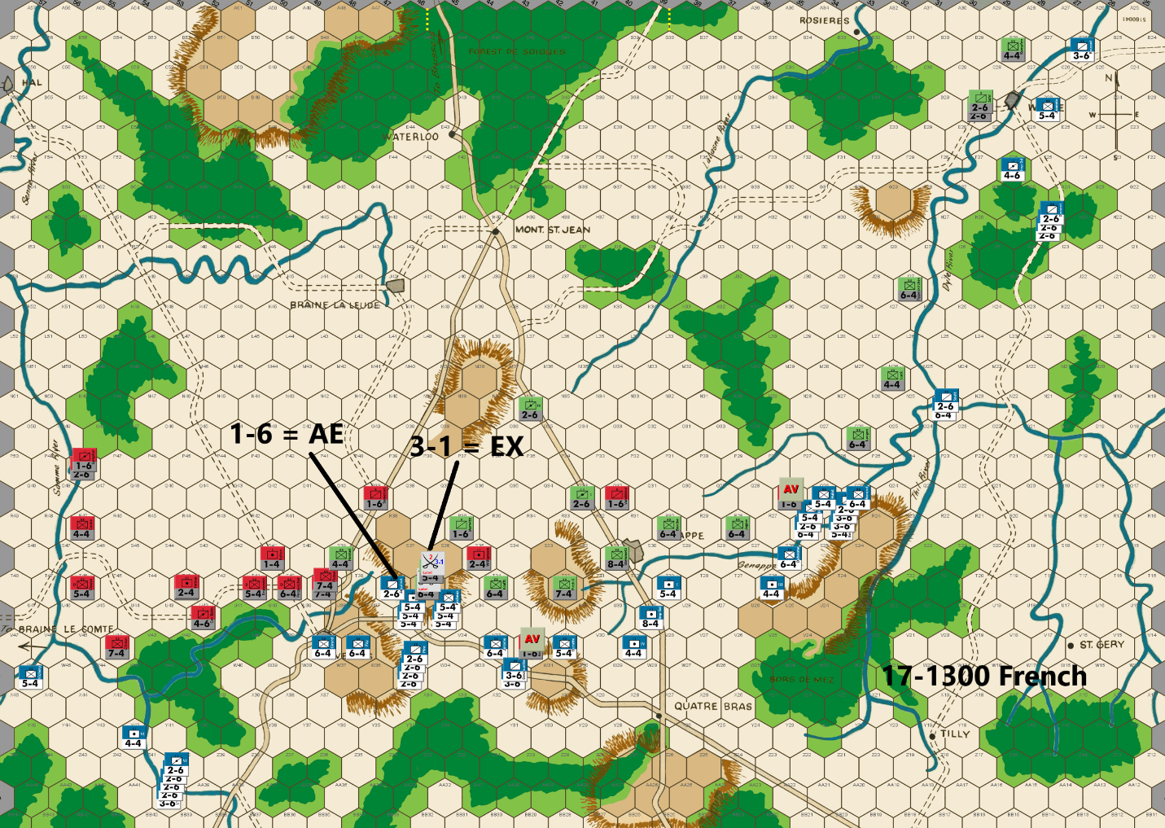
Bert: My 3-1 attack near Wavre was not rewarded with a good result, so Ed is able to have another turn of a credible defense to hold the river line. While I have a unit successfully breaching the river at B26, my additional units arriving on the scene will hopefully be enough to stretch out his defense that he can’t effectively cover the line. The clock is ticking on this foray, because the arrival of significant Prussian reinforcements to my east are a few turns away. If I haven’t cleaned up my position in this sector prior to their arrival, they might easily trap and dispose of any of my French units that survive the coming turns. I have to stay aware of this threat for the next few turns. To increase the pressure on his defense of the Dyle River, I shifted another heavy and a cavalry unit to the N24 switch hex.
In the center of the board, I have finally forced Ed to retreat back to the T row, once I eliminate his last blocking unit this turn. In theory, this has allowed the French units to sync up the Quatre Bras forces with the Nivelles forces. I say, “in theory”, because while there is indeed a minor sync up of forces, I have intentionally committed a significant part of the Quatre Bras forces to attack across and breach the eastern portion of the Genappe River. The number of units committed to here are necessary to quell any ideas of Ed trying to counterattack me as would be the case, if I didn’t put those units in that position. It will make coordination with any Nivelles units impossible for the time being. In addition to dissuading a counterattack, my units are in a position to add pressure northward if I choose to go all out to try and drive Ed back to the La Lasne River as quickly as I can. That strategic commitment can often lead to the collapse of the PAA’s center, as they will need additional units racing back to cover that last line of doubled defensive positions before the exit hexes.
I don’t have much appetite for fighting through the city and adjacent hill and river hexes of Genappe, so my approach will be a slow one from the east, as Ed is likely to continue to offer up blocking units that I’ll have to fight through. I decided to advance the 5-factor infantry unit into Q27 following the AV for multiple reasons, despite it being an easier counterattack target:
• I don’t think he can get a 5-1 attack, so an exchange result would cost him a 6-factor unit or multiple units if he does attack – I don’t think he will.
• Q28 can’t be used for a sacrificial unit on his next move.
• I block the path for him to send a unit(s) through hex P28, preventing any further shuffling between the center units and the Dyle River defense contingent unless they attack first or come through J34 or Mount St. Jean. That path will be too late to hold the line along the length of that river.
Regarding the T36 hilltop, I do have an appetite for a little fight, as the PAA position has allowed me to take a 3-1 attack without exposing any of my attacking units to a surrounded response since I don’t need any of my main attacking units to be in T37. The attack seems well worth the expected loss of my 1-6 soak off unit. Of course, I would certainly like to avoid the exchange against the doubled defender, but if that is the outcome, it’s the cost of doing business to force the action to break his defense line of doubled hexes.
It won’t be a surprise to see Ed counterattack me in attempt to keep control of the T36 hill awhile longer. My calculus is that this resulting battle favors my side since he would need to expose units on T35, T37 or both, which are undoubled positions. Plus, a counterattack will likely cost him a soak off unit. I debated putting some unit(s) in hex U37 to limit his counterattacking, but I decided it was best to leave that hex empty, since if he moves into it, his unit(s) will be surrounded on my ensuing attack. Also, I see if I put something like two 6-factor infantry units in U37, Ed can easily get 36 factors against me for a big 3-1 attack. I’m not ready to expose my units to that important of an attack.
Finally, I’ve decided that Ed’s continued deployment of strong units to protect the Braine Le Comte area is too much in his favor for me to push any forces into the risky hexes west of the Samme River. I’ll likely need those forces for the battle going on east of Nivelles. In an effort to hopefully continue to tie up some small number of Ed’s defenders, I’ve left my 5-4 unit on the river line. He can get a 4-1 attack (not surround), which would draw at least four of his heavy units away from the main battle area for an extra turn or two. That would be well worth it to the French side, especially with the risk of an Exchange or DB2 result. Continuing to breach that river line gives me a chance to send some nuisance force back that way next turn, should Ed finally withdraw some units. As I’ve done in the east, I hope to eventually send some kind of force along that river to tie up PAA units defending the Hal area, so when the battle moves to Mount St Jean, Ed is still dealing with some French units on his right.

Joe: In the West (Nivelles and the Braine le Comte Road): In view of the fact that the French bridgeheads at W46 and V46 have provoked about as much of a tactical response from the Allies as they are ever likely to, and with the opening round of a major battle about to begin near Nivelles, Napoleon orders all but one of his bridgehead units to march northwest to the sound of the guns. The Samme adventure is now essentially over; now, the real "trial by fire" for the newly-minted L'Armee du Nord is about to begin. That said, I personally think that, except for a couple of cavalry units left behind at AA40 just to keep the Samme under observation, I would have ordered everyone else to immediately start marching toward that little corner of Belgium that has only just now become the Emperor's choice for today's battlefield. [This critique doesn't actually rise to the level of a "nit," but is more of a matter of personal style.] And speaking of battlefields: Around Nivelles, there is only one question that requires an answer: Will Napoleon attack the Prussians on T36 this turn, or will he wait? Interestingly, the answer comes back sooner than expected: he attacks, but does not attempt to dislodge both defenders, choosing only to attack the 5-4, while soaking-off against the 6-4. As frontal attacks go, this is about as meticulously-planned as it gets. Unfortunately, the "Dice Gods" were not kind to the Emperor, and he loses both his 2-6 soak-off and two of his six attacking 5-4s in an exchange (a 24% chance). In my previous comments, I had raised the possibility of a hasty-assault against T36, once the Nivelles-Quatre Bras Road fell into French hands, but was halfway convinced that, even if initially successful, the timing of such an attack would be premature. [So much for my powers of prediction!] My skepticism -- putting aside the actual outcome of this specific battle -- did not pertain to the French player's choice of target, but only to his choice of timing. My worry was that, until L'Armee du Nord was able to open a path to T35 by capturing T34, any battle for the hilltop itself could well degenerate into a cardboard replay of the protracted and bloody battle for Hougomont in 1815. More to the point, since the French advance -- at least in my opinion -- was already ahead of schedule, both in the center and against the Genappe line, the risk of getting tangled-up with a potential tactical "tar baby" like T36 seemed unnecessary. Admittedly, attacking the Allied center a turn or two early would certainly apply extra pressure against a defense that was already stretched pretty thin, and any counterattack that the Allied commander could be expected to mount, would -- of necessity -- expose high value units of his own (in the open) to an inevitable French riposte. Nonetheless, while I admire the the Emperor's panache, I still think-- even if the initial combat results had all been optimal for the French player -- that this attack should have been postponed. In any case, I could always be wrong, but we will see soon enough. And last, but not least, I will finish by noting that the rest of the French player's move in this sector -- including that of most of the cavalry -- seems perfectly reasonable.
In the Center: The Emporer's advance on this part of the front is literally "firing on all cylinders!" Most of this move is really almost automatic for the French commander Needless-to-say, the two PAA sacrifice/delay units (at V32 and Q27) are dispatched without difficulty, and the majority of the Nivelles-Quatre Bras Road -- excepting only U36 -- is cleared of Allied units and their ZOCs. In addition, the Genappe line continues to be rolled up like a carpet, from east to west. Next turn, the Prussians will have to sacrifice at R28, and Hexes O29 and O30 will both start to come under threat. Farther east, the mob of French infantry and cavalry clustered on or across the Genappe River on the "R" and "Q" rows, now menace, in concert with the stack straddling the Dyle, Genappe and Thil River confluence at N24, Division Langen at O26 with a surrounded attack at 4-1 odds, if he doesn't immediately start his slow retreat north towards the shelter of the La Lasne River. On the whole, this an effective "pressurizing" effort and the only "nit" that I consider to be worth mentioning is -- what I consider to be a misuse of a powerful French unit -- the wasted placement of the Imp. Gd. Foot Arty at U28. This unit needs to move to the center where it can be used either as an advanced guard, or as a"toehold" unit against Allied doubled positions. In truth, where it should go precisely is really an open question, as several hexes will probably work. Speaking for myself, however, I think that the best choice would be W31.
In the East (the Tilly Corridor and the Road to Wavre): The Battle for Wavre is just about over; and once the Prussians retreat, and they will, the French units in that area should, at least, threaten A34. [The Allied player -- in my view -- will really have a difficult choice when it comes to this operation: If he attempts to save both Kampfen and the II Corps Hrs. Arty by retreating to B32 and A33, respectively, then he will risk either two 1-1s (using the French 4-6 and the 3-6) or a 1-2 versus both (using the 3-6 only at A32). The Allied problem, in this instance, is that, in either case, Kampfen will be surrounded. So the PAA player's dilemma is: Does he try to extricate both units, or does he sacrifice the 2-6 to guarantee Kampfen' escape?] Since the results of a French breakthrough at A33 would be so dire, it is highly unlikely that the Allied player will allow a French crossing of the La Lasne River at Rosieres, so once any Prussian survivors have slipped away from the Wavre battle area, probably the best way for the Wavre-Tilly force to continue to torment the PAA, will be for them to pry any Prussian hold-outs away from the Dyle River, and to then chase them north to the La Lasne River line. Whatever happens, this French contingent (probably about twenty-six factors once reunited and reinforced) should work to pin as many Prussian units as possible on the north bank of the La Lasne and away from the fighting in the center, especially during this critical phase of the game.

17-1300 PAA
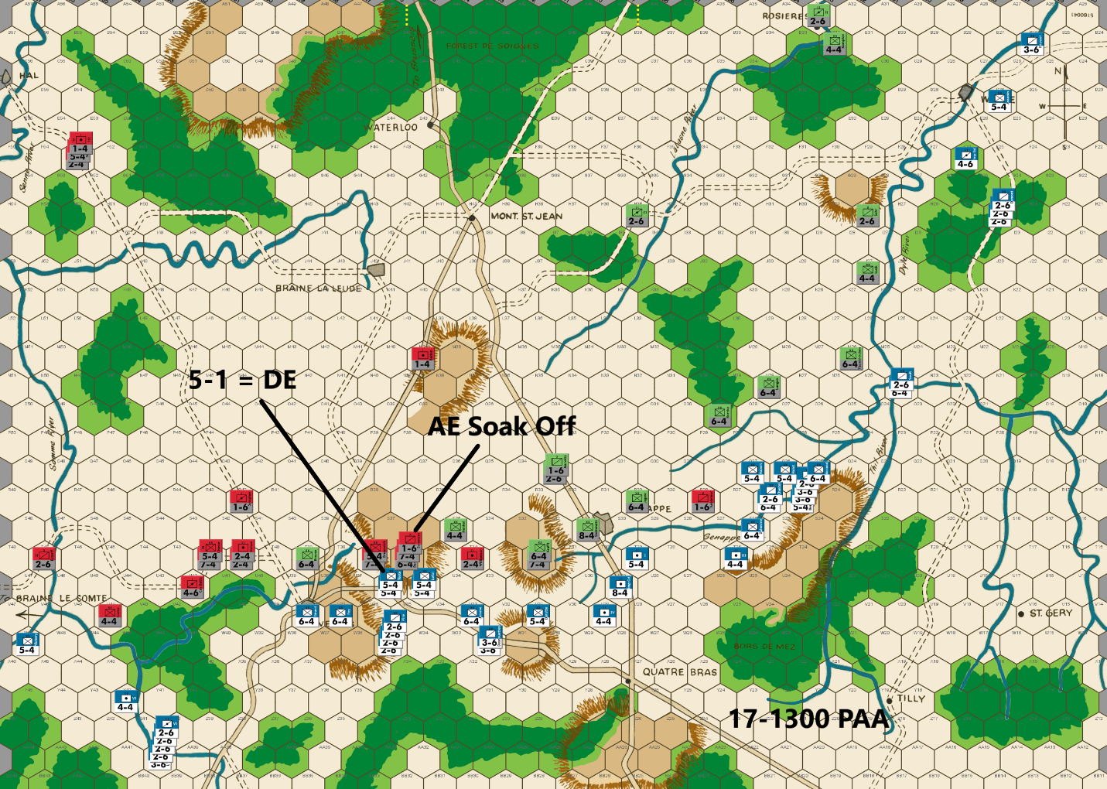
Ed: In the far west, Bert withdraws much of his strength threatening the Samme River. I respond accordingly, defending with the minimum 3-1 proof positions and moving units east toward the main battle front.
Bert attacked the T36 hilltop as I was sure he would. But there are two pieces of good news there. First, he did not try a 1-2 & 3-1 to take the hilltop as I feared he might. Second the result was an exchange against my doubled 5-4 and the loss of a soak-off unit. It is critical to hold ground, so we will counterattack. Bert has done a very good job of stretching the PAA out across the board. I can get my preferred 5-1 attack if I use every Anglo-Allied heavy within range. That is what I do and fortunately get the likely DE .
Brause is the only heavy available to defend T39. That separates him from the other Prussians, but I think that is the best option. A blocker at T34 protects against surround attacks on the two nearby hilltops. Henkel heads east to join the other Prussians. I plan to attack the French next turn to protect my defensive line, and I likely will need Henkel’s help. One worrisome thing to note is that I am running low on blocker units.
A little further to the east, I defend behind a hilltop and the Genappe River. A blocker at R28 protects the eastern flank. Last turn, I indicated I would be withdrawing from the Dyle River. I now realize that it would be a mistake. It would open up the southern branch of the Genappe River where the French could threaten my defense of the Genappe area . Fortunately, Bert did not occupy P24 which would have allowed him to undouble my defensive position. So, I 3-1 proof the river defenses, only withdrawing in the north near Wavre where the French could get a 3-1 attack. Bert can get a 1-2 vs Kampfen who will have no retreat. The Prussian II Corps HA is on the LaLasne River to defend at A34 if I lose Kampfen. And from the central front, the III Corps HA has moved north to assist in the defense of the secondary road to Brussels.
Joe: In the West (Nivelles and the Braine le Comte Road): After a day and a half of "cat and mouse," the French player suddenly decides to gamble and launches a surprise assault against the Prussian defenders on T36. Fortunately for the PAA commander, the Samme adventure in the far west has pretty much come to its predictable conclusion, so badly-needed Allied units can at last begin to shift west to meet the crisis just east of Nivelles. In terms of its outcome, Napoleon's opening attack is bloodily repulsed; however, in spite of this reversal, the Allied commander has no reason to celebrate, because to hold the hillock at T36, he knows that he will have to accept a continuing battle -- should the Emperor seek a major action -- under conditions that will be far less advantageous than those of the initial French attack. That said, the PAA player really has no choice but to counterattack; and that he does in fine form, marshaling his "favorite" 5-1 attack against a single French 5-4 at a cost of a single 1-6 soak-off. The battle lines have been drawn; events, going forward, will now rest with Napoleon and his determination to continue the fight.
In the Center: Although the PAA have been treated to at least a temporary battlefield success near Nivelles, the rest of the Allied line does not fare nearly so well. The sacrifice/delay units at both T34 and R28 are doomed, and their destruction will set the stage for future high odds French attacks across the entire central front; and this at precisely the time when the supply of PAA sacrifice/delay units is about to run out. Granted, Anglo-Allied reinforcements are at last on the march, but the road to Hal is a full five turns away from the current front. What this means is that -- no matter what happens over the next four or five game turns -- the PAA player is going to simply have to make do with the army he now has until the morning of the 18th.
In the East (the Tilly Corridor and the Road to Wavre): "Well, this is a fine mess you've gotten us into Ollie." As expected, the battle for Wavre and the Dyle Bridges is now over, and the Allies are in full flight. Interestingly, the PAA player has decided to gamble by not posting the 2-6 as a rearguard in order to cover Kampfen's escape; we will soon see whether it pays off, or not. Now, having made his bet, the key question for the PAA in this sector is: Will the French pursue the Prussians attempting to escape across the La Lasne River near Rosieres whatever the odds, or will they instead wheel northwest in order to pry the Prussians away from the Dyle line? They really can't do both, at least not at the same time. For my own part, as the French commander, I would definitely attack Kampfen and the II Corps Hrs. Arty, if only with the 3-6 from A32 (a 1-2 versus both, with a surrounded attack against Kampfen.) On the other hand, this French commander may be more interested in marching west to assist with the push towards Mont. Ste. Jean; in any case, we will soon see. [While I'm thinking about it, allow me to offer a brief explanatory note (or excuse) as to why I tend to be wrong so frequently about player intentions in this match: In a nutshell, in an attempt to prevent future game developments and combat outcomes from influencing my analysis, I review each player's move individually -- opening and writing up the latest French game file, before I open up the next PAA move -- and because of this approach, I am often surprised by the actual turn-to-turn ebb and flow of the game as it develops on the game map. This practice of mine doubtless explains my miserable record when it comes to making specific predictions about future player actions, but it does allow me to experience this game much as I would, if I was watching it unfold in real time.] Finally, as an interesting thought experiment for the Allied and French players to both consider: How much differently would this front have played out if the French player had committed an additional three cavalry units to the Tilly campaign from the very beginning?

17-1500 French
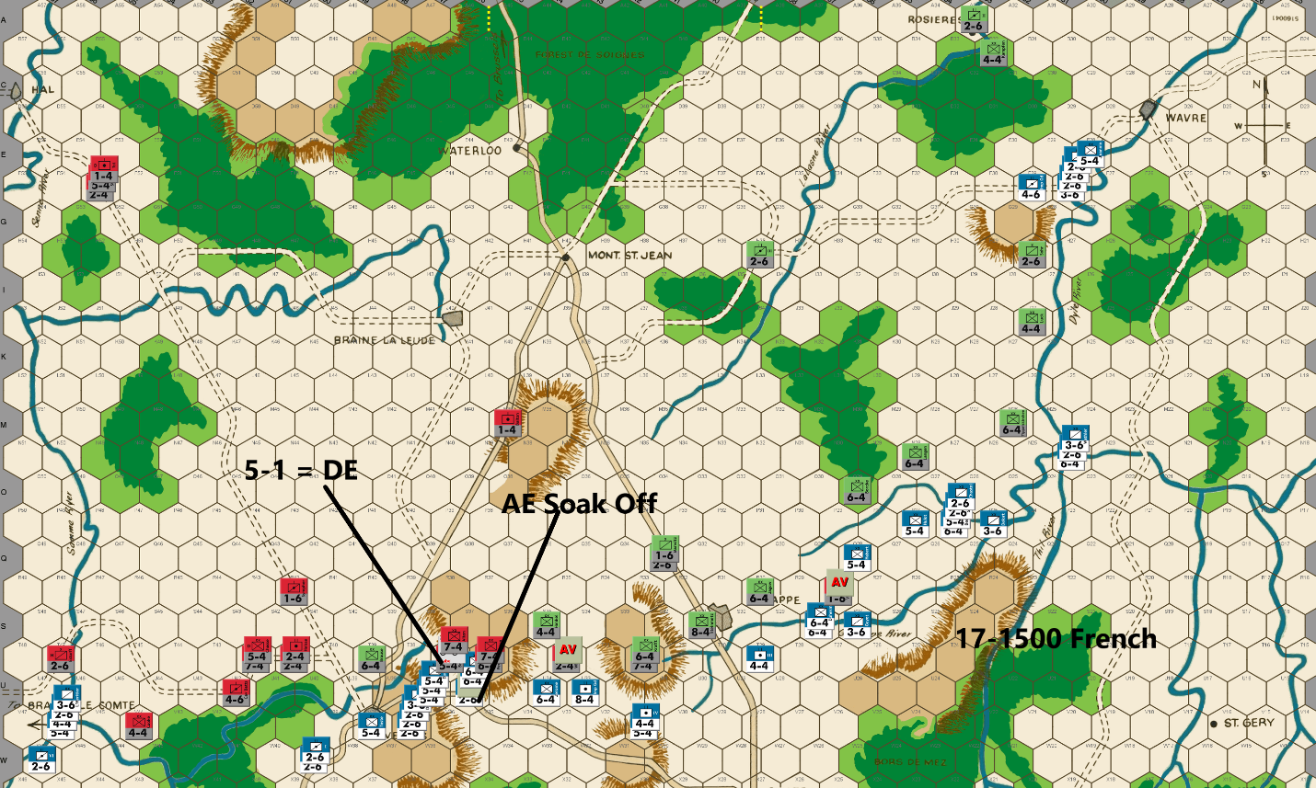
Bert: My 3-1 attack versus T36 last turn yielded an unfortunate (from the French’s perspective) exchange while Ed’s 5-1 attack secured a D Elim result, which added to my disappointing outcome so far on this exchange (pun intended!). As I noted last turn, it’s the cost of doing business but losing 17 factors to kill 6 so far is not a sustainable ratio for the French. At last, I finally got him to lose a PAA piece on a soak off initiated by him.
My follow-up 5-1 attack this turn intentionally leaves only 6-factor French units adjacent to hex T36. This is important because Ed can’t get 30 factors from either faction of his force to attack U36 and even if he could, that still wouldn’t be enough for Ed to get another 5-1 attack against that hex. As a result, at a minimum, Ed will need to risk an exchange result to make an attack from T36 again on his turn. That 30% chance has deterred Ed from doing so previously this game and so I can’t be certain that he won’t take it again. Hex U37 can be easily attacked by Ed with a 5-1 and a soak off, but that doesn’t hold the hilltop. My immediate goal is to kick Ed off that hilltop or make it expensive for him to continue to hold it. I’m guessing that if I fail to eliminate Brunswick on my 5-1 attack, Ed might be more encouraged to take that risk to hold T36 and if he loses that unit, my guess is the response will be to give up the hill, putting a blocking unit at S37 while continuing to hold the T37 river bend for another turn before an orderly withdrawal begins. Perhaps that is just wishful thinking on my part.
Elsewhere, I debated whether or not it is worth it to send troops back to the Braine Le Comte area for another go, especially with the unfavorable attrition so far in the center. The decision was it’s worth it, if by some chance it draws PAA troops back away from the main battle. I suspect that it won’t, and Ed will just set up blocking positions with minimal troops.
On the eastern side of the board, the French have captured the vacated Wavre. Further, they advanced beyond the Dyle River. The Prussians at Rosieres should not pose much of a threat, but I held my one heavy infantry unit to do rear guard work as opposed to the normal position in this game, where the cavalry is held in reserve behind the heavy infantry piece(s). Enough force remains within range of B32 in case Ed decides to remain in that hex. More importantly, the combined French units on the various northeastern rivers threaten an escape attempt by the three infantry units that were defending the Dyle River area. Ed will likely have to offer up another sacrificial unit to let them escape, but it is a tricky position that I think he is faced with on his coming move.
To assist with the above, I put hex O28 in my ZOC to block an easy exit to the southwest or reinforcements from that area joining in to support that sector. I think that Ed could easily get the two 6-4’s to escape by infiltrating through the woods on the M row. This would best be achieved by sacrificing Luck (the 4-4) to block my path from attacking them. If he tries to block the path with Sohr (the 2-6), then I can probably get a decent attack against both units. If he tries to have his 6-4’s escape through the northwest pathway, that could lead to a more difficult challenge, depending on how he does it. Ed has repeatedly gotten his units into good positions and out of trouble, so there is probably an obvious solution that I’m just not seeing. We’ll find out.
Finally, I’m taking the 2 AV’s that Ed offered while I slowly wait for him to run out of blocking hexes along the Genappe River. I’m pretty sure that there will be one more turn of me advancing at a glacial pace, but a breakthrough to drive him back towards Mt. St. Jean should follow that shortly.
Joe: In the West (NIvelles and the Braine le Comte Road): I really like the French move on this front. I confess that I was initially surprised by the size of the force returning to the Samme bridgeheads at V46 and W46, but, upon reflection, I have to admit that this kind of substantial commitment makes a lot of sense. Granted, the PAA commander could counter this threat, but with the Allied position in the center and on the Genappe both verging on collapse, virtually any PAA response that involved positioning infantry beyond one bound of the Nivelles-Mont. Ste. Jean primary road would be foolhardy in the extreme. No, the main problem facing the Allied player is not PAA combat power, per se, but the current paucity of sacrifice/delay units available with which to both screen his battle line, and to serve as soak-offs. That said, although I can definitely see how the Allies might be able to continue the fight in the center for another turn or two, I cannot conceive of a scenario in which they would be able to hold their positions around Nivelles, and at T36, T32 and Genappe through the balance of the 17th. [A possible additional bit of good news for the French: I strongly suspect that the days of the PAA player's favorite 5-1s are probably over, at least until the action moves back to Mont. Ste. Jean.] All in all, right now it looks like it's really good to be the French Emperor!
In the Center: Time is running out for the Allies on this line, as it looks like the methodical dismantling by the French of the Genappe line, is rapidly coming to a close. The PAA have one more delay position at Q30 (R30 is a problem because it undercuts the defense of S31), and after that, it's either fight in the open, or retreat back towards Mont. Ste. Jean. In my view, a standup fight with the French at this stage -- given the disparity in combat power and unit count between the two opposing armies in this area -- is just too dangerous an option for the PAA to risk. And if that weren't bad enough for Allies all by itself, there's more bad news: Napoleon also has substantial forces, including cavalry, positioned on river hexes at N24, P25 and P26 ready to run down and attack the unlucky Prussian units -- that up to now have been tasked with defending the west bank of the Dyle -- before they can withdraw to the protection of the La Lasne River to the north.
In the East: The French player -- given a choice between launching a hasty attack against the retreating Kampfen and IInd Corps Hrs. Arty, or of making a dash for the La Lasne River -- chooses the La Lasne. And why not? With French reinforcements having recently arrived in the Wavre area, a once small French expeditionary force which, a few turns ago, had totaled only three units and twelve combat factors, has now doubled in number to six units, and has grown to eighteen combat factors. With these added units, and new-found combat strength, the French commander is now keen to race the retreating Prussian infantry for the La Lasne River crossings; and with the likely help of units from the center, he thinks that it is a race he can win. [For those readers who have attentively followed the progress of the Tilly campaign in this match, two things should have become abundantly clear: First, the Tilly front does not necessarily need to become a strategic "sideshow," when compared to events taking place elsewhere on the game map; and second, because of the small numbers of units typically involved, and also because of the remoteness of the battle area and the mix of different types of terrain encountered in this sector, this campaign -- with its occasional sudden swings in fortune -- can oftentimes turn into a surprisingly enjoyable "game within a game."]

17-1500 PAA
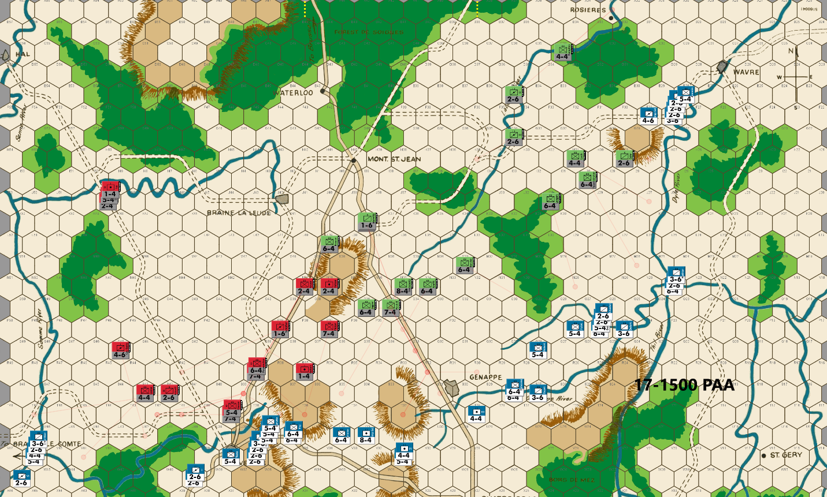
Ed: Now is probably a good time to discuss one of the metrics I use to assess how the game is going. If the PAA are able to hold the Nivelles-Genappe defensive line with modest casualties through the 17-1700 turn, the PAA is usually a favorite in my experience. Here the casualties are modest, but we have to withdraw a turn earlier than desired because of the threats all across the board. Contributing to the problems are the strong position the French have in the Wavre sector. In this game, I view the French as having the advantage.
I have three additional metrics that I like to watch. A second metric that Joe Beard taught me a few years ago is unit casualty count. The PAA get 78 units in the game and the French 50, for a difference of 28. If the PAA can maintain a loss differential of less than 28, they will have an advantage in the end game. Here the differential is 21, which is encouraging but a little early to celebrate.
There are two other metrics I use. Once the French get down to 25 or fewer units, they have a noticeably harder time mounting a set of attacks across the battle front. Here they have 41 on board – good news for the French.
In the far west my withdrawing units are out of range of French 3-1 attacks. I am able to hold the Nivelles River at T39 although that position can be attacked at 3-1 with a soak off. I use a blocker at P39. If I have calculated correctly, the rest of my units are out of range of French 3-1 attacks in the center.
In the east, I do the best that I can to limit what the French can attack at 3-1. They can attack the 2-6 (Sohr) and the 4-4 (Luck) at 4-1 and 3-1 respectively. But that has some exchange risk and potentially a counterattack.
Joe: In the West (NIvelles and the Braine le Comte Road): I really like the French move on this front. I confess that I was initially surprised by the size of the force returning to the Samme bridgeheads at V46 and W46, but, upon reflection, I have to admit that this kind of substantial commitment makes a lot of sense. Granted, the PAA commander could counter this threat, but with the Allied position in the center and on the Genappe both verging on collapse, virtually any PAA response that involved positioning infantry beyond one bound of the Nivelles-Mont. Ste. Jean primary road would be foolhardy in the extreme. No, the main problem facing the Allied player is not PAA combat power, per se, but the current paucity of sacrifice/delay units available with which both to screen his battle line, and to serve as soak-offs. That said, although I can definitely see how the Allies might be able to continue the fight in the center for another turn or two, I cannot conceive of a scenario in which they would be able to hold their positions around Nivelles, and at T36, T32 and Genappe through the balance of the 17th. [A possible additional bit of good news for the French: I strongly suspect that the days of the PAA player's favorite 5-1s are probably over, at least until the action moves back to Mont. Ste. Jean.] All in all, right now it looks like it's really good to be the French Emperor!
In the Center: Time is running out for the Allies on this line, as it looks like the methodical dismantling by the French of the Genappe line, is rapidly coming to a close. The PAA have one more delay position at Q30 (R30 is a problem because it undercuts the defense of S31), and after that, it's either fight in the open, or retreat back towards Mont. Ste. Jean. In my view, a standup fight with the French at this stage -- given the disparity in combat power and unit count between the two opposing armies in this area -- is just too dangerous an option for the PAA to risk. And if that weren't bad enough for Allies all by itself, there's more bad news: Napoleon also has substantial forces, including cavalry, positioned on river hexes at N24, P25 and P26 ready to run down and attack the unlucky Prussian units -- that up to now have been tasked with defending the west bank of the Dyle -- before they can withdraw to the protection of the La Lasne River to the north.
In the East: The French player -- given a choice between launching a hasty attack against the retreating Kampfen and IInd Corps Hrs. Arty, or of making a dash for the La Lasne River -- chooses the La Lasne. And why not? With French reinforcements having recently arrived in the Wavre area, a once small French expeditionary force which, a few turns ago, had totaled only three units and twelve combat factors, has now doubled in number to six units, and has grown to eighteen combat factors. With these added units, and new-found combat strength, the French commander is now keen to race the retreating Prussian infantry for the La Lasne River crossings; and with the likely help of units from the center, he thinks that it is a race he can win. [For those readers who have attentively followed the progress of the Tilly campaign in this match, two things should have become abundantly clear: First, the Tilly front does not necessarily need to become a strategic "sideshow," when compared to events taking place elsewhere on the game map; and second, because of the small numbers of units typically involved, and also because of the remoteness of the battle area and the mix of different types of terrain encountered in this sector, this campaign -- with its occasional sudden swings in fortune -- can oftentimes turn into a surprisingly enjoyable "game within a game."]

17-1700 French
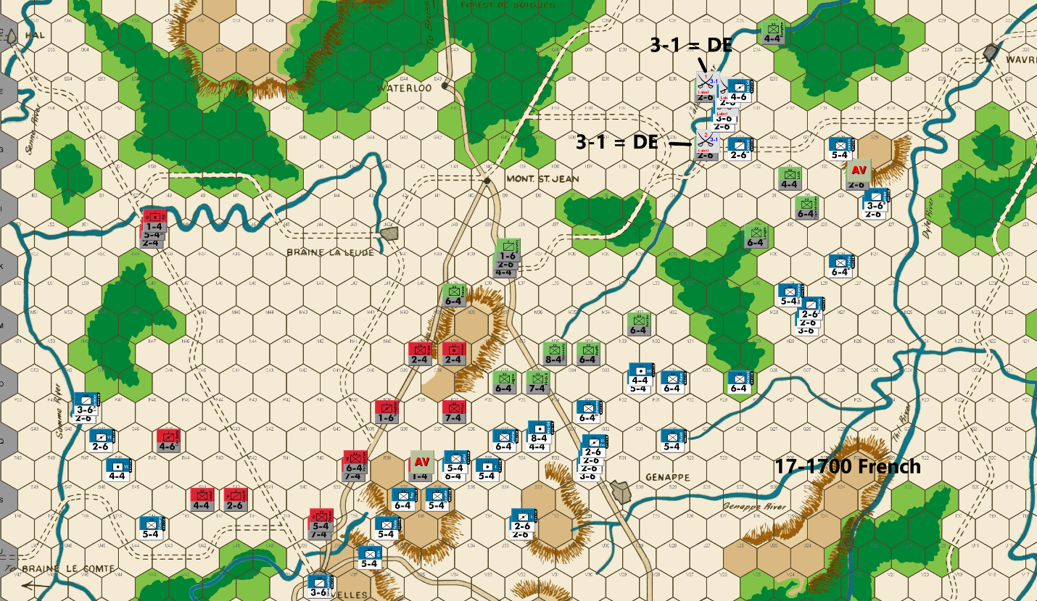

Bert: Woah, this last move by Ed has surprised me quite a bit. I kind of expected him to start withdrawing as he has done in the west, at Nivelles and in the center. What I did not expect was that he would allow my marauding forces in the east to have a direct path to the La Lasne River with two different cavalry defenders that I can get 3-1 attacks against. This has to be a trap of some sort, but I don’t quite see how I can pass this up. I do see how he can surround my units, but only if he is willing to take low odds attacks. I guess that this could be a blunder, but that would surprise me. I thought that I might have inadvertently moved the Sohr unit so that it was not blocking me, but I asked Ed to resend the move and the placement of that piece was not something I had done.
Anyway, I am more than willing to take this shot, especially with me getting the surrounded AV vs Sohr and two 3-1 attacks. I have several units that can support a follow up attack if Ed does indeed pocket and kill my units on a low odds attack. I need the dice to be favorable to me on my attacks so that I can maximize the PAA attrition with this move. I could easily see Ed making those low odds attacks and if they fail, the game will be just about over from my perspective. I really don’t think his position was desperate enough to warrant this gamble, but these games always look different, depending on the side of the table that you are sitting on.
Strap in for some fireworks…, these next few rolls could decide our game!
Everywhere else, I have tried to advance to threaten across as broad of front as possible. My goal is to push Ed as far back as quickly as I can, while forcing him to offer up at least two AV or high odds targets every turn. If I can get more than that, I should be able to wear him down and it will be tough for him to stop me if the dice are roughly even going forward.
[Editors note: The two 3-1 attacks were both DE.]
Joe: In the West: The French raiders in the far west continue to pressure the Allied Right. Although this force only totals sixteen factors, it is enough -- so long as it stays out of range of the PAA "heavies" -- to herd the Anglo-Allied units retreating from the Samme northeast away from the Nivelles-Brussels Road and towards the open ground west of Mont. Ste. Jean. This French presence across the Samme, on the PAA far right, also guarantees that the PAA commander will not be able to establish and maintain an oblique defense line running from Nivelles north to the central ridge line in the center.
In the Center: The main body of L'Armee du Nord advances north in search of battle, picking off the PAA sacrifice/delay unit at R37 as it marches north. In view of the fact that the Allies will undoubtedly choose to reform their line using the southern end of the La Lasne River on their left and the ridge line in the center, the French player can probably look forward to a couple of turns during which the PAA commander will have to sacrifice two or more delay units in order to avoid disadvantageous battles. [ Properly exploited, this absence of high intensity combat actually works -- at least temporarily -- to the French player's advantage, as this game dynamic allows the Emperor to whittle away at the PAA's dwindling stock of sacrifice/delay units, starting on the afternoon of the 17th and extending through the morning of the 18th, and if done properly, with minimal risk.] And these numbers matter. By the afternoon of the 18th, the Allies will see the influx of twenty fresh units into the Mont. Ste. Jean battle space, so every PAA unit -- whatever its combat strength -- that can be eliminated in advance of those Allied reinforcements' arrival significantly improves French prospects for victory.
In the East: The opportunity to attack and possibly eliminate two exposed Prussian 2-6s with 3-1 attacks -- in spite of the possible risk of Allied low-odds surrounded counterattacks -- is too tempting for the French player to resist, especially since there is a 91% chance of eliminating at least one 2-6, a 49% chance of eliminating the two of them, and only a 9% chance that both 2-6s survive to fight another day. And, as if the Allied player's original positional error weren't bad enough, the dice then add insult to injury by rewarding both French 3-1s with D Elims. Farther east the hapless Prussian sacrifice/delay unit at H29 is also eliminated with a 5-1 surrounded attack. For better or for worse, these results mean that "the ball is now in the PAA commander's court." Moreover, since French cavalry now straddles the northern La Lasne River at F34, and most of the local Prussian combat units are too far east of the La Lasne to use in reestablishing some sort of plausible river defense, the Allied player has only two choices: a) Occupy D36 and G35, and allow the French cavalry to seize a second bridgehead across the river farther north; or b) take the 5-1 surrounded AV versus Domont at G33, and counterattack the French units at F34 and E34 with two 1-2s, and hope to get very, very lucky!

17-1700 PAA
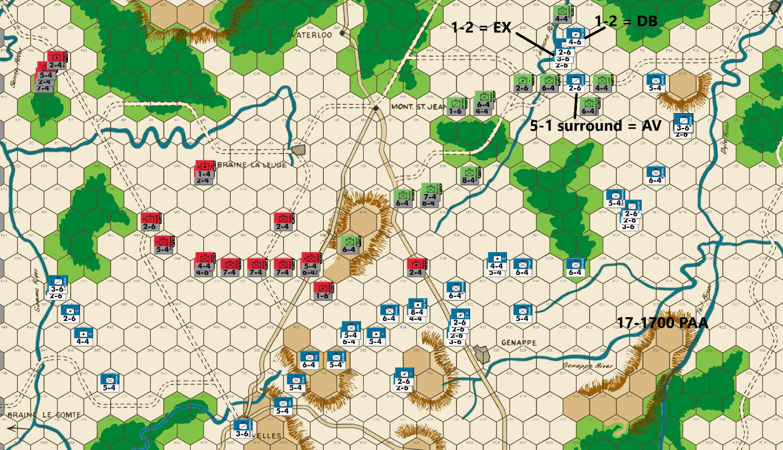
Ed: For reasons that I can’t explain, I overlooked the ability of the French to get 3-1 attacks on my two 2-6s perched on the La Lasne River. Ugh – a major mistake on my part! That plus an AV on another 2-6. Triple Ugh! I cannot afford to give away units like this!
I roll Bert’s two 3-1 attacks, and the dice gods punish me for my blunder with DE results in both attacks. The French still have two more turns to attack before the Prussian Fourth Corps enters the board. The question is how much damage the French can do before the Prussian reinforcements arrive in their rear. The situation is looking bleak for me.
Note: At this point Bert emailed me with the very gracious offer of a redo. As he expressed it:
“I’m thinking I should allow you to move Sohr where you intended & I adjust my move. I really don’t care about winning all that much. I’d hate to have our eventual audience disappointed over the game being probably decided by a blunder of the first order instead of having them learn more (hopefully?) from Joe’s analysis of our moves that just have poor choices & minor blunders instead of first order blunders.
My main passion for this particular game has been to provide our eventual audience with an educational experience that might get other players to give this game another look and provide them with an opportunity to become competitive players more quickly. … Having it suddenly blow up due to a major unforced error might lessen the effectiveness of our endeavor, which is the main reason I made my offer. … I've won my share of championships and so while that is always fun to do, it won't have the potential to be an enduring impact for the hobby like our documentation has the potential to do. I seriously don't care if I win or lose as long as my contributions end up helping those that want the help.”
Joe voiced his support for such a redo, as well.
While I very much appreciated the offer, I want to maintain the integrity of the championship match. I suggested we continue to determine the champion in this, the real game. It may be over quickly; in which case Bert deserves the Championship. We can then proceed with the redo of my move and use that game for the rest of the commentary. Bert and Joe agreed and that is the plan.
So, we carry on … at least for a turn or perhaps more. I continue to withdraw in the west and center offering two blockers to protect my infantry. In the east, there is a chance to salvage the situation. The French that attacked my cavalry have left themselves open to surround counterattacks, albeit at low odds. I can get surround attacks on four of his units if done in the proper order. First, I take the 5-1 surround attack on Domont using Langen to block any retreat for an AV. Second, Langen attacks the three horsemen at 1-2 using Kampfen at D35 to block any retreat. Kampfen then attacks the Imp Gd HA from the river at 1-2. This plan offers at least a 40% chance to eliminate four units. That is pretty good odds from where I sit right now.
The dice gods do an about face and reward me on the critical attack with an exchange on his three units. For a little icing on the cake, I also get a DB against the Imp Gd HA. That is four French units to the dead pile for one Prussian – a very favorable trade for me. It also assures that Tippleskerchen and Luck will not be subject to surround attacks. My situation has improved, and we will play on for a while.
Joe: In the West: Since his options on this front are limited, the PAA commander chooses to fall back on the Anglo-Allied reinforcements marching southeast from the road to Hal entry hex. [The only change in this sector that I would have made would have been to position Estroff at N44 rather than M46.] Although there is a small chance that the French cavalry might raid north towards the ford at I50, the fast-approaching units marching up from the road to Hal should make such a French adventure both unlikely and perilous. It is the open terrain between the Samme River and the Nivelles-Mont. Ste. Jean Road that presents the Allied player with his greatest challenge. With no sacrifice/delay units positioned to protect the Allied battle line that extends from O4 to O43, the threat of one or more French attacks (albeit with soak-offs) in this sector are obvious. Unfortunately, in order to protect Cooke's retreat, the PAA player has been obliged to form his line a little farther south than he might otherwise have preferred; so now, all he can do is await Napoleon's decision, and should the Allied line be attacked, the verdict of the dice.
In the Center: A sacrifice/delay unit at O35 and another at P38, allow the Allied commander to temporarily establish an economical (in terms of unit count) doubled defensive line extending from the southern end of the La Lasne Rive to the ridge line in the center. This is important because he needs to send every spare Prussian unit he can lay his hands on east to reinforce (hopefully) the crumbling defense of the northern La Lasne River.
In the East: Desperate times call for desperate measures, and very few situations in WATERLOO are more desperate for the PAA player than an early (before the arrival of the Prussian IVth Corps) large-scale French breach of the northern La Lasne River defenses. That being the case, the Allied commander decides that, in order to retrieve his position in the east, he must place his faith in the dice. First, he attacks Domont at 5-1 surrounded (AV); next, he uses Langen to attack the French cavalry stack on F34 at 1-2 surrounded (Exchange!); and finally, he orders Kampfen to make a cross-river attack -- and advance, if possible -- against the Imp. Gd. Hrs. Arty at 1-2 (DB2!!). Although these combat results are not perfect (there was only a 4% chance of two DB2s), they are pretty darn close (only a 16% chance of two winning outcomes). What is interesting about all this is not that the PAA commander did not roll two A Elims (there was only a 9% chance of that), but that, by winning both 1-2s, he not only salvaged his river defenses, but he also managed to save Tippelskirchen and Luck from the certainty of being surrounded by a French commander bent on revenge on the 1900 game turn. In addition, in spite of his exceptionally good luck, the PAA player still ended up losing twelve factors (and four units) to the French player's loss of nine factors (and four units); and not inconsequentially, Tippelskirchen and Luck will both still have to survive another round of French attacks before they can finally seek safety on the west bank of the La Lasne River. All in all, a short-term (if nerve-wracking) win for the Allied commander, but still a long-term, if slight, advantage for the Emperor.

17-1900 French
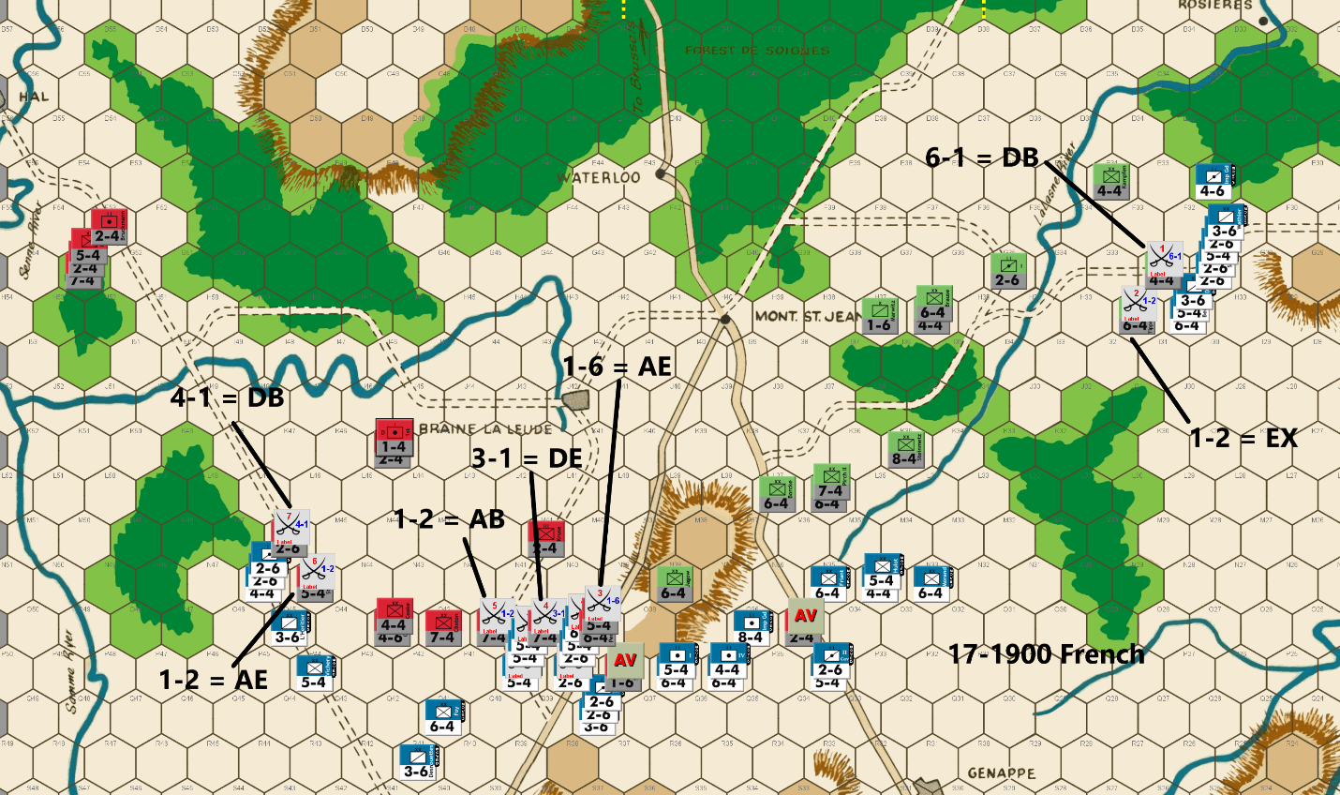
Bert: That was a fairly expensive battle at the La Lasne River as it turns out it was indeed a blunder by Ed and not a trap. In the end, the result turned into pretty much a trap as the PAA was able to hit a couple of good rolls on their low odds counterattacks to destroy three French pieces in addition to killing the blocking piece that was offered up to provide protection. The second attack resulted in a defender retreat which allowed the attacker to advance into a favorable blocking position. Overall, the French can’t complain too much since both of the original 3-1 attacks scored very favorable D Elim results. The battle will continue further this turn as I’m taking a 6-1 attack on his 4-4 (Luck) unit and looking for my own Exchange result on a 1-2 attack versus his 6-4 (Tippelskirchen) unit. I suspect that no matter the results from these two attacks, Ed will probably break off the engagement and take up doubled defensive positions behind the river. Next turn, his significant Prussian reinforcements will be entering the field from the east and it won’t take them long to approach my units to potentially surround them.
Elsewhere as we reach the end of the second day of this battle, the French command has little to complain about overall. I feel that both the attrition and the board position favor my side, although nothing it to be taken for granted as it only takes a couple of attacks to complete flip the script at this point of the game. My approach this turn is to keep the pressure on at a very high rate across the rest of the front.
In addition to my 1-2 attack vs Tippelskirchen, I’m launching two other 1-2 attacks against a couple of his heavy infantry units. Those attacks are all soak off attacks that could cause him “unexpected” damage. I need to make those soak off attacks to support the other attacks that I have ordered, and so the choice I made is to either take lower odds attacks that risk smaller French pieces or risk some larger pieces to have the shot for that unexpected damage. I understand that accept the risk of losing more than I should, but the potential reward is worth it in my calculations. Of course, I wish that I had a 4-4 infantry unit in range of Picton, but alas I don’t and so that attack will cost me a 5-4 infantry unit instead should I suffer a loss on that attack. The (20%) possibility of an exchange against one of his 7-4’s made me take that risk, as opposed to just soaking with a 2-6 unit.
I’ve exposed some French units to non-surrounded counterattacks, but with the PAA already in a weakened position with regards to total number of pieces remaining, I can’t imagine Ed launching any counterattacks that require a soak-off unless he has reached a point of desperation… and I don’t think we are there yet.
In addition to the two AVs that I took this turn, an additional six PAA pieces run the risk (only a 20% chance on each of the three 1-2 attacks) of being eliminated in these attacks. The PAA can’t maintain losses of 4+ pieces per turn and expect to hold the line for two more days of attacks. On the other side, five French pieces could be lost in these attacks, which would definitely put a crimp on my attacking force going forward. This will be another turn where I am eagerly awaiting the die roll results.
Joe: In the West: Up until now, I have generally been impressed with the French player's handling of operations in the west. This is because the Braine le Comte-Nivelles sectors -- especially in expert competition -- can be very challenging for both sides, and even seemingly small errors during the early game turns can come back to haunt a player in the middle and end game. In the current match -- at least in my view -- except for a couple of minor missteps, this French commander has otherwise hardly "put a foot wrong" thus far in the campaign. That is, until now. However, before I catalog my specific issues with the current French move in the west, I probably need to explain the logic that underpins my critique of the French commander's play in this particular instance (warning: some simple math and a bit of tedious exposition is involved, so scroll past the following section highlighted in red, if you just want to see my specific criticisms). [First, and at the risk of stating the obvious, I will begin by making a couple of simple numerical comparisons between L'Armee du Nord (at full strength: fifty units and 193 combat factors) and the Prussian/Anglo-Allies (fully reinforced: seventy-eight units and 237 combat factors). Obviously, in both total number of units, and in total combat factors, the PAA (once reinforced to full strength) enjoys a substantial advantage over the French; however, it has been my experience that many players simply do not appreciate either how or when those differences actually begin to influence the flow of the game, or how different their impact on play actually is. So, with that in mind, let us use a bit of basic math to clarify these differences. In the case of combat factors, the PAA enjoys a 22.8% advantage (237-193 = 44/193 =.228); on the other hand, when it comes to the unit differential between the two sides, the Allies enjoy a 56% edge (78 - 50 = 28/50 = .56). Clearly then, the PAA advantage in unit count is significantly greater than is their advantage in combat factors. And this, at last, brings us to my somewhat controversial personal conclusion: That maximizing the early (pre: 18 Jun 0700) elimination of Allied units (while minimizing the loss of French units) is far more important for French prospects of ultimate victory, than is the infliction of disparate casualties on the PAA at the cost of roughly comparable unit losses. Stated differently: If the French player concentrates on eliminating Allied units, while preserving his own, then the disparity in combat factors will tend to take care of itself. Second, that the tactical value of certain PAA units diminish once the game's action moves north of the Nivelles-Genappe line. What I mean by this is that, during the first day and a half or so of the campaign, the initial batch of PAA 7-4s, and the lone Prussian 8-4 serve as critical lynch-pins for the Allied player's defensive arrangements throughout these perilous early game turns; on the other hand, once the action moves north towards Mont. Ste. Jean, then I would argue that these units all become significantly less important, mainly because the opportunity for the PAA commander to utilize doubling terrain markedly diminishes. Moreover, because of the stacking problems these "large" units can pose when attacking (e.g., two stacked 7-4s cannot accommodate any soak-off unit other than a 1-4 or 1-6, and most, if not all, of these "1" strength units will usually already be in the "dead pile" by the later stages of the game), smaller units are often more tactically useful because of their flexibility when it comes to stacking. In short, during the early game turns, any one of the PAA 7-4s, or the Prussian 8-4 should be considered "high value" targets and -- especially if not doubled -- well worth it for the French player to risk incurring higher than normal soak-off and/or exchange losses just to remove them from play. Later on in the game, however, a prudent French commander will often, when practicable, eschew attacks against these Allied "heavies" and seek, instead, to attack smaller strength units against which it is usually easier both to achieve attractive odds, and to avoid awkward, expensive exchanges.] Before I get into the specifics of this critique, I probably should note that my view of the effectiveness of any player's specific game actions is always "risk/reward-based," and never "outcomes based:" for example, whether an attack actually succeeds or fails is never the criteria by which I judge a move, but only by whether a player's decisions -- given the game situation at the time -- were generally reasonable and constructive, so far as the long-term goal of victory is concerned. That said, my first major "nit" -- when it comes to this turn's French operations in the west -- must go to the ill-conceived French 4-1/1-2 attacks versus Estroff at M46 and Stedmann at N45. This lapse is particularly surprising as this French player, in previous game turns, had masterfully maneuvered this small detachment against the Allied Samme defenses, and had effectively breached the river barrier without fighting a single battle. In this case, however, the French commander -- at least in my opinion -- decided to risk far too much, for way too little potential return. The first issue that I have with this pair of combats is actually a general one: the conservation of forces. In essence, because of previous cavalry losses (seven 2-6s and one 3-6), the French player simply does not have a lot of cavalry left to waste; in fact, on the main front (the west and center), the Emperor's cavalry arm has been reduced to ten units, of which 30% will have been placed at risk in order to execute the strategically unimportant, and highly risky attrition attack against Estroff. Moreover, even in the unlikely event that the French attack was to be completely successful (a D Elim versus Estroff, and DB2 or Exchange against Stedmann), the attacking force -- because of the noticeable paucity of nearby French supporting units -- would still be vulnerable to a powerful PAA counterattack. Unfortunately for the French commander, the actual results of these two combats were the worst possible: a DB2 and an A Elim. However, even if these particular combat results had been optimal, I still think that it would have been far better for the French player to have held these units back, out of range of the local Allied "heavies," so that they could have continued to exert flanking pressure against the PAA Right as the game action moved north. Looking a little farther east, we come to my second major "nit:" the highly risky trio of attacks (one 3-1, one 1-6, and one 1-2) versus a 7-4 (Alten) and the units covering its flanks. My main problems with this set of combats are twofold: first of all, it accomplishes nothing in terms of position as the Allied battle line would have to either retreat or fight under unfavorable terms, even if Alten had not been attacked; and second, it risks four units (and fourteen factors) in order to achieve 3-1 odds against Alten (60/40 risk reward), a 1-6 versus O39 (80/20), and a 1-2 (using Lefol, a 5-4) versus Picton (30/70); as things turned out, luck actually favored the French player in this instance, as he eliminated Alten, survived the 1-2 versus Picton, and lost only the Ist Corps Hrs. Arty (a 2-6) in the 1-6. Nonetheless, despite the fact that this particular battle produced a French victory, I personally think that the downside risks associated with this specific set of attacks were simply too great, especially when weighed against the potential benefits of their success.
In the Center: The French move in this sector basically makes itself. The only Allied targets worth considering are the two sacrifice/delay units (one at O35 and the other at P38) which are eliminated without difficulty. Other than that, I suppose that one could quibble about a few of the French front-line dispositions, but once the decision was made to initiate an attack against Alten, the issue pretty much became moot, as there weren't really very many units left for the French player to redeploy.
In the East: Just as was the case with operations in the center, the French move in the east essentially makes itself. The only real choice that needed to be made after the obligatory 6-1 versus Luck is organized was whether to risk a 2-6 (for a 1-3) or a 3-6 (for a 1-2) in the required soak-off against Tippelskirchen. In this case, the French player opted for the 1-2 and is rewarded with an Exchange, which is probably fortunate, as the 6-1 misfired with a DB2.

17-1900 PAA
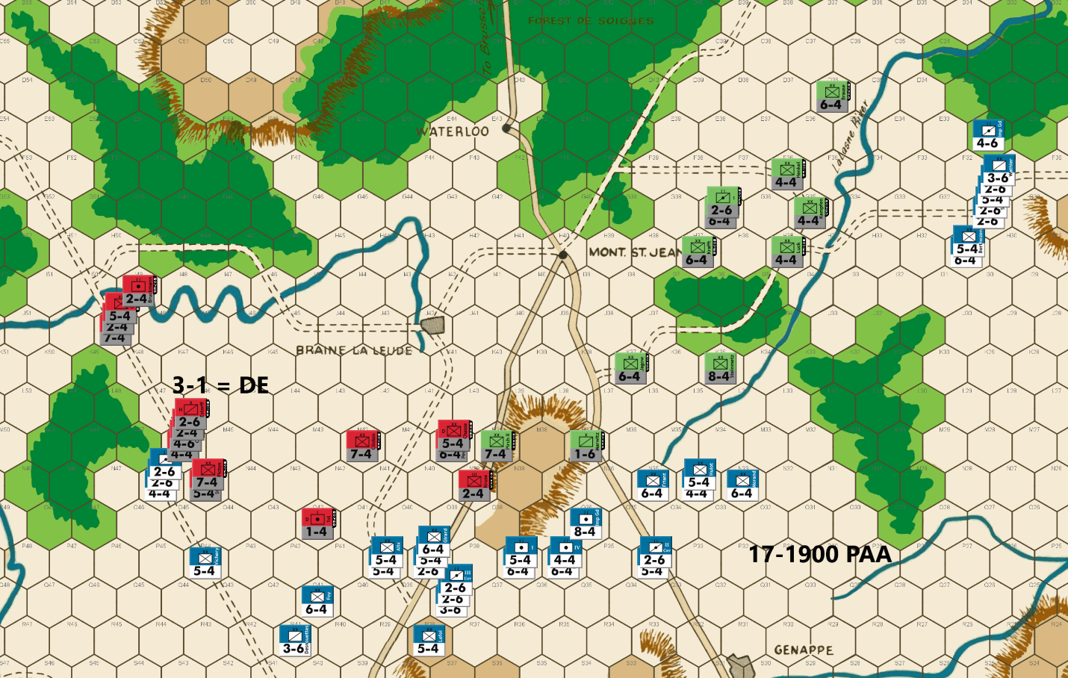
Ed: Bert’s attacks were a mixed bag with something for both of us. The French are still favored, but I now consider my situation far from hopeless. The eliminated unit count favors the French by only 23 at this point vs the PAA total unit count advantage of 28. It seems likely that I will have a few more units than the French once tomorrow’s 7am reinforcements take the field. And if the French stick around east of the La Lasne River, the Prussians will see action earlier in the day than normal. We may even have combat-strength parity.
There is another opportunity in the west. Bert’s poor attack results have left three units open to a 3-1 attack which I go for. If I can eliminate them, that will be a big boost to the PAA chances. But I also have to keep the French as far away from Mt. St. Jean as I can. Sadly, the best I can come up with requires three blockers in the center with 3-1 proof infantry flankers. Bert may decide to take some low odds attacks against my infantry, but I will risk that.
I can defend the La Lasne River along most of its length. But I can’t cover it all and I leave it undefended in the far north. To be effective he will need to devote significant strength to the bridge head. Will he want to commit that much with the impending arrival of the Prussian Fourth Corps?
Combat Results: Luck is with me again as I get the DE on his three units in the west. That is seven French units eliminated in two turns. The French are now down to 31 units. With the arrival of PAA reinforcements next turn, I will be up eight total units. It will take the Prussian Fourth Corps (nine units) most of the day to arrive at the central front. But the French have eight units in the eastern theatre as well. If the French hang around, the freshly arriving Prussians can bring pressure to bear earlier than normal. Things are looking very much better right now for the good guys. I will be interested to see what the French choose to do over the next few turns. Will he hang around in the east, threatening the La Lasne River defense?
Joe: The complete failure of the French attack against Estroff in the far west creates a "golden" opportunity for the PAA commander to eliminate, once and for all, the enemy threat to his right flank, and he seizes it in fine form by attacking the eight factor French stack on N46 at 3-1. [I should note that this counterattack is not as risky as it might first appear because, at this stage in the game, even an uneven Exchange tends to work to the Allied player's advantage.] However, unlike his Gallic counterpart, the PAA commander's attack does not misfire, and the three targeted French units all make the trip to the "dead pile," thanks to a D Elim combat result.
In the Center: The Allied player, in order to screen his center and to also shield his attacking force in the far west, has been obliged to deploy three of his precious sacrifice/delay units to cover his front. This move temporarily reduces his local store of available sacrifice/delay units from six units down to three. While this is a valid concern for the Allied commander, events in the far west will almost certainly shorten the PAA front and, more importantly, a sizeable influx of fresh sacrifice/delay will soon enter play on the road to Brussels. In addition, reinforcements marching south from the road to Hal, are now only a turn or two away from the Mont. Ste. Jean battle area.
In the East: Some very good luck, along with the timely arrival of Prussian reinforcements, has successfully plugged the French breach of the La Lasne defense line and -- at least for the time being -- averted a genuine Allied crisis. A French cross-river attack is still possible, but with a defending Allied force which now slightly outnumbers the local enemy contingent, the danger of a breakthrough on this front appears to have passed. Moreover, starting next turn, the French commander will not only have to deal with the substantial Prussian force lurking just west of the La Lasne River, but also with the possible arrival, in the French rear, of the powerful Prussian IVth Corps marching in from the east.

18-0700 French
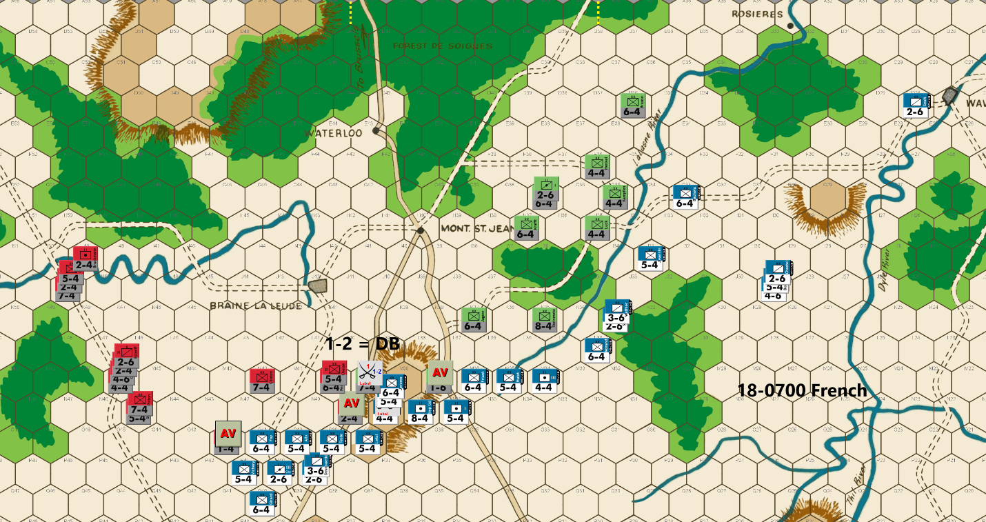
Bert: The battle in the west end of the board has turned into a disaster for my troops as I failed to eliminate his 2-6 on the 4-1 attack, lost my unit to an A Elim on my 1-2 attack, and then had three units and 8 factors go into the eliminated pile on Ed’s 3-1 counterattack. Ugh! Basically, those results have effectively shut down my western push as I don’t want to tangle with those strong Anglo-Allied troops anymore. When I combine those results with what happened to my forces in the east on the last turn, I have managed to allow my rather significant advantage in the game to almost disappear. It is time to consolidate my units to the center and make the end-game push in the center for now.
My goal at this point is to try and gain at least one hex row per turn towards Mt. St. Jean so that I can utilize the wooded hexes to separate the PAA forces into two separate groups. Ideally, I’ll eliminate 2 or more Allied units per turn, while making this push. Barring a successful counterattack, to hold a row, I think I can get to that city before the Prussian IV Corps, that is arriving this turn, can intervene in a meaningful way.
If I can achieve that goal, without losing a significant portion of my remaining units, I will be able to commit the majority of my units to one of the roads towards Brussels or the other. I’ll have about 9 turns remaining to advance 7 hexes. Failing that, with 36 PAA pieces left following my attacks this turn (pending the outcome of my 1-2 attack), I can eliminate all Allied pieces by killing 2.77 units per each of my 13 remaining turns of attacking. Neither path is very good math for the PAA side. At this point, I think I should be able to achieve one or the other without the need for any major attacks of less than 3-1 odds.
Most French players seem to like to use their 4-factor infantry units to attack Steinmetz on the Quatre Bras hill early in the game with a 1-2 attack. I prefer to not do that and instead wait for this point in the game to utilize those 4-factor units to attack undoubled Allied 7-factor (or Steinmetz) units that are holding blocking positions, at 1-2 odds. For example, I’m hitting Pirch II this turn at M39 with a 1-2 attack. While those attacks are less than 3-1 odds, I don’t consider them major. If I can get an exchange result (20% chance vs 30% of an A Elim), it can be quite a blow to the PAA player’s position. As the PAA player, I prefer to use a 6-factor unit to hold that single hex defensive position instead of the 7-factor unit. The French can still do their 1-2 attacks and only risk a 3-6 unit to do it, but that can leave a weaker unit on their front line that I can consider counter-attacking to try and hold a hex row for an additional turn.
In any case, Ed is running low on small units that can be used as blockers or as soak-offs and with the low number of remaining pieces, every counterattack he makes going forward runs the risk of him helping me to achieve my killed units per turn that I’ll need to ensure a French victory.
I considered sacrificing a piece at hex J34 to block his units from using that road to get back to the main front from the La Lasne River battle, but I don’t want to take any unnecessary losses anymore. A big decision that Ed has is where he will bring his IV Corps reinforcement on to the board this turn. I’ve dispatched a small contingent to deal with those units, should he choose to send them down the DD hex row road towards Quatre Bras. I also have sent a nuisance unit to slightly block his path coming through Wavre. I expect that this is where they’ll come in. I’ll consider minimally engaging them to slow them from reaching the main front for an extra turn, if I can do so economically.
Joe: Prologue: The arrival of the 18 Jun 0700 game turn is virtually always greeted with relief by the PAA player, and dread by the French commander. And why wouldn't this be the case? After all, it is on this game turn that the PAA player is at last able to bring into play his final contingent of Anglo-Allied reinforcements -- four Hanoverian 2-4s -- on the north edge of the game map, usually along the Brussels-Waterloo Road; and he also finally gets to usher in the nine units of the Prussian IVth Corps (thirty-four factors) somewhere (his choice between hexes A25 and FF09) on the eastern map edge. Of course, entering the game map and actually showing up in the battle space are two very different things. In the case of the Hanoverian 2-4s, they will typically reach the front in two game turns; however, when it comes to the various components of the Prussian IVth Corps, these units -- depending on whether they are cavalry or infantry -- will usually arrive, if not physically delayed, at the Mont. Ste. Jean battlefield in three to five game turns. And what all this means -- at least in my view -- is that the moods of the opposing players (whether optimistic or pessimistic) will often undergo an immediate change due to the prospect of this last batch of PAA reinforcements finally entering the game map. However, I would suggest that such "mood swings" are almost always an overreaction, as the actual situation on the battlefield -- and with it, the strategic dynamic between the opposing forces -- will only rarely be dramatically affected by the arrival of these incoming PAA units before the 1500 game turn of the 18th, and sometimes not even then.

THE FRENCH:
The sudden unexpected opportunity -- thanks to an Allied miscalculation -- for the Right Wing of L'Armee du Nord to launch a surprise attack against a vulnerable section of the Prussian line had, on the afternoon of the 17th, electrified Napoleon's headquarters' staff with hopes for an early, and victorious end to the campaign. This was only natural since the Emperor and his retinue had, very soon after the fact, received ebullient reports confirming the total success of a set of daring attacks by French horsemen on the unsuspecting Prussian cavalry pickets tasked with guarding a wide stretch of the northern La Lasne River. Subsequent events, however, soon dashed those hopes. For starters, and most disappointing for the Emperor, the promising breach in the Prussian line in the northeast -- in spite of what had initially seemed to be a decisive French victory -- could not be maintained; and, instead, all but one of the cavalry units that had just successfully attacked along the La Lasne River were, in their own turn, destroyed in a desperate, bloody, but winning Prussian counterattack. To add to Napoleon's multiplying woes, only two hours later, over on the western side of the map, a French mixed cavalry/infantry contingent, which had previously been cautiously covering the extreme left flank of L'Armee du Nord, suddenly charged forward in an ill-considered attempt to ride down a single Hanoverian cavalry brigade (Estroff). Unfortunately for the French, not only did this attack fail (with the immediate loss of a 3-6 soak-off), but three of the surviving four units committed to this assault ended up being destroyed in a PAA counterattack, all at no cost to the Allies. These several French setbacks, besides increasing casualties among Napoleon's cavalry arm to an alarming level, and more-or-less completely eliminating French pressure against the Allied right flank, also temporarily put Napoleon's campaign "back on its heels." In short, with available French cavalry units (and the mobility that goes with them) drastically reduced, with infantry losses steadily increasing, and with Allied reinforcements soon to be converging on the Mont. Ste. Jean battle space from west, north and east, the French Emperor now realized that he would have to scramble to salvage a campaign that, for the first time, looked to be jeopardy.
In the Center: The destruction of most of the units covering the French Left, leaves Napoleon with no choice but to pull what remains of the far west contingent of his front line units back towards the main body of L'Armee du Nord in the center. On its face, this decision is quite reasonable, yet reasonable or not, it is actually with the specifics of its execution that I take exception. Of special concern is the western end of the French battle line; to whit: by occupying the "O" hex row in strength, instead on the "P" row, the units at O41 and P41 can both be attacked by the PAA player from three hexes at 3-1 and/or 4-1 odds, and without the need for a soak-off. [Even double stacking both O41 and P41 -- because of the required soak-off -- could well discourage an Allied attack!] Since the French commander obviously wants to eliminate the Allied sacrifice/delay units at M37, N39 and O42, I think that it would probably be a little safer to pull the entire French battle line back one hex row (e.g., so the units in the M row, for instance, would line up in the "N" row instead; and units around the central ridge would pull back one row to the "O" row with O39 and P32 being occupied by 2-6 cavalry units serving as screeners. In addition, since the doubling effect of the central ridge is already neutralized by French units at N37, O37 and O38, I see no compelling reason to risk a 4-4 in a 1-2 soak-off/attrition attack against Pirch II. And last but not least, I personally think that the five French units (eighteen combat factors) racing south along the Quatre Bras primary road to, I assume, impede the progress of the Prussian IVth Corps (should its units enter the map at CC11 and DD10) is largely a wasted move. I understand why a French player might opt for such a defensive measure -- I used to react much the same way, myself, when the 18 Jun 0700 game turn rolled around -- but I have long since come to believe that this response is an overreaction. [Admittedly, there are a few situations (e.g., an ongoing attrition battle still going on in the Qautre Bras Gap, or a badly depleted French army which is still stalled south of the Nivelles-Genappe Line) when it might make sense for the PAA player to enter the IVth Corps on the Quatre Bras primary road, but, even in these situations, the French commander can easily discourage this move by posting a 6-4 at Y13, and a 2-6 at BB12, DD11, and FF10 on or before his own 18 Jun 0700 player turn. No the main reason that experienced Allied players almost never attempt this rear entry gambit is that the IVth Corps is actually surprisingly ill-suited -- because of its unit composition (it can only stack twenty-nine factors in two hexes: therefore no 3-1 from two hexes versus a doubled 5-4) and combat limitations (with its total combat strength of thirty-four factors: no 3-1 versus a doubled 6-4 is ever possible) -- to operate independently of the rest of the Prussian Army, especially when faced by a line of doubled enemy units. This means that, if the Prussian IVth Corps does enter play on the primary road to Quatre Bras, it will usually be fairly easy for the French player to box it in east of the central hillocks at W31 and T32, and south of the Genappe River.]
In the East: The French player, now faced with a stalemate on the La Lasne and the strong possibility of a powerful contingent of Prussians entering the map to his rear, temporarily abandons any further offensive plans in the east, and, instead, sets about extricating his units before they find themselves squeezed between two powerful enemy forces. One French 2-6 is dispatched to occupy the comparatively safe D28 (no incoming infantry can attack it initially, and Prussian cavalry cannot muster a 3-1 whether the 2-6 is doubled or not) so as to prevent any arriving Prussian horsemen from sideslipping along the Dyle River to E28 or F27. I should also note that, while this French blocking move -- should the Prussian IVth Corps enter the map near Wavre -- is virtually risk-free, ongoing attempts to delay the advancing Prussians will not be so easy but will tend to come with a steadily increasing opportunity cost in sacrificed units as the game wears on.

18-0700 PAA
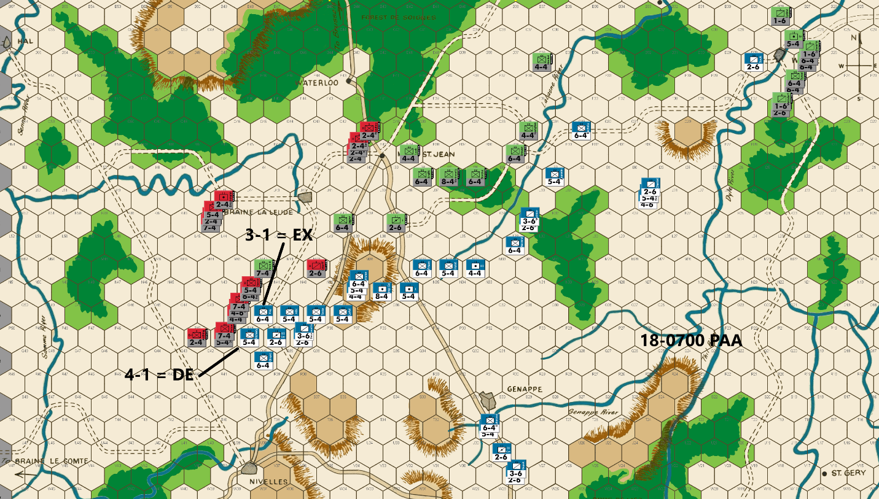
Ed: Good fortune has been on my side over the last couple of turns. Bert’s attacks have sputtered while mine have produced good results. All he got in his turn were the two blockers I sacrificed. As I start my turn, I have a five-unit count advantage. Exchanges are now helpful to my Allied Cause. I still want to minimize any soak offs in my attacks, but there is no need now to avoid 3-1 and 4-1 attacks. The order of the day is to attack wherever we can.
My attack in the west last turn has left me poorly positioned. But Bert has left two units subject to attack with no soak offs. I attack at 4-1 and 3-1. In the center, I use two blockers with (hopefully) some disadvantageous attacks on my flanking heavies. Bert blocks my Prussian cavalry in the east but stays out of range from my newly arrived infantry. And he decides to send some of his eastern forces back toward the center. I am a little unsure what the purpose of the three units at J29 is. I guess to slow the advance of the Prussian Fourth Corps.
Combat Results: More luck for me as I get a DE and exchange on my two attacks. Two more French infantry eliminated. I now think I have the advantage in the game. Of course, the dice luck can easily swing in Bert’s favor and the game is far from over.
Joe: In the Center: The Allied commander reacts to the French move pretty much as expected: he renews his attacks against the French Left, targeting Foy (6-4) at 3-1 (Exchange) and Vichery (5-4) at 4-1 (D Elim); and farther east, he screens the pullback of the rest of the Allied line with sacrifice/delay units at M40 and K38. The one "nit" I will offer about this move is that, rewarding as PAA combats in the west have been of late, the Allied player has now chosen to advance a sizeable share of his Anglo-Allied combat power out of range of the Brussels-Waterloo north-south primary road, and at least a couple of turns away from the soon-to-be central battlefield just south of Mont. Ste. Jean. Granted, reinforcements are rapidly approaching from several different quarters, but I still believe that the Anglo-Allies are soon going to have to concentrate in the center astride the two primary roads, as the local Prussians currently tasked with supporting the Allied Left have no conveniently-sized soak-off units available, and hence, their capacity for protracted "toe-to-toe" combat is going to be both brittle and severely limited, at least until the Prussian IVth Corps finally makes its appearance on the battlefield. And lastly, both Wellington and Blucher are finally able to breathe a collective sigh of relief upon learning that the desperately-needed Hanoverian 2-4s have belatedly entered the map on the Brussels Road, and are even now marching south "towards Mont. Ste. Jean and the sound of the guns."
In the East: The La Lasne River line is at least temporarily relegated -- all in the space of a few game turns -- from a critically-important front, to a strategic "sideshow." And all that was necessary for this to happen was the sudden appearance of a powerful Prussian force on the east edge of the map near Wavre. Now, the new focus of both sides, when it comes to their respective operations in this sector, has shifted to the Wavre bridges over the Dyle River, and to the French efforts to delay and otherwise impede the progress of the newly-arriving Prussian IVth Corps.

18-0900 French
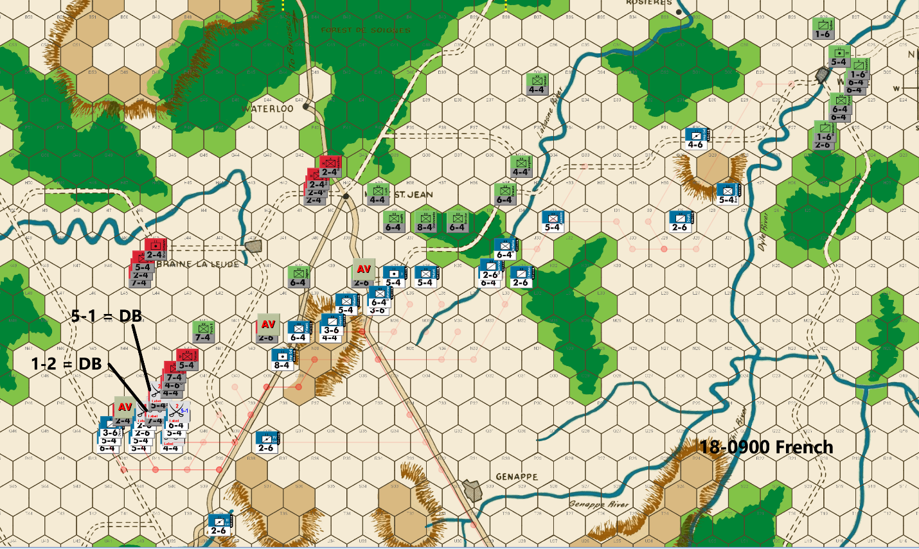
Bert: I have to admit that I did my last move rather quickly without actually counting out everything that was possible for Ed to do against me. I shouldn’t be making that kind of mistake in a PBEM championship game. Frankly, I wasn’t too worried about the PAA launching a counterattack against me. As a result, the 4-1 and 3-1 attacks against my infantry units were not expected. Unfortunately, the dice failed to bail me out (they really shouldn’t when I’ve made a poor move) and so the PAA was able to increase the total French losses up to 69 factors with those two kills. When compared to the 90 factors that the PAA has lost through the previous turn, I’d say that this game is back to a toss-up at this point, although to be fair, I really think it is leaning towards the PAA player with a little more leeway to handle some poor dice; we’ll see.
The fortunate thing for me was that the kill vs my 6-factor unit took the last remaining Anglo-Allied 6-factor unit with him in the exchange. Without a 6-factor unit left to lose in an exchange result, the Anglo-Allied forces will be risking either multiple pieces or a 7-factor unit on any further attacks versus my 6-factor defenders on any further attacks at less than 5-1 odds.
Meanwhile, the Prussians have plenty of 6-factor units left, but their dilemma is that they will have difficulty creating stacks of 15 factors. With my AV of the last remaining small Prussian unit on the main front this turn, any attacks launched by the troops clad in green will be risking larger units in any necessary soak-off in addition to having non-optimal stacks. It will still be at least 3 more turns before the small units from the Prussian’s IV Corps reach the main front.
Speaking of the IV Corps, I have committed minimal units that are trying to impede those reinforcements so that they will reach the main front with perhaps a one-tun delay. With my recent losses, it is likely not worth sacrificing a piece to gain another turn, but I’ll have at least one more turn before I need to make a final decision on that. I think Ed will send at least one if not two of his small units through the small village of Rosieres in order to avoid any further blocking moves. Unimpeded, those units can typically reach the main front by the 18-1300 turn, but I think they’ll end up getting there one turn later this game. While I can’t really afford to throw away many more units, my best move might be to sacrifice my eastern most units if it can prevent the IV corps from reaching the main front before I can reach Mt St Jean to split Ed’s armies.
At this point, I won’t be surprised by additional counterattacks by the PAA commander. My goal will be to force him to risk losses on soak-off attacks and exchanges whenever he orders an attack. Of course, I won’t complain about defender retreat results either. As an exception, I felt forced to expose the IV Corps cavalry to a high odds or AV attack this turn but making that attack will leave any PAA units in that attack or on the flanks, vulnerable to an effective follow-up attack by my units.
I made sure to position all of my attackers out of range of his reinforcements that are approaching from Hal and are on hex K45. He has enough firepower in range on that western front without me letting those units get added to his arsenal on this coming turn.
My units will use AV attacks to kill at least three more PAA units this turn. In addition, I am taking a 5-1 and a 1-2 (against a 7-factor defender) which give me a decent chance to kill at least one more unit and/or possibly a second defender. Obviously, with the way the last couple of turns have gone, the tide is turning, and I need to maximize the attrition that I cause the PAA army while hopefully minimizing my losses. If not, I’ll be in a lot of trouble and will have to consider some sort of desperation attack to turn the tide back in my favor. I feel like I don’t have much margin for error anymore.
Joe: In the Center: Given the current battlefield situation, and the combat units that he still has left to work with, the French commander does about as much as can be expected with his assets in this sector. L'Armee du Nord is now established north of the western end of the La Lasne River and is only a few hex rows south of the critical road junction at H40 (Mont. Ste. Jean). This strongly suggests a PAA counterattack, if for no other reason than that an attack is really the only way for the Allied player to be able to maintain control of the "J" hex row for another game turn, which, because of its proximity to H40, he really needs to do. Unfortunately for the PAA commander, only the Prussians (who are also currently without any available conveniently-sized soak-off units) are actually in a position to immediately counterattack the advancing French battle line in the center. In spite of that fact, the French 5-4s at K36 and K37 look particularly vulnerable; regrettably, it is also highly unlikely that stacking additional units in these two hexes would actually dissuade this Allied player who has lately become really keen on attacking the French line whenever and wherever an opportunity presents itself. Looking elsewhere on the game map, the PAA sacrifice/delay units at K38, M40 and P43 are all AV'd without difficulty, and the French player is also able to organize a promising pair of attacks (a 5-1 versus Stedmann and a 1-2 against Picton) on a couple of the troublesome Anglo-Allied units that have been tormenting the French Left since the evening of the 17th. Unfortunately, as has been the case for French "high" odds attacks over the last few game turns, the 5-1 succeeds only in retreating Stedmann, and the 1-2 versus Picton, although it does not yield an A Elim, also fails to eliminate the 7-4 with an Exchange. As a final note, I think that the IVth Cav. Hrs. Arty is actually cleverly placed: it is positioned far enough back so as to not be an attractive "high odds" target for the foe, but still far enough forward so as to prevent Cav. Batts. (at O42) from dashing through the French line to surround the Imp. Gd. Foot Arty (at N39) or any of the units farther south on the "Q" row.
In the East: It is clear that the French player has now pretty much abandoned any serious thought of continuing his offensive threat against the La Lasne line; and instead has decided to continue to gradually shift the bulk of his eastern combat power along the east bank of the river and towards the center, where the real action is certain to occur. Interestingly, the situation farther east has suddenly become a little more complicated thanks to the French commander's decision to dispatch a couple of units to impede -- at least temporarily -- the Prussian IVth Corps' western march towards Mont. Ste. Jean. Needless to say, a 5-4 and a 4-6, by themselves, cannot safely do much to delay the advance of the main Prussian force, especially once the bulk of its infantry has passed over to the west bank of the Dyle River. On the other hand, this token French force -- so long as it stays out of range of the Prussian "heavies" -- is more than enough to slow down the newly arrived Prussian cavalry for a turn or two. Of course, the real question still to be answered by the French commander is: Does he want to continue to slow the IVth Corps advance going forward and, if so, how much combat power is he willing to sacrifice, in order to accomplish that delay? [Since the topic of possible direct French interference with the entry of the IVth Corps has come up in this match, I thought that it might be helpful to mention an unorthodox French approach that can be quite effective in disrupting the Allied player's plans for the endgame, especially in certain low (French) casualty situations in which L'Armee du Nord is already on or ahead of schedule in its advance towards Mont. Ste. Jean. There are actually several different variations of this gambit, but my personal preference is to position a single 2-6 at B25, E23, H22 and K20; two 3-6s at N21; and a 5-4 at N19. Although the PAA commander has several possible counter-moves to this gambit, none of them are really all that appealing. And for those players who are skeptical, I invite you to experiment with this approach, if for no other reason than to have a prepared response should you ever encounter it your own play.]

18-0900 PAA
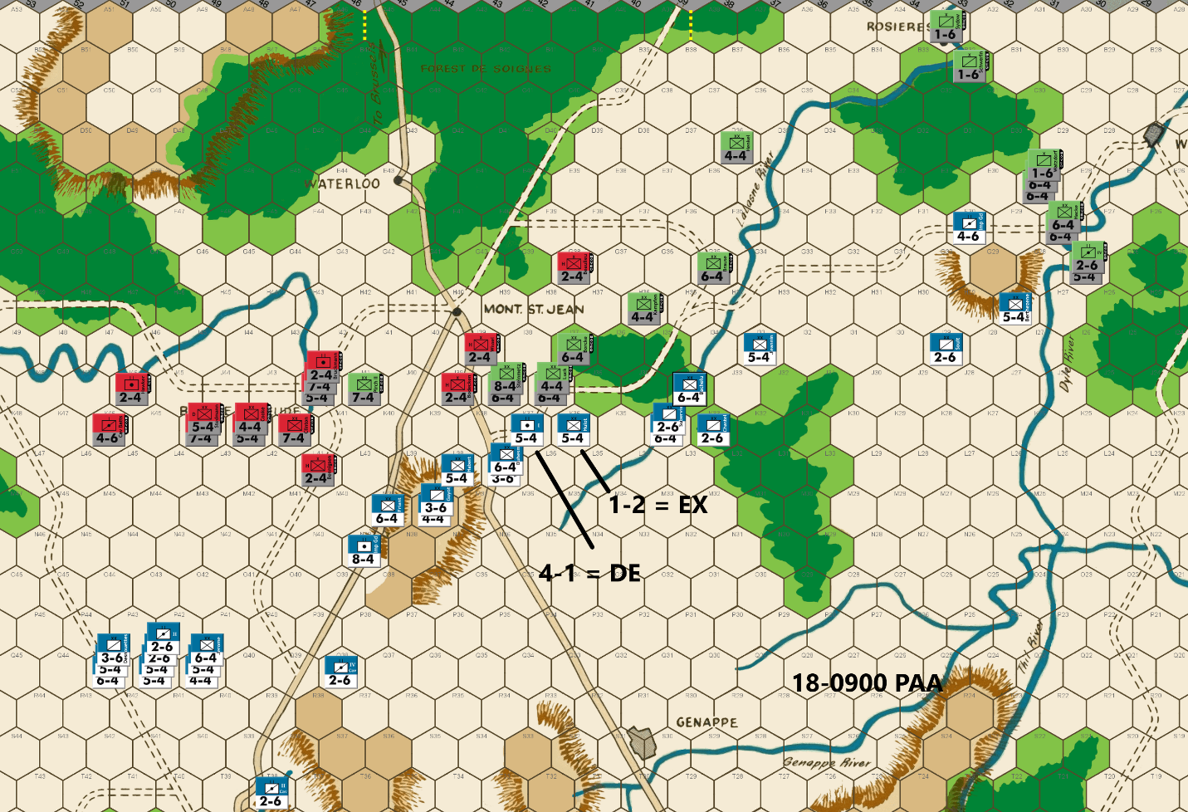
Ed: I am having a really good run of dice, as Bert’s two attacks against my heavies result in DB. We fall back on my right out of range of good French attacks. I again have to offer up two blockers but am able to launch a 4-1 attack in the center to hold ground and hopefully do some damage. This requires a soak off which falls to a 4-4 infantry for the task in a 1-2 attack.
In the east, the French again block my progress toward the central front. I decided to send two cavalries by way of Rosieres to augment the La Lasne River defense. They also have a guaranteed path to the central front in case Bert decides to continue his delay tactics against the Fourth Corps. I protect the La Lasne River with minimum forces against the now weakened French presence.
Combat Results: More luck for me as I get a DE on the 4-1 attack and an exchange on the 1-2 attack. The French are now down two more units for a positive differential for the PAA of five units on board.
Joe: In the Center: The Allied player, having again come through a pair of French attacks unscathed, opts for discretion over valor and retreats the exposed southern Anglo-Allied units northeast back towards the "K" row, and Braine La Leude. Unfortunately for the French commander, the Prussians execute their expected -- and really almost mandatory -- attacks, but unlike their foe, the Allied player rolls perfectly against both the 5-4 at K37 (a 4-1 D Elim) and the 5-4 at K36 (a 1-2 Exchange). The only good news for the French player, such as it is, was that the PAA commander was forced to trade a 4-4 for 5-4 in the K36 exchange.
In the East: The PAA player on this front is now confronted with two very different problems: a) his need to continue to defend the La Lasne River, but with as little combat power as is prudent; and b) his strong wish to push the units of the IVth Corps west as rapidly as possible. In the case of La [EdLasne, the units currently manning the defenses are adequate without being excessive. In addition, on its next move, the Hanoverian 2-4 at G38 will be able to replace the Prussian 4-4 (flank guard) at H36, which will then be able to move towards the center to take on the role of "emergency soak-off," if needed. So far as the IVth Corps is concerned, the bulk of this powerful mixed infantry/cavalry force pushes straight towards the La Lasne River crossing at H34, looking to attack and eliminate any French units that are foolhardy enough to attempt to block its continued forward progress; however, to insure that at least a couple of Prussian cavalry units are no longer delayed by the French player (no matter what he does), the Allied commander sends two 1-6s on a circuitous northern route around the French by way of Rossieres; this move guarantees that, whatever happens elsewhere on the map, at least these two cavalry units will be able to enter the fight at Mont. Ste. Jean by the 1500 game turn.

18-1100 French
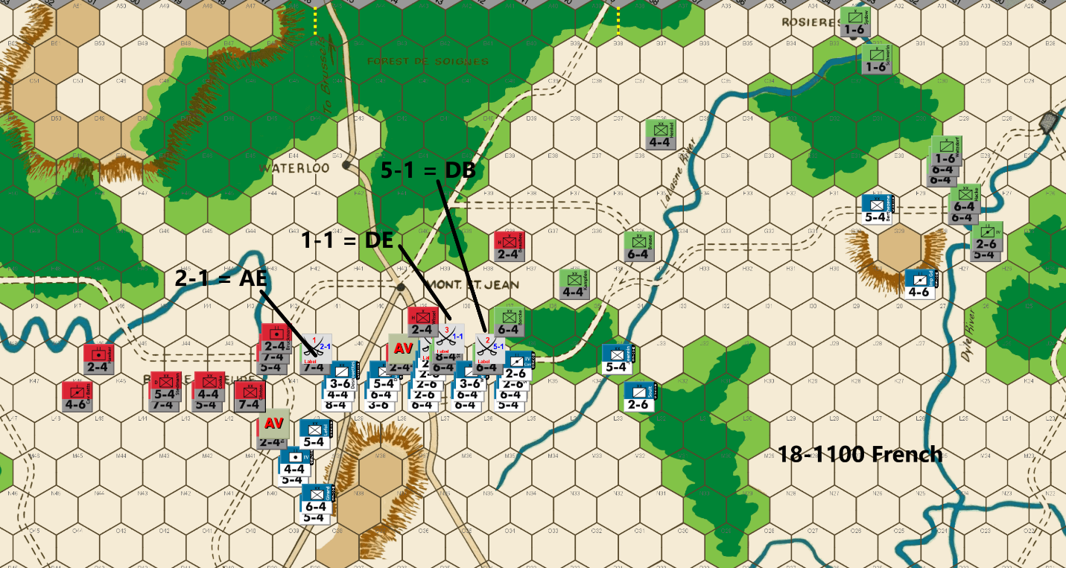
Bert: Oh my, I seem to have understated how precarious my position was this past turn. The dice have turned quite fickle for me as they have teased me with relatively worthless DB2 results on a couple of my last few 1-2 attacks. Without the defenders being surrounded, those “good” rolls don’t offer me much of an advantage, other than keeping my attackers alive and on the front line. Even worse, I managed to get another DB2 result on my favorable 5-1 attack. Meanwhile, the PAA got a D Elim on his 4-1 counterattack and a nasty Exchange on his 1-2 soak off.
Alas, 6 of the last 7 PAA rolled attacks have resulted in my defenders being eliminated. Those attacks killed 10 French pieces worth 36 factors, quite devastating attrition for my side. The tide has turned so much, that I don’t see another alternative other than launching some desperation moves to try and get this game back to even. The problem is that I’ll need almost perfect luck, which is unlikely and undeserved, but more importantly, I’ll need to survive a decent response that the PAA commander will be able to muster even if I hit on my attacks. We might be seeing an early end to this match. I never saw this coming going back to the 1700 turn of June 17th!
Anyway, I pondered a number of different combinations and alternatives for this turn. Please indulge me, but I’m going to talk about a couple of the ones I considered, but rejected, before getting to my actual move. First, I strongly considered an attack against the La Lasne River defense. I could have moved my Imperial Gd to C35 to block the two Prussian 1-1-6s from advancing to the main front, sacrificed Berthezene to a 6-1 attack in blocking the rest of the IV Corps, and then used my other units in range to make a 1-1 versus a doubled Henkel. I did some calculations and determined that even with a D Elim on the 1-1, Ed had just enough units to impede further advance of my units until the IV Corps could come to the rescue.
A second attack considered was quite similar to what I ultimately decided on. This option would have taken a 2-1 instead of a 1-1 versus the 14 Prussian factors at J38, a 1-2 vs the defender at I37, and a 3-1 vs the defender at J37. Since my only real hope for success is a D Elim result versus J38, a 1-1 attack gives me the same 20% chance of that D Elim as the 2-1 attack. As a result, I dismissed this option too. Instead, I settled on the move depicted on the screenshot.
First, I still want to block the IV Corps and so Berthezene and the Imp Guard unit took up blocking positions. Interestingly, the Imp Guard gets to take advantage of a river defense and the counter mix of that group means that the best odds the Prussians can get will be a 5-1 attack vs the 5-4. I’d appreciate getting lucky and having my defender get a DB2 result… 12
Next, I can muster two AVs on the main front and a 5-1 attack versus Kraft. You know what I’m counting on with that attack. That left me with making some attack versus J38. As I mentioned above, a 2-1 didn’t make much sense. With my forces near a breaking point, I didn’t see the need to just make a soak off attack against that stack, so the 1-1 attack was the obvious choice to make. I don’t expect it, but a timely D Elim would brighten my outlook quite a bit. An A Elim result will likely have me offering my surrender to Ed along with a huge congratulations. An Exchange result might be that same outcome, we’ll see. I’ll “try’ to be optimistic…!
I figured that if I do get lucky versus J38, I should probably push additional chips into the pot by attacking Pirch II, also. While of course, I’d love another D Elim on that attack, it might be just as important to try and hold the attacking hex, so a DB2 or an Exchange might be good enough. As a result, the 2-1 attack was the choice for that defender. The reason I need to try and hold that hex is because of the current western positions of the Anglo-Allied units. I hope to block some of maneuverability of those units from getting to good positions in front of Mont St Jean on Ed’s next move.
On this move, I’ve made my attack order so that the AV attacks follow the rolled attacks. This prevents Ed from retreating my cavalry units attacking J38 from getting retreated into a weak defensive position on an AB2 result. Without the attack sequence change, Ed could retreat them so that they are at risk of a very favorable surround attack.
Finally, even if the dice are completely favorable for me this turn, Ed will still be able to muster a decent attack on his coming turn. Since I can’t afford much more attrition, I’ll need to see some DB2 results on his attacks. I suppose a costly exchange or two might work. I’m not asking for too much, am I! Of course, that is all moot if I can’t do some damage myself, first. Looking forward to the rolls once again.
[Editor’s note: the 2-1 was an AE, the 1-1 a DE, and the 5-1 a DB]
Joe: A Possible Tipping Point?
The triumphalist euphoria that had animated French headquarters only a few hours ago has unexpectedly turned to gloomy pessimism: L'Armee du Nord has seen one Allied attack after another succeed while its own attacks have misfired repeatedly, and the result of this recent bad luck has been the destruction of an entire French corps with virtually no compensation in terms of PAA casualties. Even more worrying, the initiative, and with it the control of the battle space, has also gradually shifted to the Allied player. Under these circumstances, the temptation for the French commander to overreact can be irresistible; however, while the battlefield advantage may have lately seemed to tip in favor of the PAA, the "Hundred Days Campaign" has not yet foundered, and with meticulous planning and a little good luck, Napoleon could still retrieve his strategic situation, and with it his chance for victory. In order to do that, however, the Emperor must start with a clear-eyed assessment of both the enemy's and his own army's current strengths and weaknesses and then follow up with an appraisal of possible ways in which he might be able to exploit the terrain in the central battle space either now, or on future game turns.
First, army versus army: On the main front, L'Armee du Nord still exceeds the combined PAA force's combat power by 105 factors to 103, and the PAA unit count by twenty-five to twenty-two units. Since the French player is first to act, two Allied 2-4s can be subtracted from both of these totals as -- no matter what else happens on the battlefield this coming turn -- these two PAA units (along with their four combat factors) will be making the trip to the "dead pile." In view of the preceding, the primary (and immediate) goal of the French commander -- at least in my opinion -- should be for him to seek (3-1 or better) combats that would (statistically-speaking) be expected to expand his numerical advantage; this means that low-odds attacks should be strictly limited, and when deemed necessary -- either because of soak-off requirements or positional considerations -- should be restricted to those utilizing a single attacking unit only [one appealing option, should it present itself, would be to attack two enemy units (e.g., to attack two 7-4s with the a single 8-4) as in this specific types of attacks, an Exchange would eliminate all three units]; not surprisingly, this approach strongly implies that potential soak-off losses should be minimized. Moreover, this also means that regular (3-1 or better) attacks that risk Exchanges should be organized -- in so far as it is possible -- so that attacking units are exchanged on a one for one, and factor for factor, basis. And finally, in keeping with this tactical approach, the few French cavalry units still remaining, should be carefully husbanded and, except for exceptional circumstances, should never be exposed en mass to high odds enemy attacks.
Second, exploiting the battle space: Unfortunately, L'Armee du Nord -- because of its rough parity with the local PAA -- is currently in no position either to push the Anglo-Allies north across the eastern Samme River or to dispatch cavalry raiders around the Allied Right with the goal of threatening the PAA rear by driving towards the clear terrain along the western "A" and "B" rows. Nor is it in any position -- given the approach of the Prussian IVth Corps -- to continue to seriously threaten the northern La Lasne for more than one or two more game turns. On the contrary, in lieu of maneuver, the French player finds the majority of his army temporarily mired in a battle of attrition over control of the hex rows immediately south of the Mont. Ste. Jean crossroads at H40. However, if the PAA line can be pushed back to the "H" row or beyond, then, with the Allied front effectively cut in two, the French commander -- assuming he still possesses sufficient combat power -- may still be able to concentrate enough force against one part or the other of the now-divided Allied line to open a path to Brussels and victory.
The Move
In the Center: When I review the current French move on the central front, I am reminded of an observation made, decades ago, by George Phillies when he was critiquing a STALINGRAD Replay in the pages of The General. I am paraphrasing a little, but basically what he said was this: "Although even good players tend to make this mistake occasionally, it is still never a good idea to avoid making good attacks, in order to make bad ones." I suspect that, because of frustration with his bad luck (both attacking and defending) and more than a little bit of desperation, this French player has broken from his usual tactical style of meticulously planned attacks and has opted, instead, for a more Berserker low-odds approach to the battlefield. Of course, different players will all have their own preferred styles of play, but usually when several high risk low-dds attacks suddenly crop up in the same move by a seasoned competitor, it suggests that this player has decided that the time has come to resort to "Hail Mary" attacks in order salvage a losing situation. And while I think that we all have, at various times, appealed to the "Dice Gods" for help in dire game situations, I do not personally believe that the French player, in this game, is nearly far enough behind that it would warrant his risking some of the attacks he has chosen to make this time around. So, that being said, which specific attacks do I personally have a problem with? The French player executed five combats on his current player turn. The first two were uncontroversial 7-1 AVs versus PAA 2-4s, both of which I would have handled exactly the same. However, the problems -- at least in my view -- start with a highly risky 2-1 versus the Prussian 7-4 at J41 which used an 8-4, a 4-4 and a 3-6 (fifteen factors). Granted, the French player's reasoning for this combat seems obvious, he wanted to eliminate Pirch II by either a D Elim or an Exchange (1 50% chance), but just as importantly, it also looks like he wanted to seize and hold K40 (even in the event of an Exchange) so as to shore up the flanks of the French units at both L40 and K39: a secondary goal that, in my view, is perfectly reasonable. What was not reasonable, on the other hand, was his willingness to risk three units in a speculative attack that was not particularly advantageous attrition-wise, and although useful, was not especially important in a positional sense. My own preference -- especially since I would have had different plans for the Imp. Gd. Foot Arty(the 8-4) -- would have been to attack J41 with a single 4-4 (20% chance of DB2, 20% chance of an Exchange), and to have backed it up with a 3-6 and two 2-6s at L39. As things turned out, the actual die roll resulted in the "dreaded" A Elim which sent three French units and fifteen factors straight to the "dead pile." The next questionable French attack was a 1-1 versus a Prussian 8-4 and 6-4 at J38 using a 6-4 and four 2-6s. Needless to say, the possibility of losing five units (including almost half of the Emperor's surviving cavalry) whether by an A Elim (30% chance) or an Exchange (20% chance), all for the 20% possibility of snagging a lucky D Elim, struck me as a bit optimistic. However, in spite of the odds, the French player finally got lucky with this attack and garnered a hitherto elusive D Elim. The final combat, which actually required a die roll, was a (wasteful, to my mind) 5-1 versus the lone Prussian 6-4 at J37 using French stacks of fifteen factors at both K36 and K37. Unfortunately, the result of this high-odds attack, like so many other French combats in the last few game turns, managed to avoid the 70% possibility of a D Elim, and yielded yet another (30% chance) DB2 instead. For my own part, except for pulling the four 2-6s out of the battle line and replacing them with the 8-4, I would not have changed the positions of any of the other units along this section of the front The difference would have come in my choice of attacks: instead of a "big" 1-1 and a 5-1, I would have attacked the Prussian 6-4 at J38 at 3-1, the 8-4 at J38 at 1-1 (using the Imp. Gd. Foot Arty), and the other 6-4 at J37, also at 3-1. To my mind, the advantage of these alternate combats is: a) that a maximum of only two units, and twelve factors would actually be at risk from low-odds A Elim results, instead of the eight units and twenty-nine factors that were placed in jeopardy by the original attacks [In essence: my thinking is that losing the same number of units and eight more factors than the PAA, painful though that might be, would only lose the battle; however losing six more units and twenty-five more factors than the Allies would almost certainly lose the game]; b) There is no scenario (even one that stipulates only A Elim and Exchange results), in which the French would finish the combat round -- when counting the two Allied units AV'd in the final totals -- having lost more units than the PAA; and c) a sizeable part -- almost 50% -- of the surviving French cavalry would, in the case of my alternate choice of combats, be withdrawn from the battle line to the rear, and hence, would not be exposed to a direct PAA attack during the Allied player turn.
In the East: As was the case in the center, I would also approach this sector somewhat differently than did the French commander in the game. And so far as the original French move is concerned, I understand that the French player, by positioning the 5-4 at F30 (where it can only be attacked from two hexes at 5-1, and thus, has a 30% chance of survival), and the 4-6 at H28 (where it is doubled), is attempting to impose the maximum delay on the advancing IVth Corps without resorting to French units that can easily be AV'd. However, my own approach would be to position the 5-4 at H28, Soult (a 2-6) at F30, and move the 4-6 to stack with Jeannin (a 5-4) at I33 to block the La Lasne River ford at H34. Chastel (a 2-6) would remain at K33. Admittedly, my version of the move guarantees the automatic elimination of Soult at F30, but it also maintains a very modest (if temporary) threat against the La Lasne River, while still leaving open the option of either positioning another sacrifice/delay unit in the direct path of the incoming Prussians, or, alternatively, of conducting an orderly French retreat out of harm's way by Berthezene, Jeannin, the 4-6, and Chastel next turn, should such a move be deemed worthwhile.

18-1100 PAA
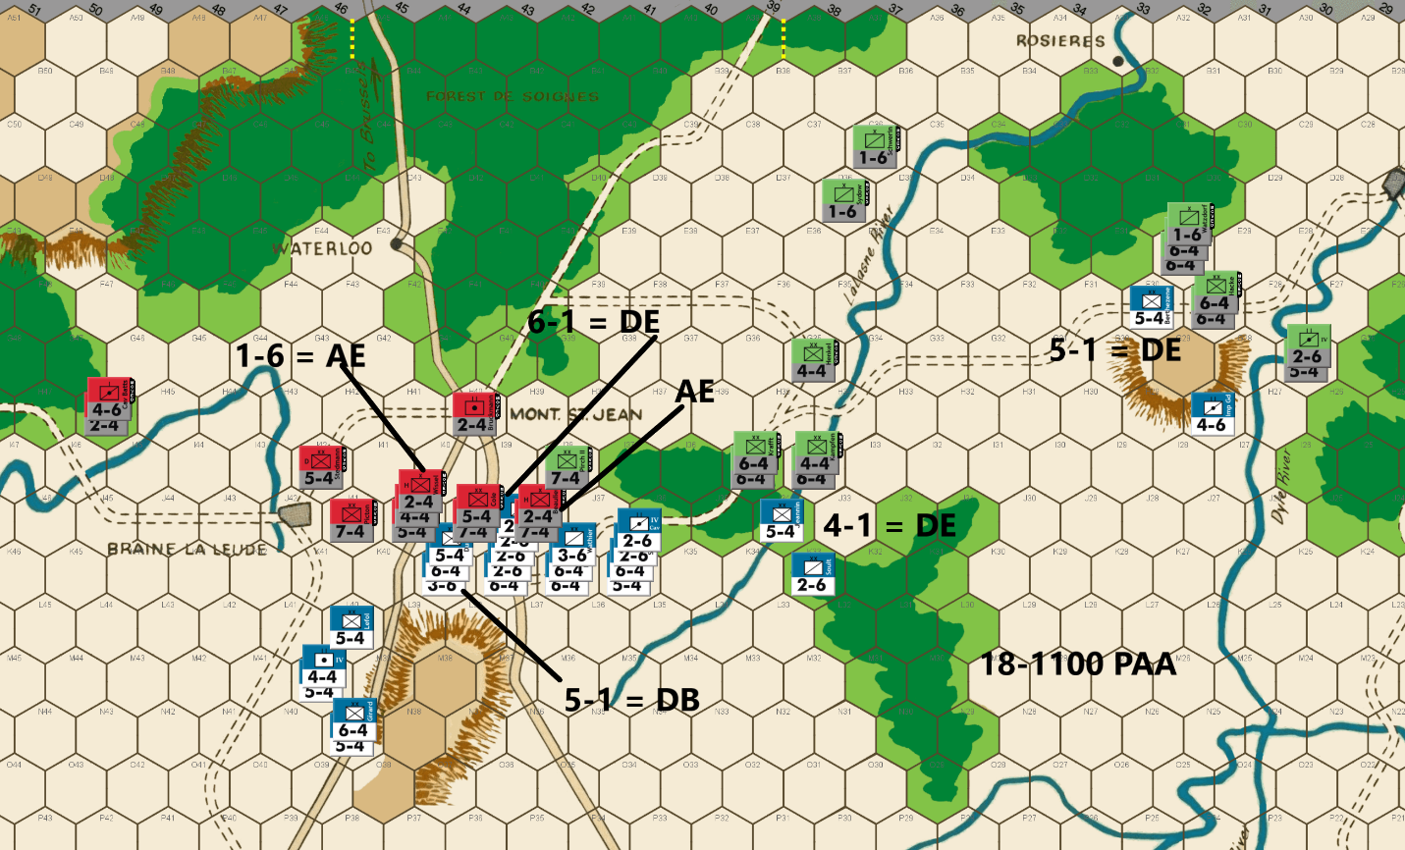
Ed: Bert’s attacks resulted in both of us losing significant units. But these exchanges are to my benefit as I have more units than he does. I am finally able to unite the Allied defense across the center of the board two hex rows in front of Mt. St. Jean. I launched two favorable attacks, which require two Anglo-Allied units for soak offs. I also put Cav Batts at H46 to protect the back door to Brussels through the G46-F48 forest gap. From there my cavalry can threaten a surround attack against the French left flank.
I’m surprised that Bert gave me two favorable attacks farther east – a 5-4 infantry on the La Lasne River and a 5-4 infantry blocker at F30.
Combat Results: I am having significantly better luck than Bert these last several turns, giving the PAA a big advantage in the game. While nice from a PAA winning standpoint, it is making the end game less interesting. I got three DEs for the cost of two soak off losses. The French are down to 21 units to the PAA count of 25.
Joe: In the Center: The PAA player-- at this point in the game -- really has only two basic goals when it comes to Allied operations in the center: a) To stall the French drive south of Mont. Ste. Jean until the Prussian IVth Corps can arrive in the battle area; and b) To whittle away at French combat strength (both numerically and factors-wise) so as to steadily degrade both the French commander's combat power, and his capacity to project strategic threats through maneuver. On the whole, the Allied player's move pursues both of these goals effectively. He attacks a couple of exposed French cavalry units at high odds (so as to avoid exchanges, rolling a DB2 against the 3-6, and a D Elim against the 2-6) and retreats his Right north behind the eastern Samme River. The only "nit" I have with this move is the decision to position a single 5-4 at I42. Given the French player's demonstrated affinity for "high risk/high reward" low-odds attacks, I personally would have either moved Cav. Batts. (a 4-6) to reinforce Stedmann at I42, or, alternatively, positioned the 5-4 at H43 where it would still be 3-1 proof, but where a successful French attack (say a 2-1, or a 1-1 using two 5-4s and a 2-6) would not allow a post-combat advance into I42 surrounding Picton at J41.
In the East: The French player's decision to expose both Jeannin (at J34) and Berthezene (at F30) to high-odds attacks (a 4-1 and 5-1 respectively) is a gift that the PAA commander is quick to accept. And, staying true to form, both PAA combats yield the usual D Elims. That said, the position of Jeannin is particularly unfortunate, as its position (at J34) as a block on the forest trail is pretty much pointless, especially since it is highly doubtful that the Allied player would advance any of his Prussian units along that track to attack the French Right, when those units could, in turn, easily be surrounded. [This, by the way, is why I personally preferred stacking Jeannin and the 4-6 at I33: besides pinning a few Prussian defenders west of the La Lasne for another turn, they would both be doubled, and any attempt by the PAA player to launch a "trapping attack" with the objective, for instance, of retreating a lone 4-6 into J32, followed by an advance, would be impossible.]

18-1300 French
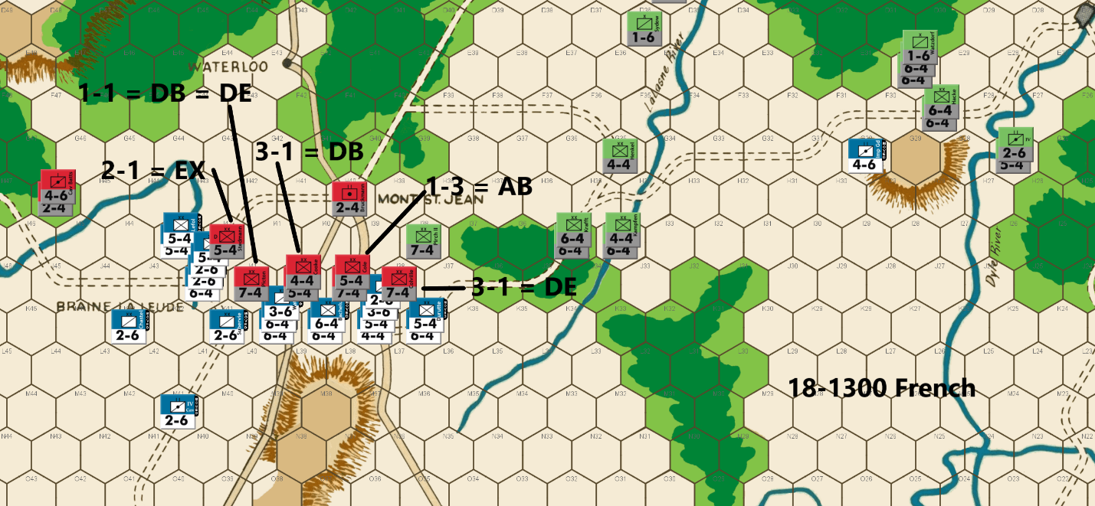
Bert: Oh well, we came close to doing what needed to be done last turn. As nice as the D Elim was on the 1-1 attack for the French, my forces were dealt a costly A Elim on the 2-1 attack. Those results are a fair outcome with something for both sides, but I needed better than a fair outcome, especially with another frustrating DB2 result on the 5-1 attack. Dealing with three more D Elim results on Ed’s attacks, my French forces are hanging on by the slimmest of threads. I like to battle on when there is a chance, and so I’ll keep pushing on.
My slim chance for success is predicated on continuing to cause as much attrition as I can to the PAA forces while trying to push forward to Mont St Jean before the arrival of the IV Corps. If I can pull this off, I will focus what is left of my army to mainly drive up the western road through Waterloo and then hopefully to Brussels.
If I can keep some semblance of an army left, I will have ten more attacks following this turn. At the end of this move, my units will be roughly 10 rows of hexes away from reaching the A row, but since there is little chance for the PAA to maneuver on the A row on that last turn, I am realistically 9 rows away. Further, my attacks this turn “could” eliminate up to five Anglo-Allied units, but let’s say that only three get eliminated. That will leave Ed with a precarious number of units left to block the western roads for the remaining turns and will make counterattacks along that road difficult. If he has to chance losing a unit on an exchange or soak-off, it will leave him likely short of units to hold that line. If he can’t, I might be able to exit enough of what is left of my rag tag forces to cause eliminations of the remaining units on the eastern side of the Forest De Soignes wood line.
Should I somehow push forward and reach the exit hex, I’m guessing I’ll need to have roughly 30 factors left to exit the board in order to eliminate the Prussian side of the defense. That will be ambitious and tight, especially with Ed almost certain to not just sit back, but to launch counterattacks with those Prussians. Hey, I didn’t claim that it was fool-proof or even a good plan!
Of course, it won’t be easy, and I could certainly be missing something, but I feel it is enough of a chance that I will play on a turn at a time until all reasonable hope is lost. My attacks could result in that happening followed by my resignation this turn, especially if I get another A Elim on the 2-1 attack or if my larger attacks are another series of D Back 2 results. I’ll try to be optimistic, until it’s actually over. It all starts from here forward with this turn.
In the east, I’ve determined that sacrificing my Imperial Guard unit to block the IV Corps is much more valuable usage of that unit rather than trying to run away to get back into the fight with the other French units. One full turn of preventing the IV Corps from reaching Mont. St. Jean is definitely worth it.
On the main battle front, I’m taking 3-1 attacks versus a 7-4 unit and a stack of two units totaling 9 factors. I can survive an exchange on at least one of these attacks so hopefully, I can get a D Elim and an Exchange result to maximize the PAA attrition. I’m taking a 2-1 attack, that really needs to displace (eliminate or retreat) the defender at I42. Again, an exchange is acceptable even though it is damaging. Any displacement of the defender will allow me to advance after combat and surround Picton at J41.
I’ll have a 1-1 versus Picton, which hopefully will be a surround attack if I get to advance on that previous attack. No matter the outcome of the 1-1 attack, Picton would be trapped, if not eliminated, following that 1-1 attack, provided I get the displacement on the 2-1. That would force an unfavorable counterattack to risk saving Picton and Ed would have to consider risking the loss of additional PAA pieces in order to save that unit on his turn.
Finally, I needed one soak off attack to allow all of the above to come together. I decided to risk my 4-factor infantry unit to make a 1-3 attack rather than a 2-factor unit to make a 1-6 attack. I did this intentionally because trying to have a better chance to keep my piece alive seems like a better risk than the almost certain elimination of my piece if I take the lower odds attack.
Let’s see a string of favorable rolls on this turn to keep this game interesting!
[Editor’s note: the 2-1 was an EX, the 1-1 a DE, the 3-1 a DB, and the 1-3 soak off an AB]
Joe: In the Center: The battlefield opportunity that the French commander has been waiting for all day has finally arrived! The PAA player -- in order to hold the French army south of Mont. Ste. Jean -- has been compelled to deploy a substantial number of his best units in a four hex battle line (in clear terrain) that can be attacked head-on from five hexes. This is a situation that the Emperor is justifiably eager to exploit to the greatest extent possible. [Moreover, these are precisely the battlefield situations that play to the French Army's unique strengths: a) a nicely balanced inventory of different unit sizes and types which, in turn, lead to b) a much more efficient organizational regime that allows French units to combine into fifteen factor stacks much more easily (and frequently) than can the component units of either the Anglo-Allied or Prussian Armies.] In view of all this, it is probably not surprising that the French player -- confronted with a veritable a cornucopia of exposed Allied targets -- falls prey to temptation and overconfidence and, instead of settling for inflicting a damaging and relatively risk-free defeat on the PAA force to his front, decides to go "all-in" in pursuit of a decisive "knockout" blow. Unfortunately for the Emperor, such a goal -- as subsequent events will show -- is probably out of reach of the French player, at least for the time being, due to the relatively evenly-matched current force levels of the two opposing armies. In any case, out of reach or not, the French commander eschews caution in favor of audacity, and mounts five attacks -- two of which are very speculative -- against the Anglo-Allied battle line in a quest for PAA casualties; to whit: a 3-1 versus Colville (D Elim); a 1-3 against the units in J39 (AB2); a 3-1 versus the two units in J40 (DB2); a 2-1 against a doubled Stedmann at I42 (Exchange, adv: Alix); and a 1-1 (now surrounded) against Picton at J41 (DB2 = D Elim; adv: Teste). While certainly not perfect (the doubled Exchange and the 3-1 DB2 were disappointing, I'm sure, to the French commander), these results are, nonetheless, a net plus for the commander of L'Armee du Nord, as the Allies end the combat phase having lost nineteen factors (and three units) to ten factors (and two units) for the French. And so, considering these generally advantageous combat outcomes, why am I still critical of certain key elements of the French move? The main reason, quite simply, is that, because I evaluate moves on a risk/reward and not an outcomes basis, I consider a couple of these French attacks to be far riskier than either the game situation or their potential combat benefits can presently justify. Consider the following: the two speculative French attacks that I find especially questionable: a 2-1 risking twenty factors and five units; and a 1-1 risking seven factors, and two units, when considered together could, with good luck, potentially eliminate twelve Anglo-Allied factors, and two units; on the other hand, two unlucky A Elim die rolls would permanently remove, from the French "Order of Battle," twenty-seven factors, and seven units. In addition, because of his post-combat advance across the Samme, Alix (a 5-4) is now vulnerable to a surrounded counterattack. Admittedly, had the "big" French 3-1 versus Cooke (a 4-4) and Chasse (a 5-4) succeeded in eliminating both units (a 70% chance), then the PAA player would have found his position south of Mont. Ste.- Jean severely compromised going into his own player turn; on the other hand, that would also have required (along with Stedmann) that Colville (a 7-4) be eliminated, as well (another 70% chance). Since the probability of the 2-1, and both 3-1s all succeeding in eliminating their enemy target units (the 1-1 versus Picton is irrelevant for this calculation) is only about 34%, I personally consider the two French low-odds attacks (however creative and potentially rewarding they might have been) to be just a little too risky -- given the 66% chance of at least one of these three key attacks failing -- to gamble on at this point in the game, especially since the French player will now be fighting on ground that is favorable to him, and increasingly hazardous to his opponent. Of course, since I have gone out of my way to criticize the kind of clever and audacious French play that conceivably might have won this game at a single stroke, it is probably reasonable to ask: what French move would I have made instead? The short answer -- in keeping with my personal "Coat of Arms" which features two crossed white chicken feathers on a field of bilious yellow, with the motto: Sauve Qui Peut! (rough translation: Every man for himself!) -- is that my own far more conservative (read: timid) version of this turn's move seeks to maximize the French advantage in efficient stacking, while minimizing both combat and soak-off losses. That said -- and having gone to the trouble of actually executing this alternative move just to make sure that it was legal -- I would have begun by attending to the flank protection for the French left, then I would have organized four stacks of fifteen factors, and one stack of fourteen, and with those units I would have made the following attacks: a 4-1 versus Picton (a 7-4); a 1-2 (using a 2-6) versus Cooke (a 4-4); a 1-5 (using a 2-6) versus Chasse (a 5-4) and Cole (another 5-4); a 3-1 versus Clinton (a 7-4); and a 3-1 versus Colville (a 7-4). Admittedly, while the current French player's move -- with better luck -- could well have fatally crippled the Anglo-Allied Army, my own move, as likely as not, would probably have only caused the PAA commander a bit of inconvenience. On the other hand, even if all of my attacks had misfired, the French battlefield situation would not have ended up being much worse than it was at the beginning of the turn.

In the East: The curtain, at least for the time being, is finally getting ready to ring down on French operations in this sector, as the troopers of the Imp. Gd. Hrs. Arty (a 4-6) prepare to "give the last full measure of their devotion" in their suicidal mission to slow the Prussian IVth Corps for one last game turn. I confess that I have mixed feelings about a French strategy that employs major French units as sacrifice/delay units on this, or any other front. On the other hand, while the loss of Jeannin, Berhezene and the Imp. Gd. Hrs. Arty has been a heavy price to pay just to gain a few extra game turns of freedom from battlefield interference, on the central front, by the Prussian IVth Corps, I will withhold judgement until I see how all this plays out in the end.

18-1300 PAA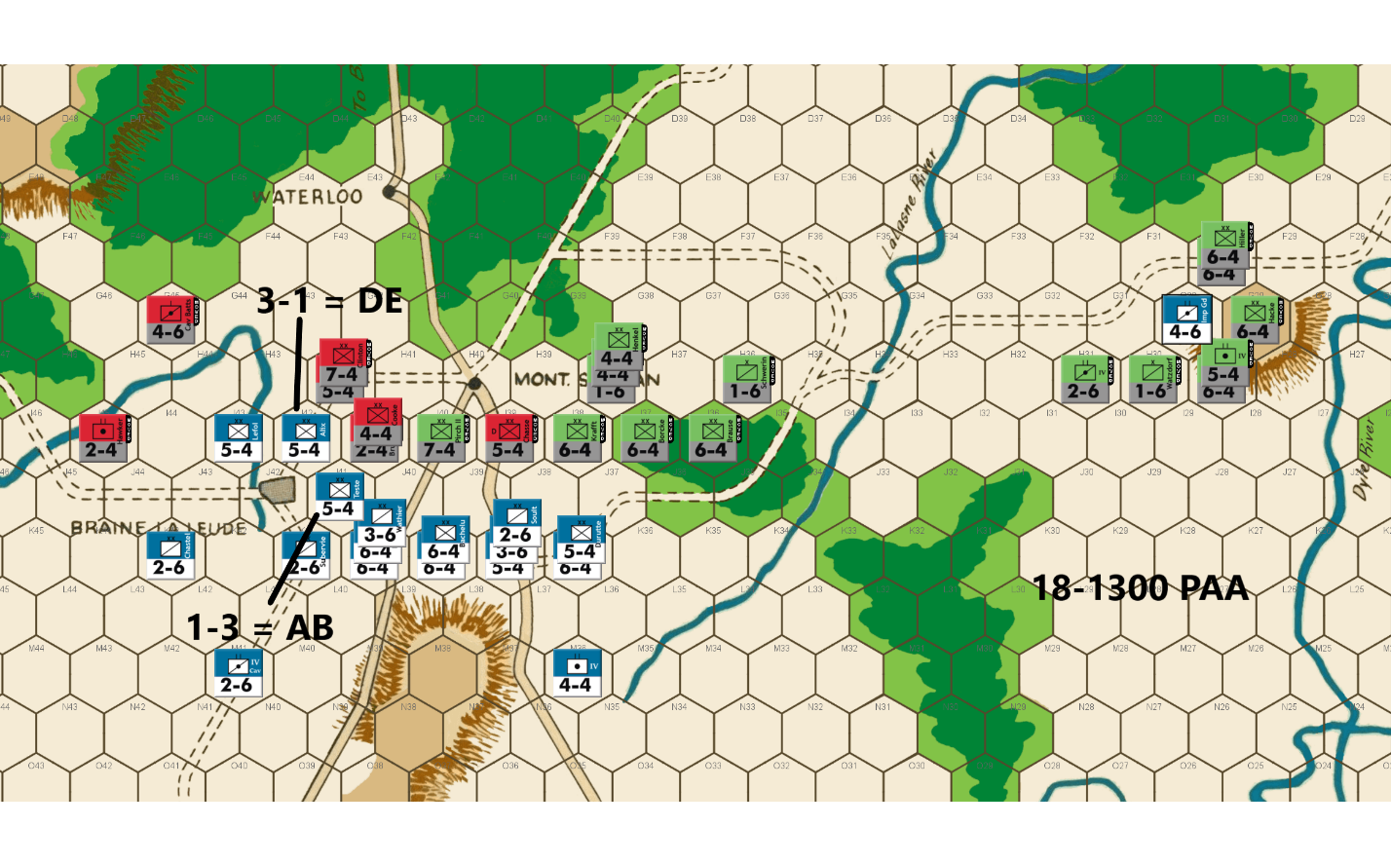
Ed: Bert did considerable damage to the Anglo-Allied forces, sending two 7-4s and a 5-4 to the dead pile. But the French suffered an exchange against a doubled position costing them three units, leaving me with a four-unit advantage in total forces. Maybe Bert felt that he was down enough in the game, and he needed to get lucky. I expected a high odds attack vs the 7-4 at J41 and advancing a unit into the vacated hex. It would require a soak off against the doubled 5-4. But that way the advancing unit would have a retreat route if attacked.
However, seven of my units are stuck in the east due to Bert’s delaying tactics. The two horse units can get into action at the center of the board in two turns. It will be three turns before that infantry can get into the battle. At the moment he has three more units at the battle front than I do.
But I believe I have an advantage in the game. I do not believe Bert will be able to eliminate all my forces with attacks. His only chance as I see it is to exit the board to Brussels, allowing him to eliminate two PAA factors for every French factor that exits. The impending arrival of the Prussian Fourth Corps likely rules out the secondary road in the east. That leaves the Primary Road, which has two options. One is through Waterloo. The second is via the back door through the forest gap at G46, F47, and E48 and on to the road to A45. He very well may try both.
I take the 3-1 surround attack against the adventurous French 5-4 infantry that has his back to the river guaranteeing his demise and holding ground. The Imp Gd FA will also die in an AV attack. That will leave the French with 16 units and 68 combat factors to my 22 units and 96 combat factors.
I move Prussians toward Mt. St. Jean where they can help defend the Primary Road and assist in blocking the exit path. I also avoid stacking units together, where possible, so as not to offer tempting targets on one hex for low odds attacks.
My 3-1 attack is a perfect outcome for me as I get the DE on the 5-4 and my 1-3 soak off survives.
Joe: In the Center: The Allied player, having just narrowly avoided catastrophe thanks to a single unfavorable French die roll, responds pretty much as expected: when it is this turn to act, he counterattacks Alix at 3-1 surrounded (D Elim), and soaks-off against Teste (AB2). Naturally, his good luck continues, as he avoids an Exchange in the 3-1 against Alix, and the A Elim in the 1-3 against Teste. On the downside, the PAA forces in the center have just about run out of room when it comes to shielding the critically-important crossroads at H40; and to add to the PAA player's woes, Anglo-Allied soak-off units are also about to run out. In view of all that, the PAA commander abandons his central front tactic of screening sections of his battle line, and, instead, arrays his units in a linear shoulder-to-shoulder formation, doubtless in hopes both of limiting the number of future French attacks, and of picking-off a few French soak-off units, as well.
In the East: The Prussians at last finish mopping up the last French remnants in this sector with a 7-1 surrounded AV versus the gallant Imp. Gd. Hrs. Arty. This attack finally clears the way for the IVth Corps to resume its march towards the distant "sound of the guns" at Mont. Ste.-Jean. However, precious time has been lost, and while the several cavalry units still accompanying the main force will now show up at Mont. Ste.-Jean by the 1700 game turn, the infantry component of the corps will not arrive at the central battle space until the 18 Jun 1900 game turn, at the earliest.

18-1500 French
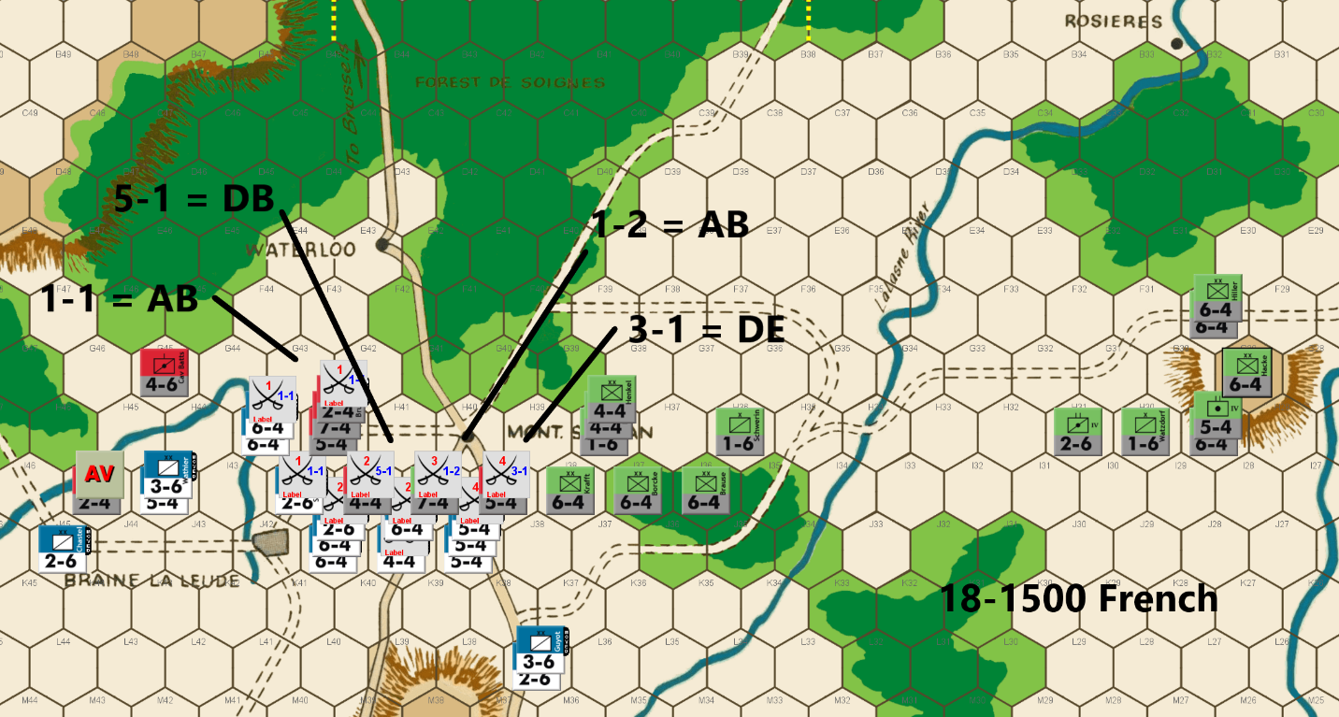
Bert: I'm happy as I’m getting to play on for at least another turn and perhaps longer. My attacks went well last turn, and I have no complaints, just a wish. Of course, I wish that I could have traded the DB2 on the attack versus J40 with the exchange on the attack versus I42 as this would have eliminated one more PAA defender and cost the French one less attack factor.
I want to point out a subtle move that I made with my attacks last turn that made Ed’s move a tiny bit more challenging. I planned for my attacks versus J40 and I42 to have retreat results move those defenders to hex I41. The idea behind this is to take advantage of the rule that a unit that starts in the ZOC of an enemy unit can’t exit that units ZOC and move into a different hex that is in that same units ZOC. My plan was that if I displaced the defender in hex I42, which I did, I would be advancing into hex I42. I wanted to make sure that the units that were retreated to hex I41, couldn’t reposition themselves to a more favorable hex to counterattack from, such as a hex on the H row. If they are to be used in a counterattack against any piece on my western flank, it would have to be from hex I41. This forces the PAA commander to leave units that I can get favorable (at least 3-1) odds against on my next move to be attacked from at least two hexes. If I had just retreated the J40 defenders to say hex I39 or H40, they would have had much more flexibility about where they would be placed on the PAA’s 1300 turn. Ed’s response was pretty much what I expected, especially with the juicy target on hex I42, that could be surrounded. Despite my best chanting for a die roll that would exchange some valuable PAA piece, it was another D Elim result – he didn’t even need the DB2. Alas, his soak off unit escaped as well.
After doing some calculating, I consider three versions of attacks this move. The first was to line up my troops on the J row and attack his pieces on the west side of the I row and hope that I could roll D Elim results on my 3-1+ attacks with an Exchange on a 1-2. The calculus was that while this would have more than likely conserved my army to fight on for awhile longer, I just don’t have enough army left to try that conservative approach.
Next, I put together a combination of taking three 3-1 attacks, two of which would have been surrounded if all went according to plan. There was also a 1-2 attack vs Pirch II, hoping for an exchange result. The key was going to be a potentially decisive 2-1 attack versus hex H42, since I could advance after combat into that hex, which would put more pressure on the PAA position.
After pondering the various combinations of the results, I concluded that an exchange or a DB2 on the 2-1 was not going to be enough to turn the tide. Further, if I somehow got the needed D Elim on that attack, it could very well be offset by lousy results (exchanges) on the 3-1 attacks, which would have offset most of the good from a D Elim on that 2-1. In the end, I determined that a 1-1 versus H42, with the same two possible D Elim outcomes that a 2-1 offers up could be combined by turning two of my 3-1 attacks into 5-1 attacks. I also would have an extra unit to cover my eastern flank slightly more efficiently.
Bottom line, if you are counting on a lucky roll to salvage a position, you need to do a couple of things if at all possible. First, try for an outcome that maximizes the damage that your lucky roll causes should you actually get it. One of the reasons I chose to retreat Bruckmann to H42 after the last combat was that I was pretty sure I would be attacking H42 at low odds on my turn. My thought was why not kill an extra piece and two more factors if I can hit a lucky roll! Next, try to maximize the effectiveness of any other attacks you are making on the turn that you’re trying for that lucky roll. As I noted above, what good would a D Elim result be for me versus H42, if I end up getting exchange results on two or three other attacks this turn? I think that would still have left me in a losing position.
Anyway, my logic and plan could be all wrong, but the point of this exercise is to let you follow along with my thinking and then decide what works best for your play. Of course, the various favorable outcomes are moot unless I actually can hit the lucky roll this turn!
Joe: The French player, it would appear, has set his heart on turning the Allied Right, no matter what it costs, and, unless he starts getting a lot luckier than he has been up to now, it could cost plenty. To be fair, I understand his desire to complete the destruction of the Anglo-Allied Army and, by so doing, to open up a path to Waterloo (E43) and the Brussels Road, before the Prussians can decisively intervene. Regrettably, this ongoing fight around Braine la Leude has already consumed three French infantry divisions and shows no sign, as yet, that the Allied commander is ready to "throw in the towel." On the other hand, abandoning J38 in order to free up units for the "big" 1-1 against the Allied stack at H42 -- while this does temporarily take the Prussians out of the fight for the center, at least for a turn -- also opens up the French Right to the possibility of a follow-on Prussian attack against J39 from J38, I39 and I40. Moreover, since I have already noted my skepticism regarding risky French low-odds attacks in my previous comments, I will not belabor the issue again now; however, I will suggest that, because the total French force now numbers only sixty-eight factors, and sixteen units, as opposed to a local PAA contingent of sixty-four factors, and fifteen units (with substantially more on the way), it might be prudent for the French player to avoid combat situations that -- either before or after battle resolution -- leave any of his units without a retreat route. For example, during this round of combats, the French player stipulated five attacks, in the following order: a 5-1 surrounded AV versus I45, a 1-1 versus H42 (AB2), a 5-1 versus I41 (DB2), a 1-2 versus I40 (AB2), and a 3-1 versus I39 (D Elim). In the case of the 1-1 cross-river/open terrain attack against H42, two 6-4s attacked from H43 (a river hex), while a 2-6 attacked from I42 (a clear terrain hex) which negated the river bonus for the units at H42. Unfortunately, there was a small problem -- ignoring its perilous odds -- with this attack as it had been organized by the French commander; to whit: the 2-6 attacking from I42 had no retreat route until the Allied 4-4 in I41 had either been retreated or eliminated. And since there is only a 30% chance that the French cross-river attack would produce an advance after combat (on a D Elim or DB2 result only), and a 30% chance that the 5-1 versus the 4-4 in I41 would yield a DB2, instead of a D Elim, this meant that together, these two results only represented a 9% chance of actually producing a DB2=D Elim (surrounded) combat outcome for the 4-4, while the chance of an AB2 retreating the 2-6 was 20%. That being the case, I believe that whatever one might think of the wisdom of the French attacks themselves, the order of their combat resolution -- unlike that in the actual game -- should have stipulated the 5-1 attack versus the 4-4 before the 1-1 versus H42. Finally, as I noted above, I think that abandoning J38 was a nontrivial positional mistake. And so, out of curiosity, I decided to deconstruct the original move and then reorganize the French dispositions so as to be able to retain French control of the "J" row from J38 to J42. Once I had finished, and all the various positional changes had been made, I discovered that the L'Armee du Nord had enough units and combat power remaining to be able to AV the 2-4 at I45, and also make the following additional attacks: a 5-1 versus the 4-4 (at I41), a 1-2 versus the 7-4 (in I40), a 5-1 versus the 5-4 (at I39) and a 1-2 versus the 6-4 (in I38). In addition, the French Army still ended up with a left-over 5-4 which could be placed at K36, so as to block the forest track on the French Right.

18-1500 PAA
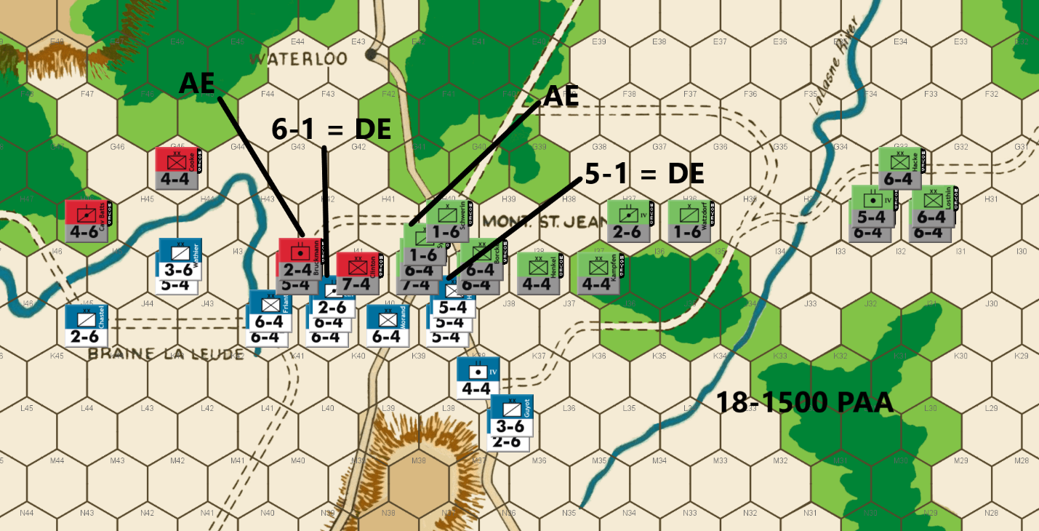
Ed: It is critical to hold the I Row to avoid having my forces split. The Anglo-Allies have been whittled down such that my attacks with them are very limited. I want to protect the back door route to Brussels which takes up Cav Batts and a 4-4. But I can muster a 6-1 on a cavalry unit.
The Prussians mount an attack on a 5-4 at 5-1 to avoid an exchange result. I need to preserve as many units as I can. Both attacks are DE, which certainly helps. I protect my flank with a pair of 4-4s. It provides a six-hex long line of PAA forces which is more than the French will be able to attack. I’m hoping for some attack opportunities next turn against however Bert deploys.
Meanwhile, the Prussian Fourth Corps infantry continues its slow slog toward the front.
Joe: In the Center: The Anglo-Allied contingent, having finally been reduced by constant combat to five total units, manages to scrape up enough combat power for one last attack against the western end of the French battle line south of Mont. Ste.-Jean. After this combat, which essentially trades Bruckmann, the last Anglo-Allied 2-4, for the IV Cav. Hrs. Arty., Wellington's surviving units, of necessity, will have to be relegated to a mainly defensive role -- except, of course, for low-odds desperation attacks -- for the remainder of the campaign. From here on out, Blucher's Prussians will be the main obstacle standing in the way of the French drive towards Brussels. And in keeping with that mission, the Prussians move to support the Anglo-Allied spoiling attack against the French Left, with a more ambitious attack against the eastern end of the French line; however, this 5-1 attack unexpectedly misfires and, although a Prussian 1-6 cavalry brigade is eliminated as a soak-off, the targeted French unit, a 5-4, is retreated unharmed.
In the East: The remaining cavalry from the Prussian IVth Corps will enter the Mont. Ste.-Jean battle area next turn, while the infantry will appear at the front on the turn after. Fortunately for Wellington and Blucher, the arrival of these Prussian reinforcements will come just in time to shore up the central front. The PAA forces, when finally concentrated, will outnumber L'Armee du Nord; however, in terms of numbers of units -- when the few surviving Anglo-Allied units are excluded -- the Prussian and French Armies will essentially be evenly-matched.

18-1700 French
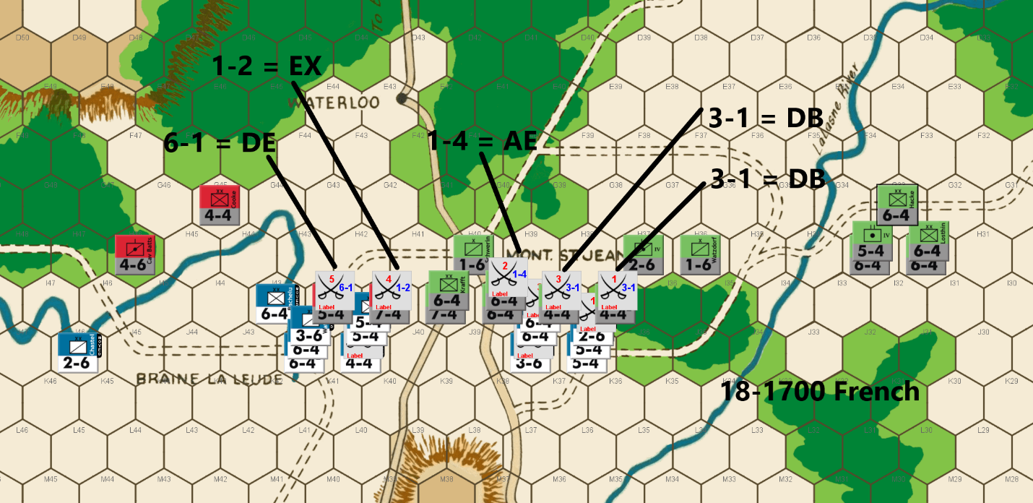
Bert: This continues to be an interesting match from my perspective. My attacks failed to accomplish my grand goals last turn, but they avoided a disastrous result as well. Those of you with an eagle eye on that turn might notice that I made the 1-1 attack versus H42 prior to the 5-1 attack versus Cooke. I knew that I would lose my cavalry piece (2-6) on an AB2 result by making the 1-1 attack first. I prioritized that eliminated Cooke was more important than that piece. IF I had succeeded in advancing after combat on the 1-1 attack, Cooke would have been surrounded on the 5-1 attack. Of course, the result ended up being an AB2 on the 1-1 and a DB2 on the 5-1… ugh. To make matters worse, had I switched the order to prioritize saving my piece on the potential AB2, the numbers rolled would have been D Elim on the 5-1 and D Elim on the 1-1 attack! Alas, it was not to be.
On Ed’s turn, he obliged me with what I was trying to accomplish by losing two pieces an attacker AV results. The dice were in my favor on his 5-1 attack, as we saw a rare DB2 result by the very effective PAA army. The remaining piece count for the PAA army is rather critical and fundamental to my strategy from pretty much turn 1 of this game.
At this point, there are 9 possible turns left in our game and the PAA army has 18 pieces left following his move which concluded the 18-1500 turn. My simple math indicates that I must somehow kill two of his pieces per turn in order to eliminate all his pieces. If he tries to run a piece away, I will hopefully be able to exit something off the board that would eliminate any wayward piece. Killing two pieces per move will not be an easy task, especially with my dwindling army. I think that there is a chance to do so without needing to resort to desperate low odds attacks for now. I am going to try and kill as many of his pieces as I can, but I will need some favorable die rolls and so the odds are still stacked against me.
Obviously, I can kill his pieces by attacking. There is another factor with which Ed might assist me in eliminating PAA units. If he continues to make attacks against me, there will hopefully be the risk of exchanges or A Elim results on any soak off attacks. I think if I was playing the PAA side, I would stop attacking and just play a complete defensive position to try and offer up only 2 units per turn to be attacked and make the French side pay the price of any DB2 or exchange results.
My previous goal of reaching Mont. St. Jean before the arrival of the IV Corps will fail, but with the unit count as I outlined, that is not as critical as it was. At this point, Ed could lose one hex row per turn for the remaining turns and that would prevent me from exiting the board. That is of course, if he can keep me from killing more than two units per turn.
Fortunately, he has exposed enough units that I have “a chance” to eliminate four more PAA pieces on this turn. Two 3-1 attacks, a 6-1 attack and a 20% chance of an exchange on my 1-2 attack. I have little leeway to absorb many exchanges or losses on my soak off attacks. If Ed does continue to attack, I’ll need him to minimize the killing of my units, unless they cost him more pieces. I’m probably asking for too much, but the game is not lost yet, so I’ll continue to play on.
Joe: L'Armee du Nord, in spite of its soldiers' yeoman efforts, finds itself stalled, during the last few game turns, in a grinding attrition battle with the PAA over possession of the "I" hex row. Both commanders know that this ground is critically important and thus, it is not surprising that the Allies are determined to hold it, and that the French are just as determined to take it. The stakes of this fight couldn't be higher: until Napoleon's army can drive the Allied battle line back, the PAA front will remain linear and unbroken, offering adequate freedom of maneuver and therefore, also preserving the capacity for the Allies to effectively counterattack the advancing French. Once the Allies are forced to retreat, however, their front will be split and the French will be able to mass against one half of the PAA force, or the other. On the other hand, while this battle is a "do or die" contest for the PAA, the French have problems other than this frustrating stalemate just south of Mont. Ste.-Jean; which is to say: in addition to the Emperor's growing concerns about both his army's mounting casualties, and a "campaign clock" that is now ticking against him, there is the new worry that the Prussian IVth Corps is fast approaching and will soon reach the central battle area. Hence, the Emperor's growing frustration: for although the the Mont. Ste.-Jean crossroads hex (H40) is tantalizingly just out of reach; the French battle line is still no closer to it now, than it was two turns ago. Needless-to-say, the French player has no choice but to renew his attack; however, with only sixty-four combat factors, and fourteen units remaining of the once powerful L'Armee du Nord, he decides that it is time to "cut his cloak to fit his cloth" and, at least for this one turn, largely eschews low-odds gambles in favor of 3-1 and better attacks. This is an interesting change of pace for this French commander, and on the whole, in spite of the potential for uneven exchange losses, I actually like the odds and targets chosen for this round's series of attacks; to whit: a 6-1 versus Cole (a 5-4), a 1-2 (soak-off) versus Clinton (a 7-4), a 1-4 (soak-off) versus Brause & Borcke (two 6-4s), a 3-1 versus Henkel (a 4-4), and another 3-1 versus Kampfen (a 4-4). Regrettably, while the French attacks start out promisingly enough against the Anglo-Allies: a D Elim on the 6-1 versus the 5-4, and an Exchange on the 1-2 versus the 7-4; they totally misfire against the Prussians: the 1-4 (soak-off) yields an A Elim, and both 3-1 attacks whiff with DB2s. Certainly, this is not a disastrous set of outcomes (twelve factors eliminated at a cost of seven) for the Emperor, but the elimination of both soak-offs also means that the French player has not been able to improve his numerical position vis-a-vis the PAA. [A quick note: although the French player's decision to target the two 4-4s with 3-1s, rather than opting for a single high odds attack against the 7-4 or one of the 6-4s may seem a little puzzling to some players, it actually makes perfect sense, from a tactical (stacking) standpoint. This is because, the one organizational disadvantage that is shared by both the Anglo-Allies and the Prussians is the challenge they both face in achieving efficient (15 factor) stacking when on the attack; and, in the case of Blucher's army, the often underappreciated (three) 4-4s and (two) 5-4s help mitigate this problem by offering much-needed tactical flexibility, especially when the Prussians are forced to trade blows with the French -- as is the case in this game -- in a protracted "toe-to-toe" slugging match.]

18-1700 PAA
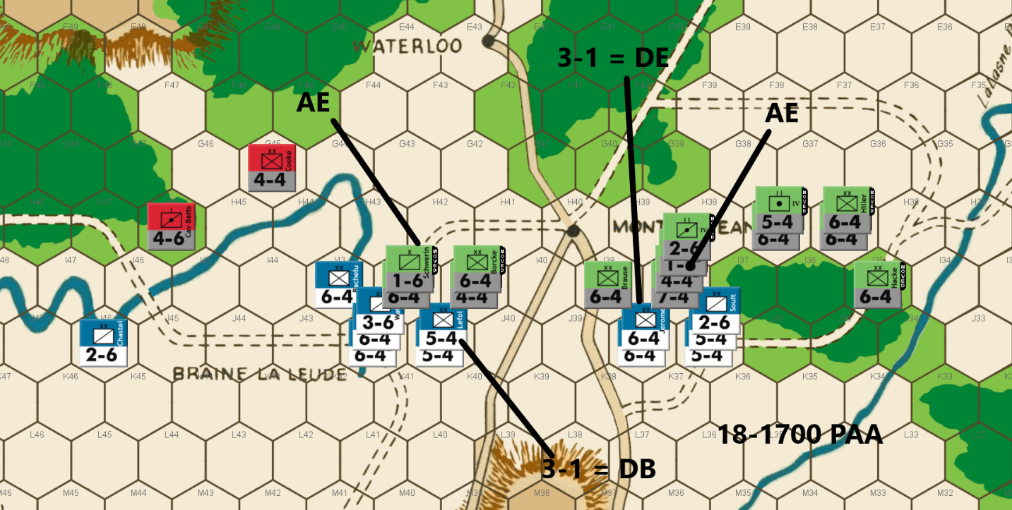
Ed: Drat! My lone remaining Anglo-Allied 5-4 and 7-4 units were eliminated in French attacks. My two remaining A-A units are now reduced to defensive rolls – at least for now.
I have enough remining Prussians to attack and hold the vital I Row. I get one DE and one DB. I only have one remaining “light” for soak off duty but at least all of the Prussian infantries will now be able to get into the fight. My two remaining A-A units continue to protect my left flank.
The French have eleven units to my fourteen after my attacks. This is a nice advantage for the PAA as any exchanges are favorable to me.
Joe: Given the forces available, and the absolute necessity for the PAA to hold the "I" hex row, the Allied move pretty much makes itself. Granted, the powerful Prussian IVth Corps infantry will belatedly show up in the central battle space next turn, but for now, the Allied player must make do with the units immediately on hand. This he does, in fine form, by attacking both ends of the French line with four separate combats: a 3-1 versus Lefol (DB2), accompanied by an automatic A Elim soak-off (using a 1-6); and a 3-1 versus Jerome (D Elim) also accompanied by an auto A Elim (with another 1-6). Needless-to-say, these combat results could have been better, but they could also have been worse: the elimination of Jerome (a 6-4) at least partially avenges the loss of Cole and Clinton, but the sacrifice of the last two PAA 1-6s really means that, for all intents and purposes, this battle has ended in a "draw." More to the point, although these attacks have succeeded in reducing total enemy combat factors by about 10%, they have not managed to decisively cripple French combat power, so a bloody enemy rebuke is a real possibility, once the French commander mounts his inevitable riposte.

18-1900 French
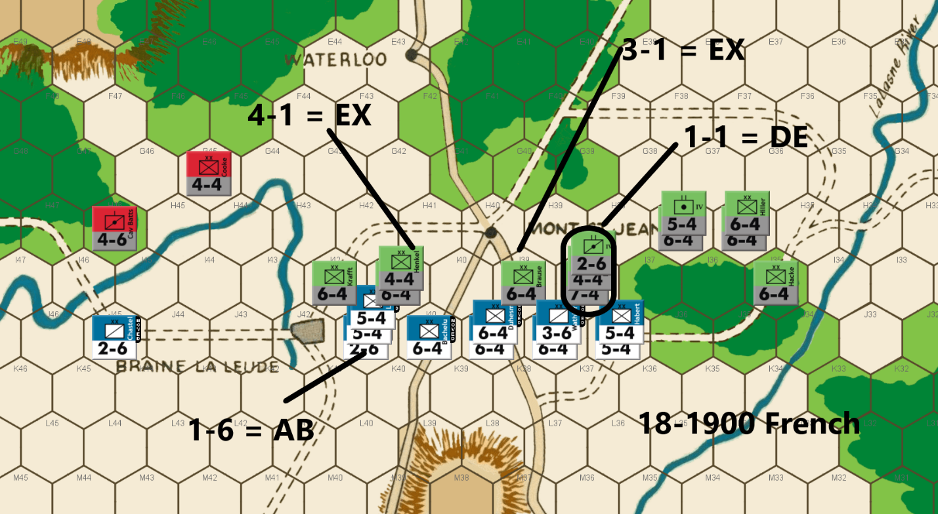
Bert: A couple more DB2 results on my attacks combined with the PAA commander eliminating another French unit on a D Elim instead of an exchange has put me in a position with just a tiny bit of leeway left. As a result, I have to go to a desperate mode to take a shot to try and turn this around.
Often, one side or the other often reaches this stage in Waterloo. Players will line up multiple desperate attacks and hope for the best. In my opinion, that approach minimizes their chance of success. It is much more likely if they can muster one key attack that can potentially turn the tide rather than count on winning multiple low odds attacks.
While every situation can be different, imagine in this situation, if I were to do multiple 1-1 attacks instead of just one. Let’s say I get a D Elim on one and an A Elim on the other. A single A Elim would almost certainly put a nail in my coffin no matter which attack yielded that result. If I limit the desperation attack to only one, I have much better chance to only count on success from just that one attack.
One more piece of advice that I’ve followed here, when you go for a desperation attack, figure out which target will give you maximum bang for your buck should you end up hitting the lucky outcome. If the game is lost anyway on an adverse result, you haven’t risked anything. If you don’t maximize value, you’ll almost certainly be making other desperation attacks to turn your position around.
Anyway, following the above guidance myself, I looked over the position at the start of my move and determined that my maximum bang for my back would be to put 15 factors in J38 and attack three defenders (2 in I38 and 1 in I39) at 1-1 odds. I could then attack the other I38 defender at 3-1 odds along with an additional attack to the west. Unfortunately, my units were just out of position to accomplish that counter mix. I settled for my next best option which is to attack the entire stack at I38 as my Hail Mary. Obviously, I’m dreaming of a D Elim result, but an AB2 would at least likely give me another shot for a desperation attack next turn, albeit that would likely be after my forces are reduced even more.
Ideally, I’ll eliminate the defenders on the other two attacks with some combination of a D Elim and an Exchange.
The results came in… and wow, I got lucky! A D Elim result on the 1-1 attack and no DB2’s on the other attacks was not a perfect result, but I’ll take that as it completely changes the complexion of our game. I even got a lucky AB2 on my 1-6 soak off. It’ll be interesting to see how Ed responds. If I were him, I would probably just conserve what’s left of the PAA army and force the French to keep attacking and get D Elim results. I wouldn’t want to do the French any favors by eliminating any of the remaining pieces on counterattacks. I'll be happy if he keeps attacking me as that could help me whittle down his remaining units.
Joe: L'Armee du Nord has finally reached a "do or die" inflection point: its total combat strength now stands at fifty-one factors, distributed among eleven units, and it faces a PAA force that, when surviving Anglo-Allied and Prussian units are counted together, total seventy-two factors and fourteen units. Even if the two marginally useful Anglo-Allied "4s" are subtracted from this combined total, that still leaves a Prussian contingent of sixty-four factors and twelve units. As if that weren't bad enough, just by itself, the actual offensive options available to the French commander are also severely limited because a significant part of his available force -- twenty-eight factors and six units -- is currently deployed so far to the west that virtually none of these units would be able to move east along the front far enough to take up new positions in hexes I37 and/or I38. In addition, once the French Army loses even a couple more units, then maintaining a cohesive line and protecting its Left Flank will become increasingly difficult because of the presence of the Anglo-Allied Cav. Batts. (a 4-6) and a likely shortage (because of soak-off losses) of French cavalry. In view of these considerations, the French player organizes his attacks -- except for the assault versus I38 -- about the only way that he can: a 1-6 soak-off (AB2!) versus Kraft & Borcke (two 6-4s); a 4-1 (Exchange) against Henkel (a 4-4); a 3-1 (Exchange) against Brause; and, last but not least, a "big" 1-1 (D Elim!) versus the three Prussian units at I38. In all honesty, the only one of these attacks that could reasonably have been organized differently would have been the attack versus I38. In this instance, the French player could have played it safe with a 5-1 against the 2-6, accompanied by a 1-4 soak-off versus the 7-4 and 4-4. However, given the impending arrival of the IVth Corps, I actually find myself in agreement -- at least this time around -- with the French commander's decision to go "all in" on the very "risky" 1-1; especially since -- given the current balance of forces -- continuing to trade units, on a one for one basis, with the PAA player is almost certainly a guaranteed recipe for a French defeat. Finally, in reviewing the results of this latest round of French combats, it is important not to assign too much significance to this impressive string of battlefield successes. Admittedly, the French commander -- thanks to the amazing survival of his 1-6 soak-off unit, and the equally astonishing annihilation of the three Prussian units in I38 -- no longer finds himself nearly as outnumbered as he was when he began his move. Moreover, the destruction of literally all of the Prussian soak-off units (including the 4-4s) means that any future PAA attacks -- unlike those initiated by the French who, it should be remembered, still possess three soak-off units -- will necessarily have to risk major units in the thankless role of required soak-offs. Still, it is important to recognize that, in spite of everything, L'Armee du Nord is still outgunned in terms of absolute combat power: the PAA totals forty-nine factors (counting the two surviving Anglo-Allied "4s") distributed among nine units ; while the French Army totals forty factors, also distributed among nine units. Thus, while it is certainly too early to say that the French player has suddenly become the heavy favorite to win, it is also true that he is no longer the obvious "underdog" that he was only a turn or two ago.

18-1900 PAA
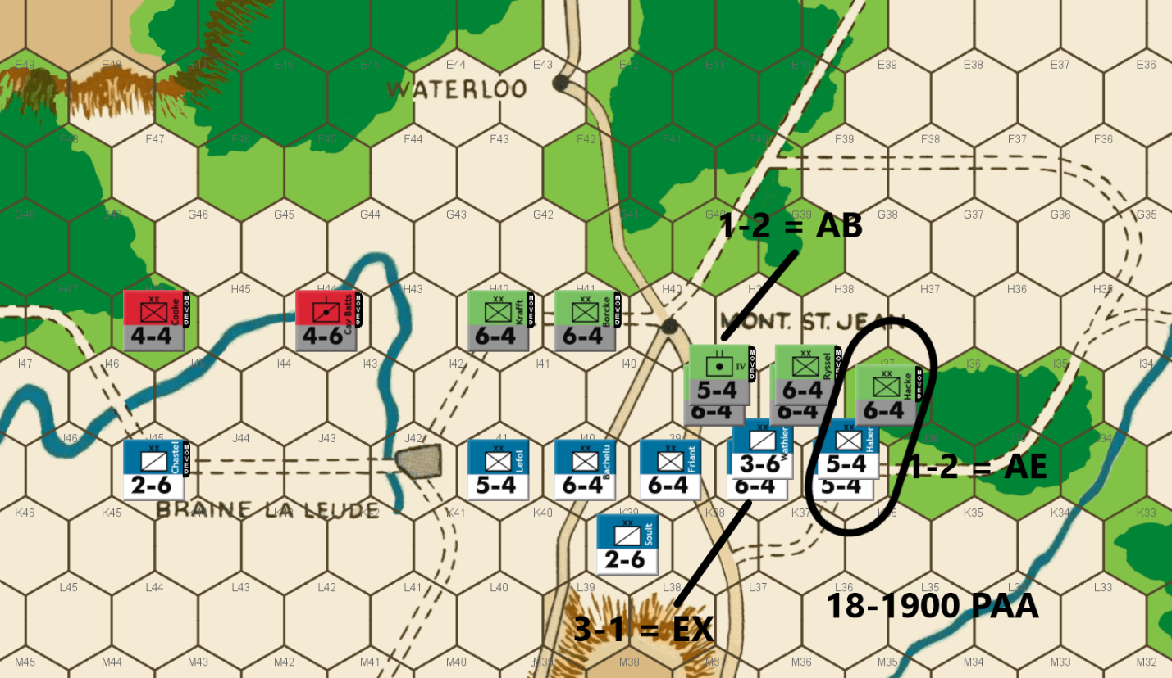
Ed: Yikes!! Yet another DE on his 1-1 attack. Five Prussian units go to the dead pile. All of a sudden things have gone from a good PAA advantage to being an underdog. I now have seven units to the French eight on the central battle front.
To make matters, I don’t have enough to maintain the I Row. If I don’t attack, I’m afraid he will be able to attrite my split forces for a French win. Ugh. Compounding my problems is the lack of any small units for soak off duty.
I don’t like any of my options, but I decide to attack. I can use a 6-4 to attack a pair of 5-4s. That gives me a 40% chance for a good result – either an exchange eliminating two units for one or holding my position with a DB.
I can also get a 6-1 on a 3-6 and a 5-4 against a pair of 6-4s at 1-3; or a 3-1 on a 6-4 and a 1-2 on a 6-4 and a 3-6. I decide to go for the last option. Unfortunately, the attacks go badly for me. I get an exchange on the 3-1 and AB/AE on the 1-2 attacks. Things are not looking very good for the forces of democracy.
Joe: The Allied player had fully expected that the arrival of the infantry divisions of the Prussian IVth Corps would finally -- in concert with the Anglo-Allied and Prussian units already fighting along a battle line south of Mont. Ste.-Jean -- be powerful enough to put an end to Napoleon's imperial ambitions, once and for all. Unfortunately, what the units of the IVth Corps encountered at Mont.-Ste.-Jean, instead of the demoralized and exhausted French troops that they had expected, were the shattered remnants of two once great Allied armies, whose soldiers -- only a few hours before -- had been convinced that their combined numbers would be able to halt and then fix L'Armee du Nord in place, long enough for the powerful Prussian host marching in from the east to be able to fall upon and destroy the French Right. Events, however, had been turned on their head: the PAA Center and Left -- and not the French Right -- had been virtually obliterated by a wave of devastating French attacks that had swept, west to east, across the whole of the Allied front; only a small handful of PAA units had actually survived this ferocious French onslaught, and they had dutifully remained behind at their posts and hence, were still present to greet the hard-marching Prussians when they, at last, debouched onto the battle field. Enter "Alt Vorvarts" who, having only recently come face-to-face with one military catastrophe, nonetheless wastes no time in searching for another. And in furtherance of that goal, he chooses to hurl his newly arrived reinforcements immediately into battle against the more numerous foe. Of course, crazy as Marshal Blucher might be, even he is not so unmoored from reality as to attack the entire French battle line; instead, he launches the whole of the IVth Corps forward, straight from the march, in a set of three attacks (two of which are speculative) against the French Right, all in hopes of getting lucky enough, in his own turn, to inflict disproportionate and unexpected casualties on his French tormentors. Unfortunately for Blucher, his hurried attacks do not go well. The first of his combats is a 1-2 (AB2) with a 5-4 versus Friant (a 6-4) and Wathier (a 3-6); the second, more reasonable attack is a 3-1 (Exchange) with three 6-4s versus Morand (a 6-4); and the third attack is another highly speculative 1-2 (A Elim) with a 6-4 versus Habert and Durutte (two 5-4s). As combat results go, these are not the worst possible, but they are bad enough: twelve factors and two Prussian units traded for a single French 6-4. "Alt Vorvarts" probably hoped to partially salvage the Allied situation south of Mont. Ste.-Jean, but thus far, he has only made it worse.

19-0700 French
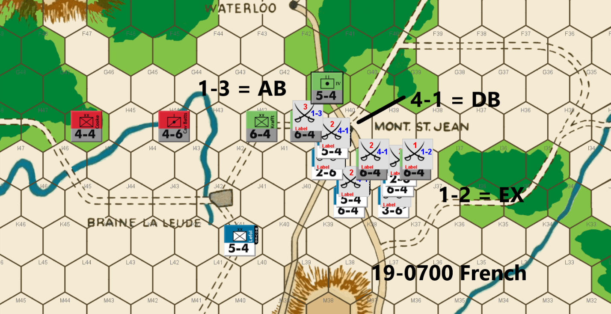
Bert: As morning of day 4 of this battle breaks, it is amazing to see how much this game turned around in a single turn. My very lucky shot on my 1-1 attack last turn, combined with the less-than-optimal results on the PAA counterattacks and this game is at a minimum, back to even.
Ed did not take the path of conserving his army and the attacks he decided to pursue likely worsened his position a bit. The A Elim on one of his 1-2’s hurts him and the exchange (I figured eventually we’d see that result for a PAA attack, again!) on his 3-1 has left him with a total of 7 pieces (37 factors) left with 7 turns to go in the game. Meanwhile, the French have just a measly 8 pieces and 34 factors left to work with – what a game!
As mentioned, there is still a full day of game play left… I’m fairly sure the game will be decided before we play out all seven turns.
The French have two paths to victory at this point. The first and most obvious one will be to kill at least one PAA piece per turn for each of the remaining turns. Without much of an army left, this option is not something I can count on with all the DB2s available on the CRT. The other path is to finally get to Mont. St. Jean and split the PAA in two. In this case, I can try to eliminate only half his pieces via combat and then exit what is left of my army to hopefully eliminate what is left of his. I think this is the more viable choice. The woods hexes on the north side of Mont. St. Jean makes it quite difficult for the PAA player to cover both sides, especially without many pieces.
One other point on Ed’s attacks, the AB2 that he rolled on his other 1-2 attack, allowed me to retreat that attacker to hex G41. This is important because if I can get a piece into hex I41 as of the end of this turn, which I will be able to do, the PAA could have one (or even zero if I am lucky enough to get another exchange on a 1-2 attack) units left that can protect the east side of the front for this coming turn. That could mean I’ll be able to attack without the need for a soak off or I might even have a clear path towards an exit hex. I’ll worry about that next turn since it is also possible that both of his PAA units on the east side survive this turn.
While I considered other options for how to make my attacks this move, I decided that the key was to be sure to occupy I40 to split Ed’s forces. It worked out that I could make my best possible soak off at 1-3 versus H41, while getting a 4-1 attack versus I39 and a 1-2 attack versus I38. This left a single piece to “protect” my left flank. The AA’s Cav Batts piece is positioned to consider trying to outflank me but that will mostly just allow him to possibly make some surround attacks in the coming turns since that piece can’t combine in any attack along with the Prussians.
If a single Prussian piece to the east of Mont. St. Jean survives my move, it will be difficult for Ed to risk surrounding my unit at I40. That hex will be vulnerable to a 3-1 attack without the need for soak off, as is. I’m afraid that both Prussian units might survive my move and so I felt I had to allow that 3-1 attack rather than stack another one of the French units in that hex and then Ed could maximize his bang for buck in his own desperation attack.
With both of our forces down to scraps, this final end game is likely to come down to which of us can get lucky on the remaining die rolls. I hope it has been as entertaining for you to follow along as it has been for me, no matter how it concludes, as a player.

Joe: After three campaign days of maneuvering and fighting, with player fortunes swinging wildly back and forth, this match has finally arrived at a decisive tipping point wherein a single lucky (or unlucky) die roll could well determine victory or defeat. In situations like this, players will oftentimes overlook the continuing importance of positional play, and place their faith, instead, in the verdict of the "dice." This is actually understandable: after all, during the late game turns of WATERLOO, counter density tends to be very low, and luck really does exert an exaggerated influence on the turn-to-turn flow and tempo of the game. Unfortunately, this sanguine player attitude -- at least in my view -- is also a mistake. And this is a point that I hope to prove by considering the several offensive options that were actually available to the French player on this game turn, and who -- in spite of commanding a numerically depleted army, with very modest combat power -- was, nonetheless, able to exploit terrain in a very limited battle space and, by initiating a meticulously-planned set of attacks, was also able to seriously threaten his opponent's whole defense.
For starters, let us consider the posted French move, and what the phasing player actually hoped to accomplish with it; then we will consider a pair of alternative French moves, each with its own advantages and disadvantages. So, to set the scene, L'Armee du Nord, after campaigning since the morning of the 16th, has been reduced from one hundred and ninety-three to thirty-four combat factors, distributed among eight units; the the combined strength of the PAA has likewise been severely depleted and now totals only thirty-seven factors spread among seven units. Referring to the accompanying "screen shot" of the French move, it can be seen that the Emperor has elected to gamble on three attacks: a 1-2 (die roll: Exchange!) soak-off versus Losthin (a 6-4); a 4-1 (die roll: DB2) versus Hiller (a 6-4); and a 1-3 (die roll: AB2) soak-off versus Borcke (another 6-4). The reason for the 1-3 soak-off is clear, it is to satisfy ZOC combat requirements so that Habert (a 5-4) can legally occupy I40 at the end of the combat phase and, by so doing, split the Allied front at Mont. Ste.-Jean. This also means, since Habert's ZOC would extend into H40 at the start of the PAA player turn, that Kraft, Borcke and the IV Corps Foot Arty would all be blocked from shifting east along the "H" row to defend the forest gap at H38, should the French break through on the Allied Right. Interestingly, once the French 1-2 yielded an Exchange, any outcome from the 4-1, other than a DB2 -- because the French Army would then have had an open path to the eastern Brussels Road -- would have almost certainly ended the game immediately. Alas, it was not to be. Nonetheless, and in spite of its very real risks, I really like the general strategy underpinning this French move. Granted, it only had a 14% chance of winning the game outright for the French, but I still think that it was worth a shot.
And since I cannot seem to leave well enough alone, I will now present my own (very similar) plan for the French, which is based on the fact that there is a 76% chance that at least one of the two eastern Prussian 6-4s would be eliminated as a result of the 1-2 or 4-1 attacks. So, with all that in mind, I personally would have modified this game's French approach slightly so as to take advantage of the unfortunate predicament of the IV Corps Foot Arty (a 5-4) trapped at G41. In essence, I would have deployed Durutte at K40, Bachelu and Chastel at I40, Friant, Habert and Soult at J39, and Lefol and Wathier on J38. The French attacks would have been set up in the same order, and with the same odds as the originals. The main advantage of these modest changes -- at least to my mind -- is that the Allied player would no longer be able to attack the French unit at I40 at 3-1 (because it is a 6-4, rather than a 5-4), without bringing in either Hiller or Losthin, a move that would be exceedingly unlikely -- due to the French threat against the H38 forest gap -- if even one of these two Prussian 6-4s had been eliminated.
But wait, I also have a much more conservative alternative French move for those players who dislike the idea of risking two (potentially painful) soak-offs to support a single high-odds attack; in that case, consider the following unit dispositions: Chastel at M40; Habert on K40; Friant, Durutte and Soult at J39; and Bachelu, Lefol and Wathier on J38. Needless-to-say, in the case of this "conservative" French move, there would only be two attacks: a 1-2 and a 4-1; there would also be, it should be noted, absolutely no chance that this move could win the game in a single bold stroke; but then, one takes the good, with the bad. Finally, my purpose in discussing these several alternatives at some length is not to bore my readers, but to illustrate the fact that -- even when it comes to supposedly simple battlefield situations -- the opportunities to make creative "game winning" moves, especially during the final turns of a game like WATERLOO, are actually there, but are too often overlooked, simply because, as the game winds down, a lot of players tend to stop looking for them at all.

19-0700 PAA
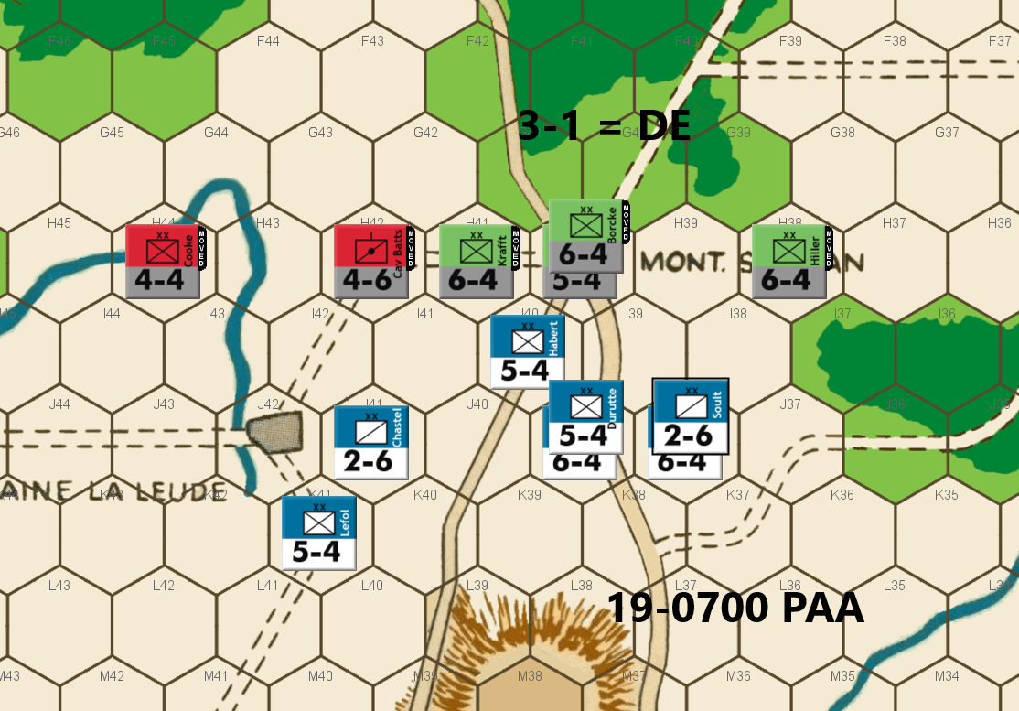
Ed: Well, I am still alive after the French attacks, but barely. Bert has seven units to my four Prussian and two A-A units. The non-cooperation rule really hurts the PAA’s ability to fight in this end game.
I bring the two A-A units forward to better assist the defense and be able to at least threaten an attack on a 2-6. The Prussians have an easy 3-1 attack with no soak off requirement. I get the DE result. Whew!
Every future attack result will be critical from here on.
Joe: The French commander may have had multiple options during his player turn, but the Allied player really has almost none. In fact, except for possible minor adjustments to the positions of the Anglo-Allied units, Cooke and Cav. Batts., the PAA move basically makes itself: the French 5-4 (Habert) at I40 absolutely has to go. And to that end, the good news for Marshal Blucher is that, this time around, the Prussian 3-1 versus the troublesome Habert does not require a soak-off, and, even better, it scores a D Elim. This small victory, however, does not solve a key problem for the PAA going forward: that of preventing the French from slipping around the Allied Left, and then making a dash for the eastern Brussels Road exit hex. As things currently stand, only a single Prussian 6-4 defends the forest gap at H38, and there are literally no PAA units currently in position -- should a French unit or two move into J34, J35, or J36 -- to stop any of those units from racing north towards A39 and a possible French victory.

19-0900 French
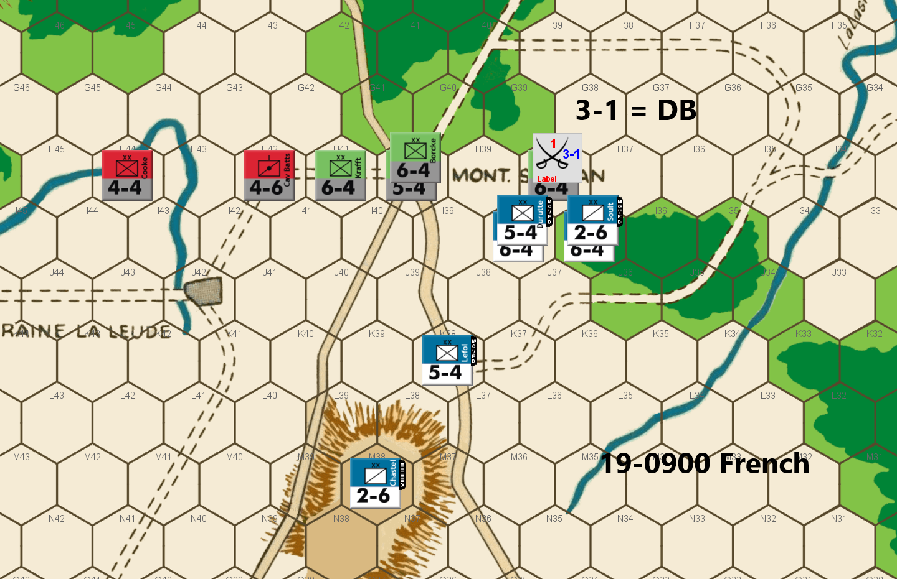
Bert: Dang, so close to probably ending this game with a French breakout. Following the exchange on my 1-2 attack, the follow-on 4-1 attack had a 70% chance to eliminate the last blocking piece on the eastern section. Alas, another DB2 result. To make matters worse, the PAA commander’s 3-1 counterattack yielded another D Elim result. The pendulum has swung back in favor of the PAA’s position.
Relatively easy move with just 6 pieces left to shift around against the 6 defenders. I’ll hope for my own D Elim result on a 3-1 attack while still trying to hold the line against a flanking attempt. I did consider running my cavalry units to the La Lasne River, but I decided to utilize the hilltop at M38 as a defensive position but more importantly, allow me to potentially swing my forces back to the western sector, should Ed over commit to stopping me on the east side.
One last thing, I could have stacked two defenders at I40 last turn to force Ed to utilize a soak off unit, rather than get a straight 3-1 attack. I was fearful of I40 getting surrounded and I also figured that I had a 70% chance for a DB2 or exchange result and this was better than risking a stack for a potential desperate low odds attack in addition to the risk of being surrounded.
Joe: The French player opts for the only attack that does not require a soak-off: a 3-1 versus Hiller. Unfortunately, as seems to be an ongoing theme in this match, L'Armee du Nord continues its string of misfires on its 3-1s and 4-1s with yet another DB2. The other bit of bad news for the French player is that, with the Allies having again wrested uncontested control of H40, they can now shift units east to reinforce Hiller, via the G40 - F40 forest track. So far as this French move is concerned, while it would have been nice to position Chastel at M37 (so that he could reach J34 in a single bound), I understand why the Emperor opted to shelter this 2-6 on the ridge hex at M38, instead.

19-0900 PAA
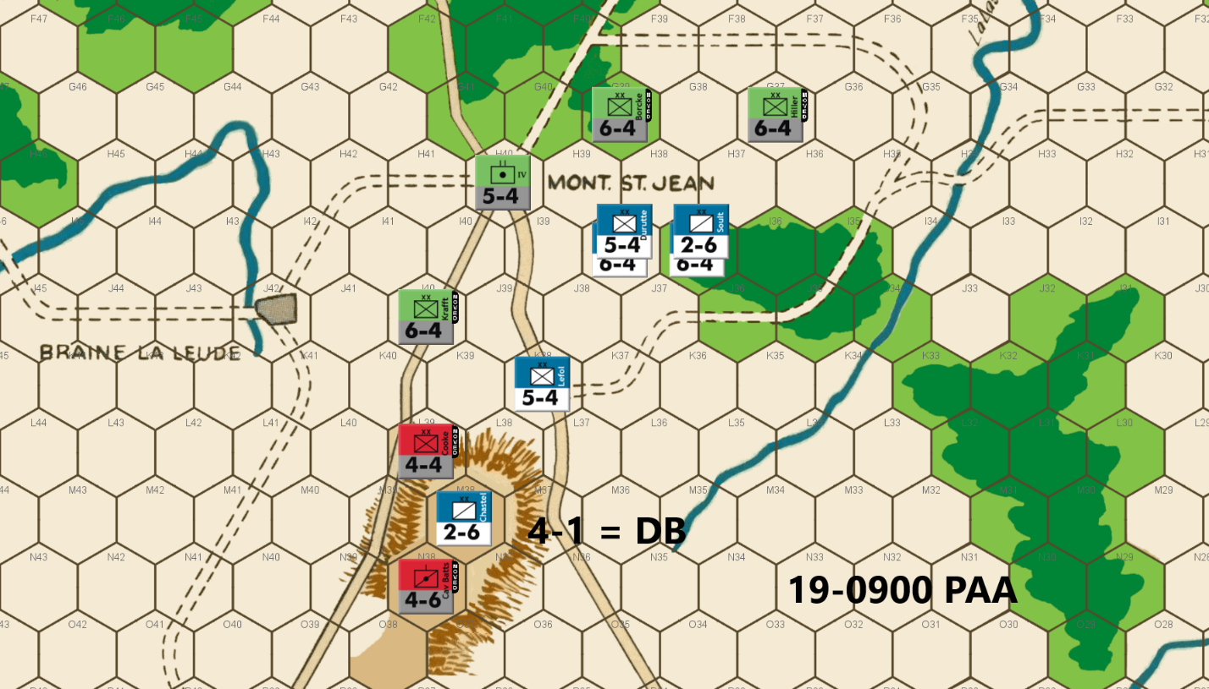
Ed: The question is whether it is better to attack with the Prussians or set up a defensive screen. Any attack will require a soak off which I really can ill-afford to lose. They are better utilized on the defense here, I think.
The A-A pair of units do have a 4-1 attack option. That is a 70% chance to eliminate a 2-6 and threaten the French rear. That is what I decide to go for. Drat, it is DB.
Joe: As expected, the PAA player immediately acts to shore up the fragile Allied Left by dispatching Borcke to G39. Farther south, the remnants of the Anglo-Allied contingent -- eager to get back into the fight -- launch themselves against Chastel (a 2-6) at 4-1. I personally am not particularly excited by this Anglo-Allied move. Better, I think to have left them where they were and to have stacked both Kraft and the IV Corps Foot Arty in H40: the French are going to have attack next turn, and the most likely target will be Borcke, so better to force the Emperor to soak-off at 1-6 rather than at 1-3! In any case, an attack by the PAA player finally misfires with a DB2 result.. Chastel retreats to J36, and Cooke advances into M38.

19-1100 French
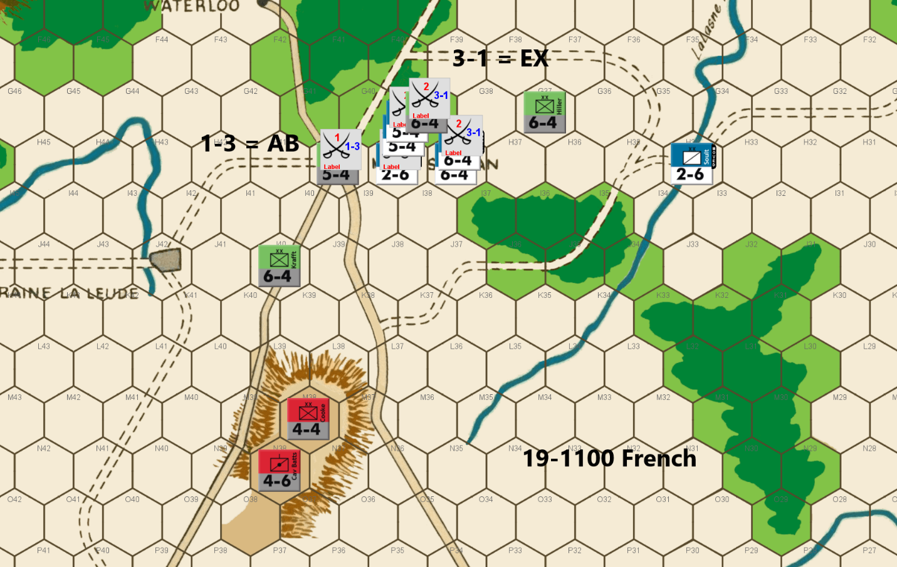
Bert: What a topsy-turvy game this has been! My 3-1 attack last turn yielded another bummer DB2 result. Worse, I obviously failed to count the hexes correctly and so I ended up permitting the Anglo-Allied two remaining pieces to ascend the hilltop and take a 4-1 against one of my two remaining cavalry units. Lo and behold, I got lucky again as Ed’s attack misfired and my boys escaped via their own DB2 result.
The resulting position looks like I’m going to be easily surrounded, however, I think that the PAA commander has left my remaining pieces a glimmer of hope. There are only two Prussian pieces left defending the east side of the forest line and I can get a 3-1 attack versus one of them this turn. Importantly, I will be occupying hex H41 at the conclusion of the attack. That hex prevents Ed from easily moving additional defenders to that east side. If I can get a D Elim on that attack (or even an exchange), it will make it challenging for Ed to keep me blocked with only that lone piece (Hiller). Either of those results will leave the PAA with only Hiller to the east as I mentioned and it will mean that Ed can no longer get a 3-1 attack versus one of my 6-factor units. Note, I’d have only one left on the board if there’s an exchange.
I tried multiple combinations of how to try and maximize my chances in this situation and I ended up settling on the combination of taking the 3-1 versus G39, soaking off at 1-3 versus H40, and running a lone cavalry unit to be astride the La Lasne River to the east. This seems optimal to me because I am mostly counting on my remaining ‘heavies’ to lead the charge since with the remaining combination of units for the PAA, make further counterattacks a bit risky. I could have made the attack a 4-1 by keeping my other cav unit in that attack, but both the 3-1 and the 4-1 have a 30% chance of the DB2 and avoiding that outcome is the optimal result for me. The annoyance that running my cavalry to the river line seems worth it to me too.
I was and am concerned about giving Ed a counterattack opportunity that surrounds and pins my units that survive this attack, especially if the cavalry unit is still in that location following the 1-3 attack, but I don’t see a way for Ed to actually completely pin me without him risking at least one attack at less than 3-1 odds to complete a pin. I think that I will be able to move to G39 or through H37 to ‘escape’ unless Ed risks that less than 3-1 attack. (Of course, I might have another late game blind spot.) We’ve already seen both sides succeed with low odds attacks, but if Ed is forced to take and win an attack at 2-1 or less to seal a PAA victory, I’d be happy to have gotten the game to that point. It meant I had “a chance” to pull it out at the end.
All of that is predicated on my eliminating his defender on my 3-1 attack. Without that, I’m pretty sure that Ed will be able to utilize a combination of the two eastern defenders to combine with his other units to effectively pin my units and wrap up this game. So, let’s hope that doesn’t happen!
Joe: The Emperor scrapes together virtually every unit he can and throws them against the Allied Left in two attacks: a 1-3 with Chastel against the IV Corps Foot Arty (a 5-4) at H40, and a 3-1 versus Borcke (a 6-4) at G39. The French results, not surprisingly, are mixed: an AB2 on the 1-3 retreats Chastel to J37?, while the 3-1 Exchanges Bachelu for Borcke. [I should note that the Allied choice of flight hexes for Chastel is somewhat unexpected, as a retreat to I37 would probably have been marginally better, especially if Borcke had survived.] The Exchange result, although a bit disappointing to the French commander, is nonetheless useful because it removes a key Prussian unit from the eastern section of the PAA defense line, while still leaving L'Armee du Nord with (barely) enough combat power to attack the lone surviving PAA unit (Hiller) on the Allied Left at 3-1. Now, "the ball is in the Allied player's court," and one thing is clear, since Hiller will be vulnerable to a surrounded 3-1 -- either now, or on a future turn -- if the Allies do not act promptly, it therefore follows that some sort of PAA counterattack is virtually guaranteed.

19-1100 PAA
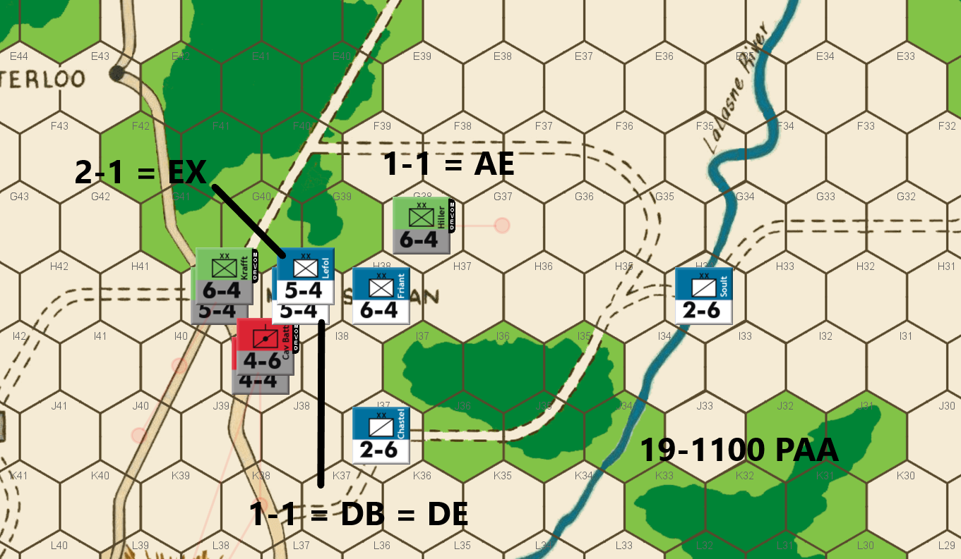
Ed: I made a mistake when I retreated Chastel on the French attack this turn. He should have been retreated to I37 instead of J37 which would have given me better options. I realized my mistake a few minutes after sending off the retreat message. But having sent the message, I didn’t feel right in asking if I could change it.
That left me with some less attractive options. I can get a surround attack vs Chastel with the two A-A units. If Hiller stayed at G37, Bert could get a 3-1surround attack, although it would take all four of his remaining units. Once Hiller is gone, I don’t have enough Prussians or A-A factors to get a 3-1 attack on anything but a 2-6. Not good. Definitely not good.
I can also attack Friant at 1-1, hoping for the DE/DB result (40%), to prevent Friant from heading north to march off the board. By adding two other attacks, I am able to end up with 3 surround attacks, albeit at less than 3-1 odds. That is the choice I made. First, I took the 2-1 on a 5-4 which ended up in an exchange. Next the two A-A units attacked the other 5-4 at 1-1 surround, yielding a DB which turned into a DE. The game now rode on my last 1-1 attack. Alas, my luck ran out when the dice yielded an AE. That opened up the path for Friant to reach Brussels unopposed requiring the PAA to remove 12 factors. Since I only had 13 factors left on the board, I had to remove all my units. That left a pair of French cavalries as the only two units remaining.
What a game!! We were each favored to win multiple times as luck swung back and forth. Congratulations to Bert on his hard-fought win.
Joe: The Allied commander does, indeed, promptly counterattack, and he does so with a mix of desperation and elan. Since all of his attacks are at low-odds, he opens his offensive with the most favorable attack first: a 2-1 surrounded attack (using Kraft & the IV Corps Foot Arty) versus Lefol (a 5-4) which yields an Exchange eliminating both Lefol and the IV Corps Foot; the second combat is another surrounded attack, in this case a 1-1 (using Cooke and Cav. Batts.) against Durutte, and this time the attack eliminates Durutte without cost; the third, and final "do or die" combat for the Allied player is a 1-1 surrounded attack (using Hiller) against Friant; and, at long last, the Allied player's luck runs out, and Hiller is dispatched to the "dead pile" by an A Elim. And, just like that, the campaign is quite astonishingly suddenly over: all because, even though the Allies currently outnumber the French, fourteen factors to ten, the path is now wide-open for the few surviving French units to march off the game map to Brussels and victory!

19-1300 French
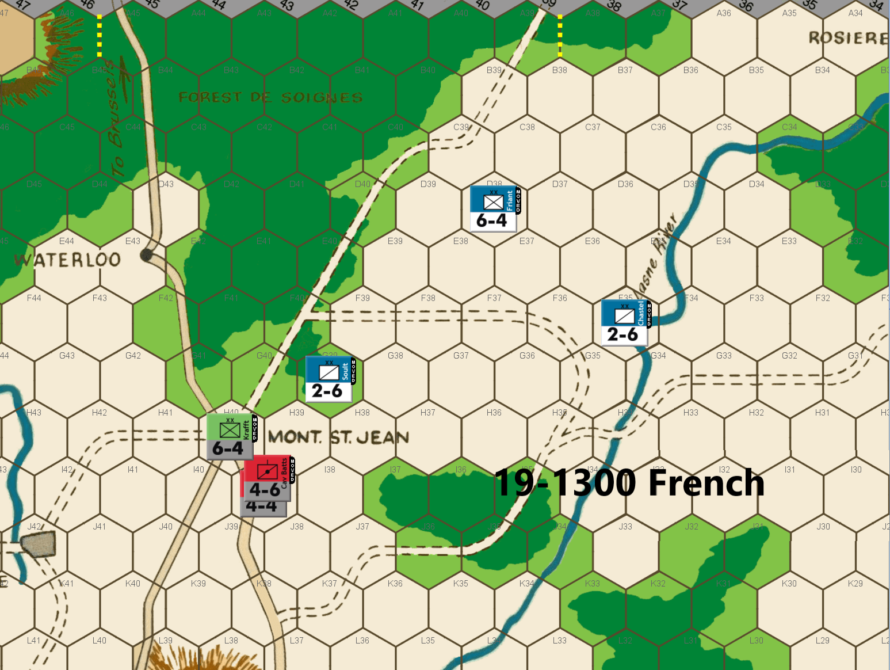
[Editor Note: French move guaranteeing their exit to Brussels next turn and a French win.]

Epilogue:
Bert: Wow, that game was fun to play! I feel a bit guilty about having won the game. Despite various mistakes that both of us committed, I think both players had made good enough moves to earn a win in this match. In the end, that last die roll, luckily fell my way.
Obviously, I think this game became quite a different match when Ed made a mistake in the east on the 1500 turn of June 17th. His inadvertent blunder allowed two 3-1 attacks unnecessarily and the dice fell my way with two DE results. That move and the results almost ended our game as Ed’s position was precarious. He made the correct response with some potentially last-ditch attempt to save the position with a couple of 1-2 attacks and the dice fell his way to prolong our game. From there, it seemed to become a free-for-all with both of us throwing major blows at one and another and both of us made mistakes as well as more last-ditch rolls that could have ended our game on multiple occasions.
Neither player gave up and the play was exciting, at least from my perspective. Throughout that end game, I kept my initial strategy in mind – play for attrition of the PAA forces. I feel that one of the best ways for the French to win in Waterloo is the high attrition strategy. It can almost be narrowed down as a math problem. There are 28 turns in the WBC version of the game and the PAA player starts out with 78 pieces before the bid. If the PAA side loses 2.79 pieces per turn, they will end up with none left and the French win the game. While it is not easy to make that happen, it can often work if it is employed early and throughout the game. This strategy involves taking a few high-risk attacks along with pushing positions that can force the PAA player to counter-attack- especially forcing losses via soak-offs and exchanges on their attacks.
Looking back, I did miss taking a couple of attacks that were available, especially that early 3-1 attack versus one of Ed’s 7-factor pieces in the Nivelles sector when I first broke through to the Y row. Overall, starting with the risky 3-1 attack on turn one, I pushed this envelope throughout the game. Early on, Ed showed restraint on counterattacking me which protected him from losing pieces on his own attacks. After the pivotal turn mentioned above, he pushed the counterattacks hard for the rest of the game. The problem for me is that the dice seemed to reward him with a bit unbalanced set of outcomes as he got an inordinate number of D Elim results and very few Exchange results when he did start counterattacking. I think that with a bit more balance on those attacks, and we would have seen the French finish off this game more easily as the additional PAA attrition would not have been easy to overcome.
We reached a point where the game was looking quite sad for my side, but you play the hand you are dealt and play on. Fortunately, the dice gave me lifelines on low odds attacks to keep my pulse beating. In my opinion, there was a point where the PAA could have gone conservative on the counterattacking and just focused on defending his position for the remainder of the game. My belief is that would have allowed him to win but almost just in time for my boys, the dice started evening up on his attacks and they yielded some needed DB2 and exchanges on his big attacks and AEs on his rolled soak-offs.
An important aspect of the attrition strategy is to drive the French advance to Mont St. Jean in order to split the PAA army. The vast number of wooded hexes to the north of that city make it quite difficult for them to defend both sectors. The French can sometimes focus most of their efforts, after achieving the split, to one side or the other if there are enough turns left to eliminate those forces and then exit units to take out the remaining army on the other side. This can be accomplished even if the French army is at a numerical disadvantage on the overall battlefield!
Ed brilliantly defended that Mont St. Jean section to where I was unable to ever get the split and hold it... until the final set of attacks. Ideally, the goal of the French is to gain that split as early as possible, typically before the IV Corps arrives in that area. I almost did this, but I think that mid-game set of D Elims on my forces on Ed’s attacks weakened my army sufficiently to prevent that goal from happening.
Finally, I was able to read Joe’s comments when the first day was sent out by Ed via email. After that, I decided to not read the rest of his feedback until after our game was over because I felt like the comments might influence my play. As a result, I am writing this last set of comments having read some of his feedback after our game ended. I think it was awesome to have him share his expertise throughout the game and I truly appreciate his candid feedback. I didn’t agree with everything just like I have no expectation that anyone should have agreed with my comments throughout this match. I did want to address a few of the points to offer my perspective on them:
• The early commitment of my large cavalry force was intentional and something that I would easily do again and repeatedly. In my opinion, the mobility of those units is precisely why they should be deployed to the west in the early game. Their mobility allows them to relatively easily be brought back to the center and east as needed after the early turns. For the most part, the PAA is able to clog up the Tilly Pass and the Quatre Bras heights for most of the first day and so having a bunch of cav units sitting behind the big infantry units adding little to the fight is a waste of the benefits they provide.
• My “delay” in getting infantry to the western sector was mostly due to that those pieces move slower. I intentionally diverted some force to the wooded hexes southeast of Nivelles, because this works in threatening a 3-1 attack when the PAA tries to defend against that path at Z35 or Y35. Also, I did have a slight delay because I wanted to make sure that I could effectively counterattack had Ed pursued an attack versus my cavalry that took the 3-1 attack on my first move.
• I made it clear from the beginning that my strategy was to cause the PAA as much attrition as possible as early as possible. It would have hurt had I rolled an exchange on that first attack, but I think it was worth it. My only real fear was an all-out counterattack to kill more of my cav units. I assessed that Ed was unlikely to do that while there are some others that I’ve played, who would have done that for sure. A battle at that point could have gone either way.
• The units that I sacrificed on day 3 to cause the IV Corps to be delayed in getting to the main front were pivotal in preventing the PAA from getting into ideal defensive positions earlier and I think were a key piece in allowing me to hang on and finally win the game. I think those units being alive and adding to my main front firepower would not have made up for the extra turn and likely two that their sacrifice gave me. Of course, it would have been even better if one of them had gotten a lucky DB2 result on one of Ed’s attacks. I guess I just need to let you decide how you’d play it out if you find yourself in that same situation.
In closing, thanks again for reading along. I sure hope that this labor of love helps you improve your own play and understand and appreciate how much fun this Waterloo game can be even though it is an “old” game. While I have been gaming at a pretty high level in a number of games for over 40 years now, Waterloo was not one of “my games” for those first 30+ years! I only started playing this game seriously once Ed started running these on-line tournaments. I studied the game replays that were published on this site between Joe and Marty and then Joe and Richard (all three brilliant gamers). I played more opponents that beat me pretty handily at some of the face-to-face tournaments. Each time I played, I learned more and utilized some of my own ideas that helped me to now be competitive against the best in this game. I still feel like I’m looking uphill at some of their skill, but even playing this game and reading the comments of the other guys will improve my play even more. I sure hope it does the same for you if you want to play this game at a high level. The game allows both sides to attack and defend and there are plenty of different strategies and tactics in this game to make it a joy to play. Good luck and enjoy your own gaming efforts!
Ed: I have never played a game that ended as this one did with both sides down to three units on the last turn. As I look back, I thought Bert played an excellent French game keeping the pressure on me across the board. I had a few missteps along the way, but none turned out to be a game changer in the end.
The real game changer in my opinion was the combination of a French 1-2 attack at Nivelles and the 2-1 attack across the Thiel River on the 16-1900 turn. I had counted on Bert being dissuaded from attacking at worse than 3-1 odds against my doubled defenses. I was very badly prepared for a French success in either one. The 1-2 attack resulted in an AE. But the success on Bert’s 2-1 attack (DB = DE) totally disrupted my Quatre Bras and Genappe River defenses. The probability of French success on one or both attacks was too high to leave for an aggressive French player. I should have been better prepared for a French success.
That fundamentally altered the course of the game. My Genappe River defense crumbled a few turns early which forced an early withdrawal toward Mt. St. Jean. My eastern defense was crumbling. But a couple of missteps by Bert and a nice streak of lucky attack results allowed me to get back in the game and become a favorite. But then just as I was feeling guilty about my luck, Bert had some nice luck with 1-2 exchanges against my heavies and a couple of 1-1 DE attacks against PAA stacks that evened up the game. It was a roller coaster of a game that came down to a few die rolls at the very end.
Joe: This final commentary is not going to be what any of our readers would reasonably expect to see at this stage in this project; nonetheless, it is in keeping with a personal habit of mine that I cultivated during the many years that I was actively competing. For want of a better term, I will refer to this as my "Butterfly Effect" approach to post-game analysis: which is to say, instead of revisiting the outcomes of major battles (always dubious, because the dice are innately capricious and unreliable), or the success or failure of large-scale maneuvers (also questionable, because "big" moves inevitably provoke "big" responses from one's opponents), I long ago found it more useful to look closely at my (and my opponent's) early game, often quasi-automatic, decisions. These are the type of player choices that, although considered fairly inconsequential at the time, somehow -- when later scrutinized closely -- seem to contribute, all too often, to completely unexpected, and even game-changing outcomes. That said, what follows are my admittedly subjective thoughts on what I consider to be the key inflection point in this game: and one that I don't think any of us, me included, recognized at the time.
"No plan of operations extends with any certainty beyond the first contact with the main enemy forces. Only the layman believes that in the course of a campaign he sees the consistent implementation of an original thought that has been considered in advance in every detail and retained to the end." Helmuth von Moltke
Prior to the start of this championship match, I'm pretty sure that both Bert Schoose and Ed Menzel were expecting a challenging contest that, nonetheless, would probably still hew fairly closely to the familiar flow and rhythm of a conventional WATERLOO game. I know that I was. After all, both tournament finalists were seasoned Avalon Hill classics experts with decades of experience, and both had already won numerous war gaming championships (both face-to-face and PBeM) in the course of many past tournaments. This competitive match-up was also interesting -- at least to me -- because of what I considered to be the subtle differences that separated these two adversaries' individual playing styles. In the case of Bert (the French), my own experiences from competing against him had convinced me that his play, while generally solid, could be unpredictable, and even unorthodox; and that he was also capable of mounting speculative, low-odds attacks when they were least expected. When it came to Ed (the PAA), his style -- my having competed against him for many years -- was very familiar to me. Ed was the more conservative of the two players, but he was still opportunistic and, I knew from personal experience, that, if he detected any exploitable weakness in his opponent's dispositions, he could reliably be counted on to attack immediately and relentlessly.
In view of all this, it is probably not surprising that the opening and early middle game moves of the two adversaries pretty much developed along familiar (and traditional) lines of play: the PAA player used sacrifice units to delay the advancing foe, and studiously avoided combat; the French commander, for his part, pushed north -- as rapidly as prudence and the Allied player would allow -- towards virtually all of the most promising avenues of advance (Braine le Comte, Nivelles, the Quatre Bras Gap, and the Tilly Corridor), but generally eschewed low-odds attacks against Allied blockers, and contented himself, instead, with picking-off the PAA sacrifice/delay units that were arranged, like "speed bumps," in his army's path.
Of course, a PAA strategy that relies exclusively on "delay and retreat," can only slow, not stop L'Armee du Nord's advance. Thus, it was not really surprising that -- through a combination of speed, audacious maneuver, and multiple credible threats -- the French player was able to "steal a march" on the PAA commander in the west and, by so doing, was able to push through the Nivelles forest gaps a couple of game turns ahead of schedule. However, while events in the western sector were rapidly becoming a cause for concern to the Allied player, it was actually a missed opportunity for a PAA attack in the Tilly Corridor -- barely remarked on at the time -- that, I sincerely believe, would ultimately turn out to be the critical inflection point in this contest: one that would -- through the subsequent cascade of player actions, and reactions -- completely alter the trajectory of this match, and transform it from a conventional, and relatively predictable, WATERLOO game, into an extraordinary and protracted slug fest (think the last act of ROCKY, the movie), that neither the two players, nor yours' truly, ever would have expected; and one that would not end until the afternoon of the 19th, by which time both armies had been reduced to three units apiece, and in which the side with fewer combat factors would actually win.
"Sometimes a single battle decides everything and sometimes, too, the slightest circumstance decides the issue of a battle. There is a moment in every battle at which the least manoeuvre is decisive and gives superiority, as one drop of water causes overflow." Napoleon Bonaparte
The specific decision -- at least in my view -- that would, bit by bit, gradually bend the narrative arc of this championship match in a completely unexpected direction was actually made by the PAA player during his portion of 16 Jun 1500 game turn. Since I commented, in some detail, on the advisability of this Allied Tilly attack during the course of my original turn-by-turn commentary, I will not revisit that discussion here. Instead, I will describe what, I think, would have likely been the initial repercussions of such a PAA attack, had it actually been made. First, even putting aside the 70% chance of eliminating Habert with the 5-1, the French Tilly detachment -- even if reinforced by the units at Y19 -- would still have been stalled on the "T" row for at least one more game turn, and that delay would have allowed both Stulpnagel and the Prussian III Hrs. Arty to move to straddle the Thil River, in their own turn, which would put them in a position to reinforce the Tilly Prussians, if needed. And while I can readily envision another one or two rounds of combat on this particular line, a precipitate PAA retreat -- with a sacrifice/delay unit left behind as a rearguard -- on the 1700 move, would pretty much have guaranteed that the French commander would not be able to launch a low-odds attack (2-1 or otherwise) against the Thil defenses until his 17 Jun 0700 move; nor would a French attack against the eastern Genappe, before the 17 Jun 0900 turn (at the earliest), have been very likely. Moreover, the benefits to the PAA player of a one or two turn delay in French operations in the east would have also directly impacted Allied offensive options in the west; to whit: such a delay would have made it possible for the Allies to launch at least one turn of coordinated Anglo-Allied/Prussian spoiling attacks at Nivelles, both to halt the advance of, and to inflict losses on, the French Left Wing, and all before the Prussian contingent would likely have been obliged to counter-march back towards Quatre Bras. In addition, the PAA decision not to fight in the Tilly Corridor, by allowing an early French bridgehead across the Thil River, guaranteed not only that the Genappe line would be rolled up two turns earlier than usual, but also that the Allied defense of the Dyle River would crumble ahead of schedule. And that's where I'll leave it: in all honesty, beyond these obvious initial outcomes, the subsequent effects that this decision might have had on the course of this particular game, is anybody's guess.
Finally, and on a completely different topic: I promised in my previous comments to share my views on the pros and cons of the French player sacrificing units (of any type) in order to slow the advance of the infantry component of the Prussian IVth Corps in its march towards Mont. Ste.-Jean. This is an intriguing question, and while there are doubtless situations in which this might actually be a reasonable option, I have personally never felt the need to resort to this gambit. There are a couple of reasons for this. First, there is my general disinclination to allow PAA reinforcements -- whether Anglo-Allied or Prussian -- to attack French units any earlier than absolutely necessary; and by offering up delay units, the French player is not only doing just that, but he is doing so without any hope of material compensation. Second, when it comes to the IVth Corps, itself, I remind myself that -- short of blocking (with units and ZOCs) the actual board edge entry hexes -- there really is no economical way to prevent the incoming Corps' cavalry units from detouring through Rosieres, and then on to Mont. Ste.-Jean. Of course, if the French player is willing to commit a substantial force of his own in order to block the Prussians, then an effective delay, of sorts, might be possible; however, its cost in numbers of units required, will usually be prohibitive. The other reason that I dislike the idea of sacrificing French units in order to slow the arrival of the incoming Prussian infantry, is that there are only five Prussian units at issue in the first place, and if two or three French units (preferably including the 4-6 and one or two 3-6s) hover just within range of the La Lasne River, then that French threat will usually be sufficient to pin at least two (and maybe three) of the incoming Prussian infantry units to the west bank of the river and away from the Mont. Ste.-Jean battlefield.

